Dubrovnik, Dalmatia, Croatia
The Pearl of the Adriatic: a UNESCO-listed medieval walled city rising straight from the sea, famous for its 2 km circuit of stone walls, Game of Thrones filming locations, and that impossible-blue Adriatic light.
⚓ Docked (Port Gruž) · 🕒 Typical call: 8–12 hrs · 💶 Euro (EUR) · Cards widely accepted · 🗣️ Croatian · English widely spoken · 🎬 Game of Thrones filming location
✍️ MY DAY IN PORT (FILL IN)
Ship / Date
In port | arrive ______ · all aboard ______
Booked excursion
Notes / meeting point
GETTING ASHORE
- Docking: Port Gruž — 3 km northwest of Old City
- To Old City: Shuttle ~€3 · Bus 1A/1B ~€2 · Taxi €10–15
- Best For: City Walls · Cable Car · Island Escapes
- Don't Miss: Walk the full 2 km walls — buy tickets online
GETTING AROUND
- 🚕 Taxi: €10–€15 — Standard taxi from Gruž Port to Pile Gate takes about 5–6 minutes. Fixed-rate private transfers (sedan) run around €30 f
- 📱 Rideshare: ✅ Uber, Bolt
- 🚌 Hop-on hop-off: ✅ · from €32
TOP THINGS TO DO
- Walk the City Walls — The 2 km circuit of Dubrovnik's medieval walls is one of the great urban walks in Europe.
- Cable Car to Mount Srđ — A 4-minute ride up Mount Srđ (412 m) delivers the most dramatic panorama in Dalmatia — the Old City laid out like a model, Lokrum…
- Lokrum Island — A 15-minute ferry from the Old City harbour drops you on a forested nature reserve with botanical gardens, roaming peacocks, a…
- Elafiti Islands Boat Tour — A half or full-day cruise visits three tranquil islands northwest of Dubrovnik — Koločep, Lopud, and Šipan.
- Mostar Day Trip (Bosnia & Herzegovina) — A full-day cross-border excursion to the iconic city of Mostar, famous for the 16th-century Stari Most (Old Bridge) arching over…
BEST WALKS
- The Stradun Circuit: 45–60 min · Flat · Free — The classic introduction: enter at Pile Gate, stroll the entire Stradun (Placa) limestone promenade…
- Above the Old City: Steps to Buža Bar: 30–45 min · Some stairs · Free to walk — From Stradun, climb any staircase heading south toward the city walls and follow signage for 'Buža…
- Fort Lovrijenac & Pile Gate Beach: 45 min round trip · Easy · €40 walls ticket or separate fee — Cross the bridge outside Pile Gate and climb to Fort Lovrijenac — 'Dubrovnik's Gibraltar,' a…
WEATHER · DAYLIGHT · MONEY
Month | High °F | Low °F | Rainy days
May | 71 | 57 | 10
Jul | 85 | 70 | 4
Sep | 78 | 64 | 8
Daylight: May 5:25AM–8:02PM · Jul 5:23AM–8:23PM · Sep 6:27AM–6:57PM
cruiseports.org/dubrovnik · Confirm terminal & all-aboard time with your ship

Dubrovnik, Dalmatia, Croatia — Port Map
Red = walkable sights · Amber = excursions farther out · P = cruise terminal
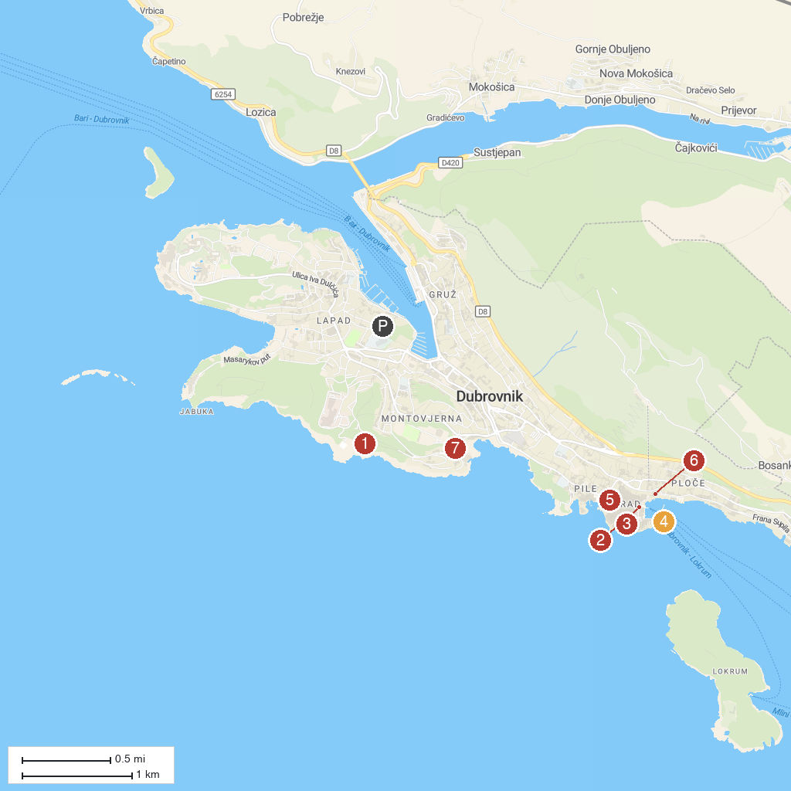
MAP KEY
1. Church of St. Blasius | 5. Onofrio's Large Fountain
2. Clock Tower of Dubrovnik | 6. Archeological Museum
3. Church of St. Ignatius | 7. Merit Casino Libertas
4. Porporela
P. Cruise port / terminal
Map © MapTiler © OpenStreetMap contributors · cruiseports.org

