Dubuque, Iowa, USA
Iowa's oldest city rises dramatically above the Mississippi on limestone bluffs, offering a walkable riverfront, Smithsonian-affiliated river museum, and a funicular ride to a three-state panorama.
⚓ Docked (pier) · 🕒 Typical call: 7–9 hrs · 💵 USD · 🗣️ English · 🌊 River port (Mississippi)
✍️ MY DAY IN PORT (FILL IN)
Ship / Date
In port | arrive ______ · all aboard ______
Booked excursion
Notes / meeting point
GETTING ASHORE
- Docking: Pier — docked at American Trust River's Edge Plaza / Port of Dubuque riverfront
- Walk to center: 10–15 min to downtown Main Street; National River Museum is 3–5 min from dock
- Best For: River history, bluff scenery, Midwestern food, relaxed walkable days
- Don't Miss: National Mississippi River Museum & Fenelon Place Elevator (tri-state view)
GETTING AROUND
- 🚕 Taxi: $8–$15 — Bell Taxi LLC and A1 Taxi serve the Dubuque area. Fares for short city-center runs are modest given the compact downtown
- 📱 Rideshare: ✅ Uber, Lyft
TOP THINGS TO DO
- National Mississippi River Museum & Aquarium — A Smithsonian-affiliated museum and aquarium exploring the ecology and history of America's great river.
- Fenelon Place Elevator (Shortest Scenic Railway) — Ride the world's shortest and steepest scenic funicular — a 189-foot cable car climb up a limestone bluff.
- Field of Dreams Movie Site (Dyersville) — Thirty minutes from Dubuque in Dyersville, Iowa, the original baseball diamond from the 1989 Kevin Costner film still stands in a…
- Hotel Julien Dubuque — Al Capone Connection — Downtown's elegant historic hotel was a known hideaway for Al Capone, who allegedly rented the entire 8th floor when laying low.
- Eagle Point Park — Bluff Panorama — Perched on a high bluff at the northern edge of town, this beautifully landscaped park overlooks Lock & Dam No.
BEST WALKS
- Riverfront to Downtown Stroll: 1.2 miles · ~25 min one-way · Flat — Follow the Mississippi Riverwalk north past the National River Museum, outdoor sculpture exhibits…
- Downtown to Fenelon Place Elevator: 0.6 miles · ~15 min from downtown · Moderate uphill — Walk up from Main Street through the Cathedral District to the base of the Fenelon Place Elevator.
WEATHER · DAYLIGHT · MONEY
Month | High °F | Low °F | Rainy days
May | 70 | 52 | 12
Jul | 82 | 66 | 9
Sep | 75 | 59 | 9
Daylight: May 5:40AM–8:17PM · Jul 5:39AM–8:37PM · Sep 6:43AM–7:11PM
cruiseports.org/dubuque-ia · Confirm terminal & all-aboard time with your ship

Dubuque, Iowa, USA — Port Map
Red = walkable sights · Amber = excursions farther out · P = cruise terminal
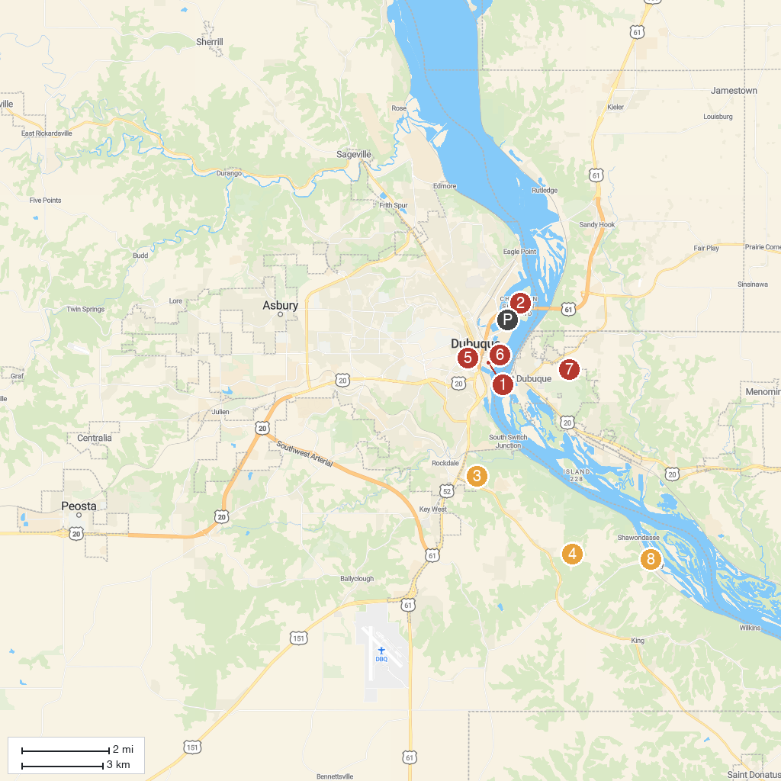
MAP KEY
1. Diamond Jo Casino Dubuque | 5. Washington Park
2. Q Casino + Resort | 6. Dubuque Shot Tower
3. EB Lyons Interpretive Center | 7. Dunleith Park District
4. Crystal Lake Cave | 8. Massey Marina and Park
P. Cruise port / terminal
Map © MapTiler © OpenStreetMap contributors · cruiseports.org

