Duisburg, North Rhine-Westphalia, Germany
Where rust-belt grit became high art — Duisburg's blast furnaces and waterfront warehouses have been reborn as one of Europe's most original urban destinations.
⚓ Docked (river pier) · 🕒 Typical call: 8–10 hrs · 💶 Euro (€) · 🗣️ German
✍️ MY DAY IN PORT (FILL IN)
Ship / Date
In port | arrive ______ · all aboard ______
Booked excursion
Notes / meeting point
GETTING ASHORE
- Docking: River pier — Steiger Schwanentor (Inner Harbor) or Duisburg-Ruhrort
- Walk to center: 5–10 min from Schwanentor pier to Inner Harbor & city center
- Best For: Industrial heritage, modern sculpture, art museums, local beer & currywurst
- Don't Miss: Landschaftspark Duisburg-Nord — climb Blast Furnace No. 5 for panoramic views
GETTING AROUND
- 🚕 Taxi: €8–10 — Standard metered taxis from the port to city center. Base fare ~€4.50 plus ~€2/km; expect €8–10 for the short run to the
- 📱 Rideshare: ✅ Uber, Bolt
TOP THINGS TO DO
- Landschaftspark Duisburg-Nord — A decommissioned coal and steel plant turned public park is the city's crown jewel.
- Museum Küppersmühle (MKM) — Housed in a converted 19th-century grain mill right on the Inner Harbor, MKM holds one of Germany's finest collections of…
- Inner Harbor Boat Tour (Hafenrundfahrt) — A 2-hour narrated cruise into the world's largest inland port, passing giant container terminals, coal docks, and historic…
- Lehmbruck Museum — A world-class sculpture museum in the leafy Kant Park dedicated to modern sculpture, featuring works by Lehmbruck, Giacometti…
- Tiger & Turtle — Magic Mountain — A walkable roller-coaster sculpture atop the Heinrich-Hildebrand-Höhe in Angerpark, southern Duisburg — an award-winning art…
BEST WALKS
- Inner Harbor & Schwanentor Stroll: 45 min · Flat · Free — An easy loop from the pier along the revitalised Innenhafen promenade, past the MKM grain mill, the…
- City Center & Königstraße: 30 min · Flat · Free — Walk from the pier northwest through the pedestrian zone to the main shopping street and the…
WEATHER · DAYLIGHT · MONEY
Month | High °F | Low °F | Rainy days
May | 65 | 49 | 12
Jul | 75 | 59 | 13
Sep | 68 | 54 | 10
Daylight: May 5:41AM–9:18PM · Jul 5:34AM–9:42PM · Sep 7:08AM–7:46PM
cruiseports.org/duisburg · Confirm terminal & all-aboard time with your ship

Duisburg, North Rhine-Westphalia, Germany — Port Map
Red = walkable sights · Amber = excursions farther out · P = cruise terminal
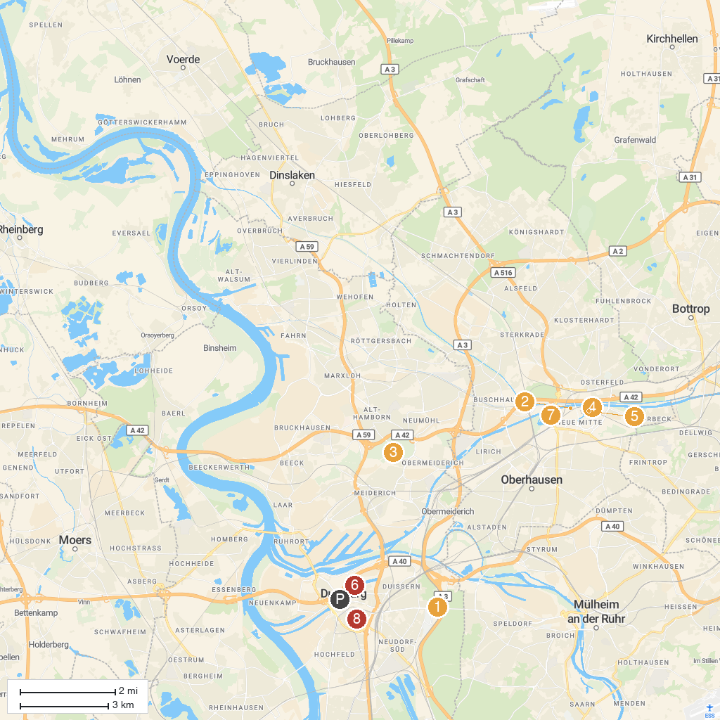
MAP KEY
1. Duisburg Zoo | 5. LEGOLAND Discovery Centre Oberhausen
2. Gasometer | 6. Duisburg Inner Harbour
3. Landschaftspark Duisburg-Nord | 7. LUDWIGGALERIE Schloss Oberhausen
4. SEA LIFE Oberhausen | 8. Lehmbruck Museum
P. Cruise port / terminal
Map © MapTiler © OpenStreetMap contributors · cruiseports.org

