Duluth, Minnesota, USA
Perched at the western tip of Lake Superior, Duluth is an industrial port city with rugged bluffs, a booming craft-food scene, and an iconic 1929 lift bridge that towers over passing thousand-foot ore freighters.
⚓ Pier dock (DECC seawall) · 🕒 Typical call: 8–10 hrs · 💵 USD · 🗣️ English · 🌊 Freshwater sea — pack a windbreaker
✍️ MY DAY IN PORT (FILL IN)
Ship / Date
In port | arrive ______ · all aboard ______
Booked excursion
Notes / meeting point
GETTING ASHORE
- Docking: Pier — DECC seawall, Canal Park
- Walk to Canal Park: Instant — you step off into it
- Best For: Maritime history, craft food, ship watching
- Don't Miss: Aerial Lift Bridge lifting for a 1,000-ft freighter
GETTING AROUND
- 🚕 Taxi: $5–10 — Taxis queue at the designated wait zone outside the DECC. Short rides to Canal Park or downtown run roughly $5–10 plus t
- 📱 Rideshare: ✅ Uber, Lyft
TOP THINGS TO DO
- Aerial Lift Bridge & Canal Park — Walk to Duluth's most photographed landmark and watch it rise for passing freighters.
- SS William A. Irvin Museum Ship — Tour a retired 1938 Great Lakes ore freighter docked just steps from the DECC.
- Great Lakes Aquarium — One of North America's only freshwater-focused aquariums.
- Glensheen Mansion — A spectacular 39-room Jacobean estate built in 1908 on the Lake Superior shoreline.
- Park Point Beach & Sandbar Walk — Cross the Aerial Lift Bridge on foot to reach a 7-mile freshwater sandbar lined with pine-backed sandy beaches.
BEST WALKS
- Canal Park & Aerial Lift Bridge Loop: 1–2 hrs • Flat • Free — Start at the DECC dock, walk east past the Great Lakes Aquarium and SS William A.
- The Duluth Lakewalk: 1.5 hrs one-way • Flat • Free — Head northeast from Canal Park on the paved Lakewalk trail hugging the Lake Superior shoreline.
WEATHER · DAYLIGHT · MONEY
Month | High °F | Low °F | Rainy days
May | 60 | 44 | 11
Jul | 77 | 63 | 10
Sep | 68 | 56 | 10
Daylight: May 5:33AM–8:36PM · Jul 5:30AM–8:58PM · Sep 6:46AM–7:19PM
cruiseports.org/duluth-mn · Confirm terminal & all-aboard time with your ship

Duluth, Minnesota, USA — Port Map
Red = walkable sights · Amber = excursions farther out · P = cruise terminal
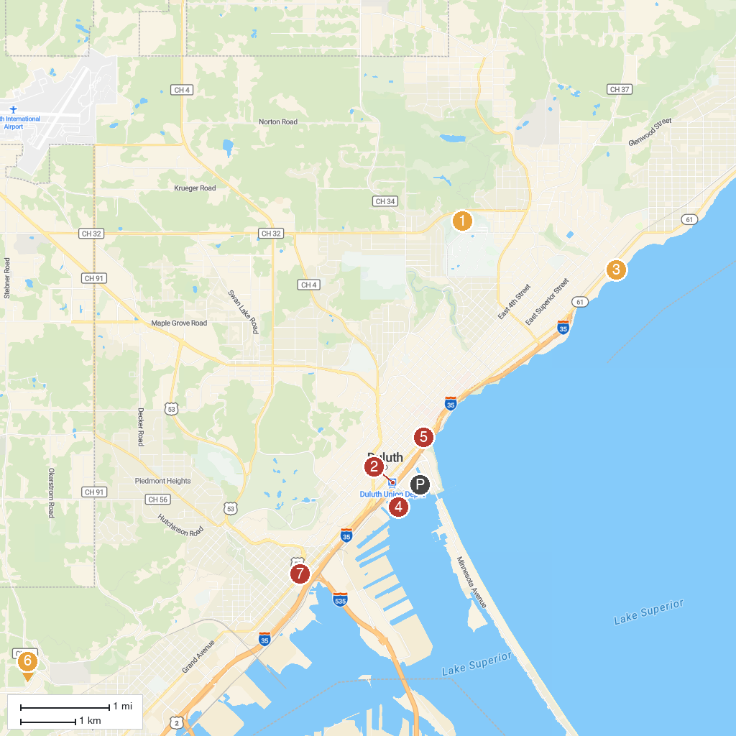
MAP KEY
1. W.R. Bagley Nature Area | 5. FOND-DU-LUTH CASINO
2. North Shore Scenic Railroad | 6. Fairmount Park
3. Glensheen Mansion | 7. Duluth Children's Museum
4. Bayfront Festival Park
P. Cruise port / terminal
Map © MapTiler © OpenStreetMap contributors · cruiseports.org

