Durban, KwaZulu-Natal, South Africa
Africa's busiest cruise port pairs a sun-drenched Indian Ocean beachfront with deep Zulu heritage — you can surf North Beach in the morning and visit a traditional village by afternoon.
⚓ Docked (pier) · 🕒 Typical call: 8-10 hrs · 💵 South African Rand (ZAR) · 🗣️ Zulu, English
✍️ MY DAY IN PORT (FILL IN)
Ship / Date
In port | arrive ______ · all aboard ______
Booked excursion
Notes / meeting point
GETTING ASHORE
- Docking: Nelson Mandela Cruise Terminal, Point Waterfront — ships dock directly, no tender
- Walk to center: 3–4 km to CBD / Golden Mile beachfront; rideshare or taxi recommended
- Best For: Zulu culture, beach days, Big Five safaris, Indian-influenced food
- Don't Miss: uShaka Marine World, Moses Mabhida Stadium SkyCar, Valley of a Thousand Hills
GETTING AROUND
- 🚕 Taxi: R200–R350 (~$11–$19 USD) to city centre — Metered taxis are available at the cruise terminal. Confirm the meter is running before departure; walking to the city c
- 📱 Rideshare: ✅ Uber, Bolt
- 🚌 Hop-on hop-off: ✅ Ricksha Bus
TOP THINGS TO DO
- Big Five Safari — Hluhluwe-iMfolozi Park — A full-day drive (about 2.5–3 hrs each way) to one of Africa's oldest game reserves, home to the Big Five and renowned for white…
- Tala Private Game Reserve Half-Day Safari — Closer option (45 min from port) offering giraffes, zebras, white rhinos, wildebeest, and prolific birdlife on a private reserve.
- Valley of a Thousand Hills & PheZulu Cultural Village — Scenic drive into the misty hills west of Durban to experience authentic Zulu culture — traditional dance, beadwork, homestead…
- uShaka Marine World — The largest aquarium in Africa, themed around a series of four 'wrecked' cargo ships at Point Waterfront — minutes from the…
- Moses Mabhida Stadium SkyCar — Ride the aerial SkyCar to the top of the iconic 2010 World Cup stadium arch for sweeping panoramic views of Durban's skyline and…
BEST WALKS
- Golden Mile Beachfront Walk: 3 km · Easy · 45–60 min — Durban's famous 6 km beachfront promenade runs along shark-netted swimming beaches from South Beach…
- Point Waterfront to uShaka Marine World: 0.5 km · Easy · 10 min — A short waterfront stroll from the cruise terminal directly to uShaka Marine World's entrance…
WEATHER · DAYLIGHT · MONEY
Month | High °F | Low °F | Rainy days
May | 75 | 62 | 6
Jul | 71 | 56 | 5
Sep | 73 | 62 | 8
Daylight: May 6:33AM–5:10PM · Jul 6:50AM–5:13PM · Sep 5:54AM–5:48PM
cruiseports.org/durban · Confirm terminal & all-aboard time with your ship

Durban, KwaZulu-Natal, South Africa — Port Map
Red = walkable sights · Amber = excursions farther out · P = cruise terminal
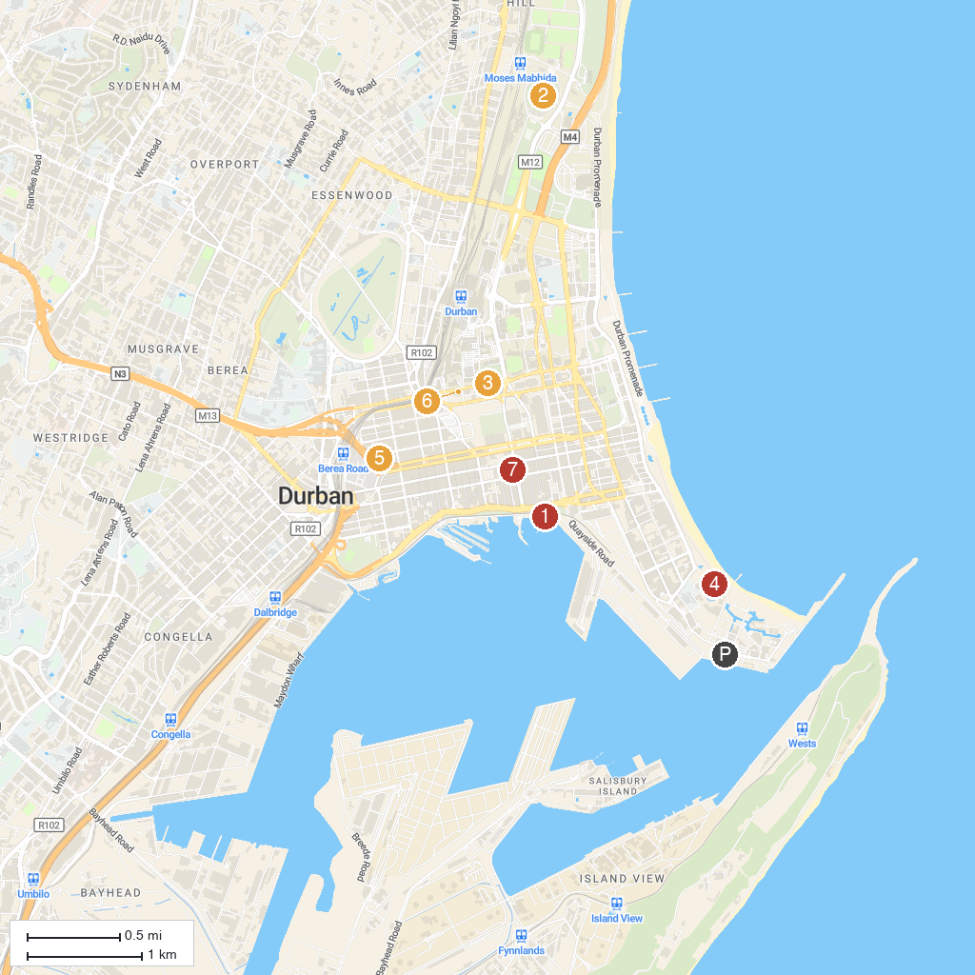
MAP KEY
1. The Bat Centre | 5. The Bergtheil Museum Westville
2. Moses Mabhida Stadium | 6. Emmanuel Cathedral
3. The Old Fort | 7. Natural Science Museum Research Centre
4. uShaka Marine World | 8. Local History Museum
P. Cruise port / terminal
Map © MapTiler © OpenStreetMap contributors · cruiseports.org

