Dutch Harbor, Unalaska, Alaska, USA
America's busiest fishing port sits under skies thick with bald eagles and WWII ghosts. Dutch Harbor and Unalaska offer raw Aleutian beauty, world-class history, and zero tourist kitsch.
⚓ Pier (industrial dock) · 🕒 Typical call: 8–10 hrs · 💵 USD · 🗣️ English · 🦅 Wildlife destination
✍️ MY DAY IN PORT (FILL IN)
Ship / Date
In port | arrive ______ · all aboard ______
Booked excursion
Notes / meeting point
GETTING ASHORE
- Docking: Pier (UniSea or Kloosterboer industrial dock; shuttle to town required)
- Walk to Center: Not walkable from dock — free/paid shuttle ~2–3 miles to town
- Best For: WWII history, bald eagle watching, Deadliest Catch boats, Unangan culture
- Don't Miss: Holy Ascension Cathedral, Museum of the Aleutians, Bunker Hill hike
GETTING AROUND
- 🚕 Taxi: $5–$10 — Several local taxi companies operate in Unalaska (Alaskan Taxi, Aleutian Taxi, Island Taxi, Star Taxi, and others). Shor
- 📱 Rideshare: ❌ not available
- 🚌 Hop-on hop-off: ✅
TOP THINGS TO DO
- WWII Aleutian History Tour — Van tour of Dutch Harbor's extraordinary WWII sites: Fort Schwatka (the highest coastal defense battery built in the US during…
- Bunker Hill Hike — A moderate 1.5-mile gravel road hike to the top of Bunker Hill rewards you with WWII concrete bunkers and sweeping 360° views of…
- Museum of the Aleutians — One of Alaska's best small museums, covering 9,000 years of Unangan (Aleut) culture, the Russian fur-trade era, and the WWII…
- Bald Eagle & Wildlife Walk — Dutch Harbor may have the highest density of bald eagles of any US port — they perch on telephone poles, shipping containers, and…
- Deadliest Catch Fleet Walk — Walk the Spit dock area to spot famous crab boats from the Discovery Channel show — vessels like the Northwestern and Wizard are…
BEST WALKS
- Bridge Walk: Grand Aleutian to Museum of the Aleutians: 1.2 miles one-way · 25 min · Flat · Stunning harbor views — Walk across the bridge connecting Dutch Harbor (Amaknak Island) to Unalaska Island.
- Bunker Hill Road Hike: 1.5 miles · 45–60 min · Moderate uphill · WWII ruins at top — Follow the gravel road up Bunker Hill from the Unalaska town side.
WEATHER · DAYLIGHT · MONEY
Month | High °F | Low °F | Rainy days
May | 45 | 38 | 18
Jul | 55 | 49 | 14
Sep | 53 | 46 | 16
Daylight: May 7:03AM–11:02PM · Jul 6:55AM–11:28PM · Sep 8:40AM–9:20PM
cruiseports.org/dutch-harbor-unalaska · Confirm terminal & all-aboard time with your ship

Dutch Harbor, Unalaska, Alaska, USA — Port Map
Red = walkable sights · Amber = excursions farther out · P = cruise terminal
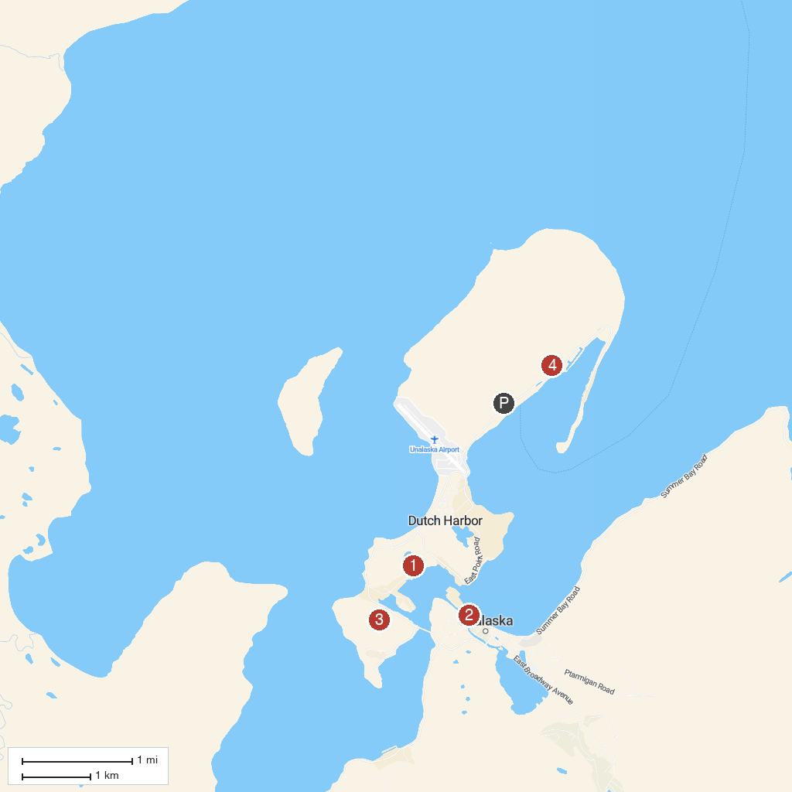
MAP KEY
1. Museum of the Aleutians | 3. Bunker Hill WWII Memorial Site
2. Church of the Holy Ascension | 4. Mount Ballyhoo
P. Cruise port / terminal
Map © MapTiler © OpenStreetMap contributors · cruiseports.org

