Easter Island (Hanga Roa), Chile
One of the most remote inhabited islands on Earth — a wind-swept triangle of volcanic craters, ceremonial platforms, and nearly a thousand brooding moai staring out from the Pacific. Your shore day here is genuinely unlike anywhere else.
⚓ Tender port (no pier — weather-dependent) · 🕒 Typical call: 7–10 hrs · 💵 Chilean Peso (CLP) · 🗣️ Spanish / Rapa Nui
✍️ MY DAY IN PORT (FILL IN)
Ship / Date
In port | arrive ______ · all aboard ______
Booked excursion
Notes / meeting point
GETTING ASHORE
- Docking: Tender to Hanga Roa Caleta
- Walk to center: 5 min from tender dock
- Best For: Moai · Archaeology · Remote
- Don't Miss: Rano Raraku & Ahu Tongariki
GETTING AROUND
- 🚕 Taxi: $3–5 USD in town; island tours ~$50–130/person — Taxis are available in Hanga Roa for short hops or can be hired for half/full-day island tours. Negotiate the rate befor
- 📱 Rideshare: ❌ not available
TOP THINGS TO DO
- Rano Raraku & Ahu Tongariki — The volcanic quarry where nearly all 900+ moai were carved, with dozens still half-finished in the hillside — hauntingly surreal.
- Rano Kau Crater & Orongo Birdman Village — A steep-walled volcanic caldera filled with a reed-covered freshwater lake, and perched on its rim: Orongo, the ceremonial stone…
- Anakena Beach — The island's only white-sand beach on the north coast, framed by palm trees and two ahu (platforms) — including a platform with…
- Ahu Akivi — Inland-Facing Moai — The only ahu whose seven moai face the ocean rather than land — astronomically aligned to the setting sun at equinox.
- Snorkeling & Diving — Easter Island's waters are some of the clearest in the world — visibility can exceed 40 meters.
BEST WALKS
- Hanga Roa waterfront & Ahu Tahai: ~2 km · 1 hr · easy — A short walk north along the coast from the tender dock brings you to Ahu Tahai — a restored…
- Hanga Roa town center: ~1 km · 30 min · easy — A stroll up Avenida Atamu Tekena, Hanga Roa's main street, past local restaurants, souvenir shops…
WEATHER · DAYLIGHT · MONEY
Month | High °F | Low °F | Rainy days
May | 71 | 69 | 10
Jul | 67 | 65 | 9
Sep | 66 | 64 | 6
Daylight: May 7:50AM–6:36PM · Jul 8:06AM–6:41PM · Sep 8:15AM–8:10PM
cruiseports.org/easter-island · Confirm terminal & all-aboard time with your ship

Easter Island (Hanga Roa), Chile — Port Map
Red = walkable sights · Amber = excursions farther out · P = cruise terminal
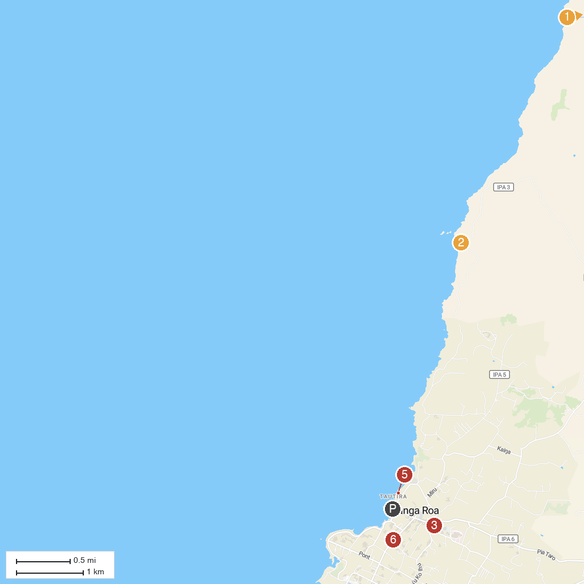
MAP KEY
1. Rapa Nui National Park-Land Of the Shark Spirits | 5. Caleta Hanga Roa
2. Cueva De Las Dos Ventanas | 6. Playa Poko Poko
3. Rano a Raraku | 7. Varua Ora
4. Parroquia de la Santa Cruz
P. Cruise port / terminal
Map © MapTiler © OpenStreetMap contributors · cruiseports.org

