Eberswalde, Brandenburg, Germany
Brandenburg's 'Forest Town' sits where Europe's oldest artificial waterway threads through dense woodland — river cruisers arrive on the Oder-Havel Canal, steps from free botanical gardens and one of Germany's most impressive engineering feats.
⚓ River cruise — moored at canal quay · 🕒 Typical call: 6-8 hrs · 💶 Currency: Euro (€) · 🗣️ Language: German · 🌲 Forest & waterway town
✍️ MY DAY IN PORT (FILL IN)
Ship / Date
In port | arrive ______ · all aboard ______
Booked excursion
Notes / meeting point
GETTING ASHORE
- Docking: River ships moor alongside the Oder-Havel Canal quay; town center is a short walk
- Walk to center: ~10 min to Marktplatz from canal mooring
- Best For: Scenic waterways, engineering history, zoo, free botanical garden, local pastry
- Don't Miss: Niederfinow Boat Lift (~12 km away) and an Eberswalder Spritzkuchen from a local bakery
GETTING AROUND
- 🚕 Taxi: €4.50 base + €2.60/km (first 6 km) — Local taxis use the Barnim district tariff. The port is close to town so most rides are short and reasonably priced.
- 📱 Rideshare: ✅ Uber
TOP THINGS TO DO
- Niederfinow Boat Lift — Germany's landmark ship lift bridges a 36-metre elevation change on the Oder-Havel Canal.
- Forest Botanical Garden (Forstbotanischer Garten) — One of Europe's oldest botanical gardens, founded in 1830 in the leafy Schwärzetal valley.
- Eberswalde Zoo — A surprisingly excellent zoo set in 15 hectares of woodland.
- Finow Canal Towpath & Old Town Walk — The Finow Canal dates back over 400 years (first built in 1605), making it one of Europe's oldest artificial waterways.
- Eberswalder Spritzkuchen Tasting — Eberswalde's beloved pastry since 1832 — a ring-shaped fried choux with sweet sugar glaze, lighter than a doughnut and unique to…
BEST WALKS
- Finow Canal Towpath to Old Town: 2 km · 25 min · Easy · Free — Walk west along the car-free Treidelweg canal path from the mooring, passing lock infrastructure…
- Botanical Garden Loop: 3 km · 45 min · Easy · Free — From the town center, walk south into the Schwärzetal valley to reach the Forest Botanical Garden.
WEATHER · DAYLIGHT · MONEY
Month | High °F | Low °F | Rainy days
May | 65 | 48 | 8
Jul | 75 | 59 | 11
Sep | 68 | 53 | 8
Daylight: May 5:07AM–8:55PM · Jul 4:58AM–9:21PM · Sep 6:39AM–7:19PM
cruiseports.org/eberswalde · Confirm terminal & all-aboard time with your ship

Eberswalde, Brandenburg, Germany — Port Map
Red = walkable sights · Amber = excursions farther out · P = cruise terminal
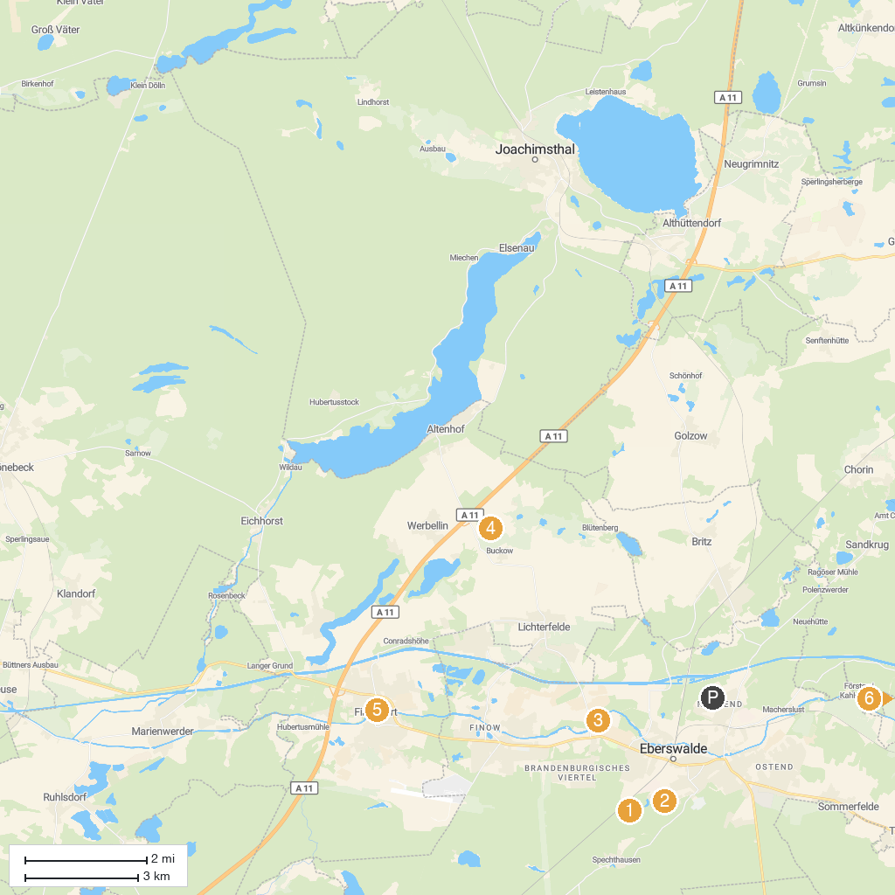
MAP KEY
1. Zoologischer Garten Eberswalde | 5. Schleuse Schöpfurt
2. Forest Botanical Garden Eberswalde | 6. Lieper Schleuse
3. Schleuse Drahthammer | 7. Schleuse Grafenbrück
4. Buckowseerinne | 8. Askanierturm
P. Cruise port / terminal
Map © MapTiler © OpenStreetMap contributors · cruiseports.org

