Eden Island, Mahé, Seychelles
A modern marina island grafted onto Mahé's southeast shore, Eden Island is Seychelles at its most polished — bobbing superyachts, granite peaks in the distance, and the Indian Ocean stretching to the horizon.
⚓ Docked (marina berth or Port Victoria) · 🕒 Typical call: 6-8 hrs · 💵 SCR / EUR / USD accepted · 🗣️ English & French · 🌴 Indian Ocean
✍️ MY DAY IN PORT (FILL IN)
Ship / Date
In port | arrive ______ · all aboard ______
Booked excursion
Notes / meeting point
GETTING ASHORE
- Docking: Marina berth at Eden Island or pier at Port Victoria, Mahé (~4 km away)
- Walk to town: Eden Plaza shops & restaurants are steps from the dock; Victoria is ~4 km / 5–10 min by taxi
- Best For: Beach lovers, snorkelers, shoppers, and Seychelles first-timers
- Don't Miss: St. Anne Marine National Park snorkel trip or a day trip to Praslin/La Digue
GETTING AROUND
- 🚕 Taxi: $25–35 USD — Eden Island is connected to Mahé by a bridge, about 4–6 km from Victoria city center. Taxis take 5–10 minutes; agree on
- 📱 Rideshare: ❌ not available
TOP THINGS TO DO
- St. Anne Marine National Park — A glass-bottom boat or semi-submarine tour through the protected marine park just off Mahé.
- Praslin & Vallée de Mai — Ferry or fly to Praslin to walk through Vallée de Mai, a UNESCO World Heritage forest of towering Coco de Mer palms.
- La Digue by Bicycle — The postcard island of La Digue is famed for Anse Source D'Argent — its pink-granite boulders and turquoise shallows are among…
- Victoria City Tour — The world's smallest capital packs in a colourful market, the Clock Tower (a mini Big Ben), Botanical Gardens with giant…
- Curieuse Island Giant Tortoises — A boat trip to Curieuse Marine National Park, where Aldabra giant tortoises roam freely on the beach.
BEST WALKS
- Eden Island Marina Boardwalk: Easy · 30–45 min · Flat — Wander the marina promenade past gleaming superyachts, browse the boutiques and Spar supermarket in…
- Bridge Walk to Mahé & Anse Royale Road: Moderate · 1-2 hrs · Some hills — Cross the 300m bridge to Mahé on foot, then follow the coastal road south toward Anse Royale for…
WEATHER · DAYLIGHT · MONEY
Month | High °F | Low °F | Rainy days
May | 86 | 76 | 9
Jul | 82 | 74 | 6
Sep | 84 | 75 | 8
Daylight: May 6:17AM–6:11PM · Jul 6:28AM–6:20PM · Sep 6:11AM–6:15PM
Representative sunrise/sunset — 2025, 15th of each month; local civil time including DST (Indian/Mahe). Source: Astral; not a forecast or climate average.
cruiseports.org/eden-island · Confirm terminal & all-aboard time with your ship

Eden Island, Mahé, Seychelles — Port Map
Red = walkable sights · Amber = excursions farther out · P = cruise terminal
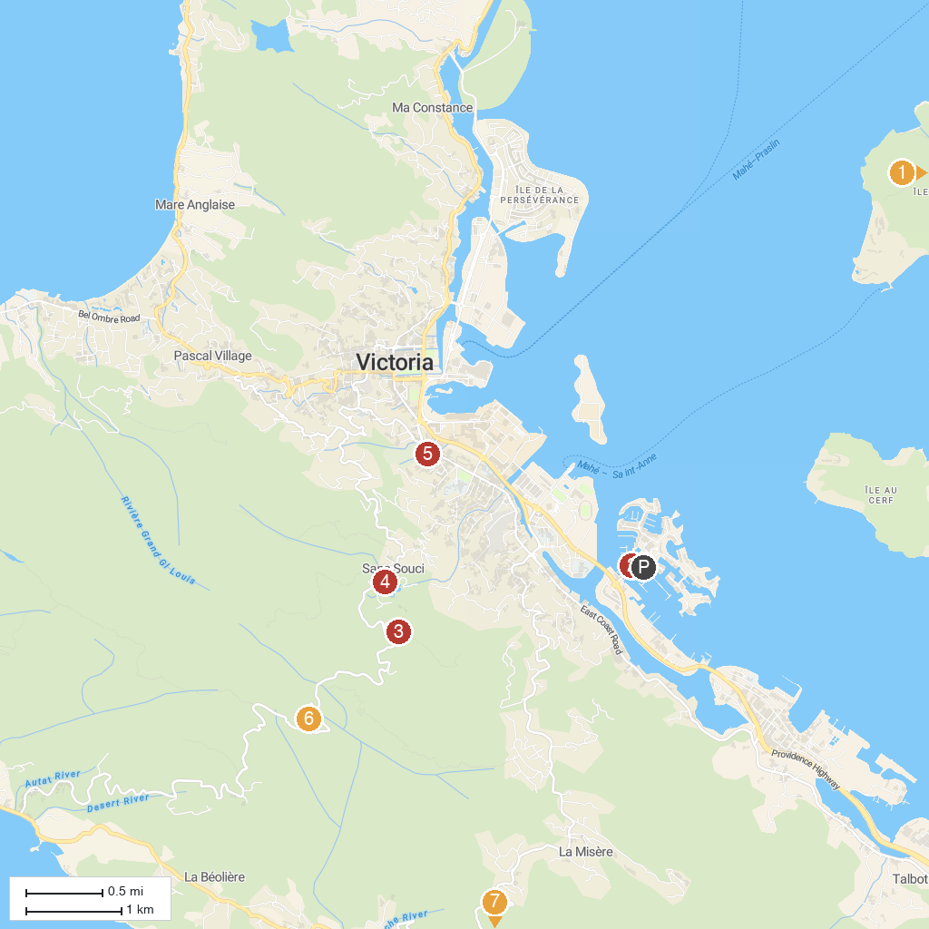
MAP KEY
1. Saint-Anne Marine National Park | 5. Victoria Botanical Gardens
2. Semi-Submarine Seychelles | 6. فين تاون - ميشن لودج
3. Copolia Trail | 7. Vallée des Fruits
4. Copolia view point
P. Cruise port / terminal
Map © MapTiler © OpenStreetMap contributors · cruiseports.org

