Eden, New South Wales, Australia
Perched on Twofold Bay — one of the Southern Hemisphere's deepest natural harbours — Eden punches well above its size. This small Sapphire Coast town was once Australia's whaling capital, and the legendary orca named Old Tom made it world-famous. Today it's all whale watching, red-cliff coastal trails, and oysters fresh from the bay.
⚓ Pier (Snug Cove Cruise Wharf) · 🕒 Typical call: 8–10 hrs · 💵 AUD — cards & tap-and-go universal · 🗣️ English · 🐋 Whale season: May–November
✍️ MY DAY IN PORT (FILL IN)
Ship / Date
In port | arrive ______ · all aboard ______
Booked excursion
Notes / meeting point
GETTING ASHORE
- Docking: Alongside at Eden Cruise Wharf, Snug Cove — no tender
- Walk to centre: ~5 min to main street; Killer Whale Museum 10 min
- Best For: Whale watching, whaling history, coastal walks, local oysters
- Don't Miss: Old Tom's skeleton at the Eden Killer Whale Museum
GETTING AROUND
- 🚕 Taxi: AUD $10–$15 — Taxis wait at the port entrance. The short hop to the town centre (2–3 km) typically costs AUD $10–15 depending on time
- 📱 Rideshare: ✅ Uber
TOP THINGS TO DO
- Whale Watching on Twofold Bay — Twofold Bay's deep, sheltered water draws humpbacks and southern right whales on their annual migration.
- Eden Killer Whale Museum — Home to Old Tom — the skeleton of an orca who co-operated with local whalers for decades.
- Beowa National Park & Red Cliffs — Formerly Ben Boyd NP, Beowa protects striking red-and-white eroded cliffs, heath wildflowers, and tall eucalypt forests.
- Kayaking the Pambula River — Paddle the calm, tannin-dark Pambula River through coastal wetlands, spotting birdlife and the occasional dolphin.
- Sydney Rock Oyster Tasting — The Sapphire Coast is prime Sydney Rock Oyster country.
BEST WALKS
- Snug Cove to Eden Lookout: 1.5 km • 20–25 min • Easy–moderate (gentle climb) — Walk from the cruise wharf along the waterfront, up through town past the Killer Whale Museum, and…
- Aslings Beach Stroll: 2 km return • 30 min • Easy — Head south from the town centre along Mitchell Street to reach Aslings Beach — a sheltered arc of…
WEATHER · DAYLIGHT · MONEY
Month | High °F | Low °F
May | 67 | 46
Jul | 62 | 41
Sep | 66 | 45
Daylight: May 6:52AM–5:00PM · Jul 7:11AM–5:01PM · Sep 6:01AM–5:50PM
cruiseports.org/eden · Confirm terminal & all-aboard time with your ship

Eden, New South Wales, Australia — Port Map
Red = walkable sights · Amber = excursions farther out · P = cruise terminal
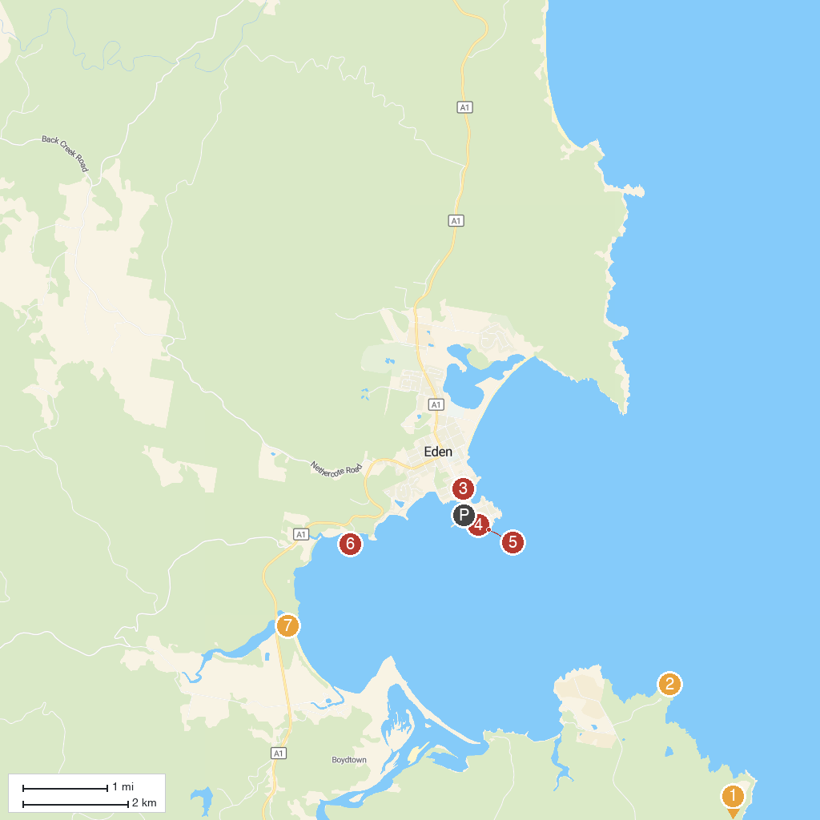
MAP KEY
1. Ben Boyd (Beowa) National Park | 5. Eden lookout point
2. Boyd's Tower | 6. Quarantine Bay Boat Ramp
3. Eden Killer Whale Museum | 7. Nullica River
4. Eden Lookout and Rotary Park
P. Cruise port / terminal
Map © MapTiler © OpenStreetMap contributors · cruiseports.org

