Edfu, Upper Egypt, Egypt
Rising from the sands between Luxor and Aswan, Edfu's towering Temple of Horus is the most completely preserved ancient Egyptian temple — buried for centuries, rediscovered intact, and every bit as awe-inspiring as Karnak.
⚓ River dock (no tender) · 🕒 Typical call: 2–3 hrs · 💵 EGP / USD accepted · 🗣️ Arabic · 🌡️ Hot & dry year-round
✍️ MY DAY IN PORT (FILL IN)
Ship / Date
In port | arrive ______ · all aboard ______
Booked excursion
Notes / meeting point
GETTING ASHORE
- Docking: Riverboats moor on the Nile Corniche (West Bank); boats often raft 2–3 deep
- Walk to Temple: ~1.5 miles (2.4 km) — take a caleche, not your feet
- Best For: Ancient Egypt lovers, history buffs, photography
- Don't Miss: The black granite Horus falcon statues flanking the hypostyle hall entrance
GETTING AROUND
- 🚕 Taxi: LE 100–200 per trip (negotiate) — Traditional metered or negotiated taxis can be found near the pier. Useful for travel between Edfu and Luxor or Aswan if
- 📱 Rideshare: ❌ not available
TOP THINGS TO DO
- Temple of Horus Deep Dive — Built between 237–57 BC, the Ptolemaic Temple of Horus is the best-preserved ancient temple in Egypt.
- Caleche Ride Through Edfu — The horse-drawn carriage ride is itself part of the experience — rattling through dusty backstreets past daily Egyptian life…
- Tell Edfu Archaeological Mound — Immediately beside the temple, the mound of Tell Edfu preserves ruins of the ancient city dating to the Old Kingdom — viewable…
- Edfu Souvenir Bazaar — The exit path from the temple winds through a covered market selling spices, alabaster statues, scarabs, and cotton gallabeyas.
BEST WALKS
- Inside the Temple of Horus: Easy | ~60–90 min | 0.5 km of pathways — From the massive pylons at the entrance, move through the open Court of Offerings, into the Great…
WEATHER · DAYLIGHT · MONEY
Month | High °F | Low °F | Rainy days
May | 103 | 75 | 0
Jul | 107 | 81 | 0
Sep | 104 | 79 | 0
Daylight: May 6:04AM–7:25PM · Jul 6:08AM–7:40PM · Sep 6:34AM–6:52PM
cruiseports.org/edfu · Confirm terminal & all-aboard time with your ship

Edfu, Upper Egypt, Egypt — Port Map
Red = walkable sights · Amber = excursions farther out · P = cruise terminal
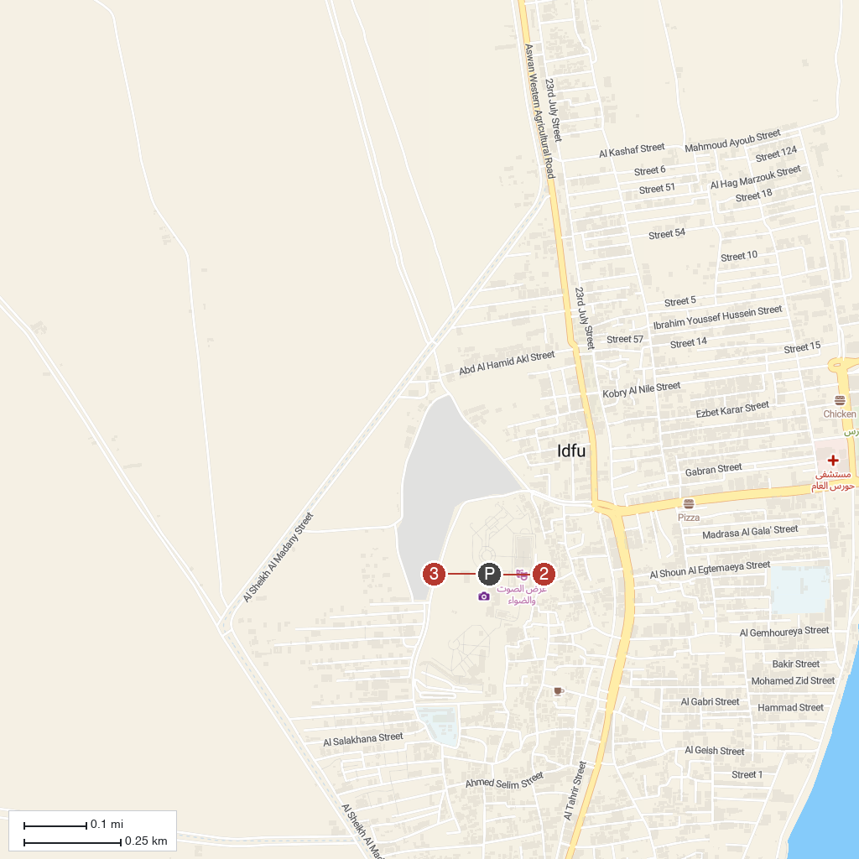
MAP KEY
1. Temple of Edfu (Temple of Horus) | 3. Edfu Souk
2. Edfu Corniche, West Bank
P. Cruise port / terminal
Map © MapTiler © OpenStreetMap contributors · cruiseports.org

