Egersund, Rogaland, Norway
One of Norway's largest wooden-house towns sits right off the cruise pier — pair that with a UNESCO geopark, a dramatic rock formation at Trollpikken, and a family-run brewery dating to 1899.
⚓ Pier (Dampskipskaien) · 🕒 Typical call: 6–8 hrs · 💵 Norwegian Krone (NOK) — card-only culture · 🗣️ Norwegian / English widely spoken
✍️ MY DAY IN PORT (FILL IN)
Ship / Date
In port | arrive ______ · all aboard ______
Booked excursion
Notes / meeting point
GETTING ASHORE
- Docking: Pier — Dampskipskaien, steps from the town centre
- Walk to centre: 5 min on foot from the cruise quay
- Best For: Historic wooden town, geology, easy hiking, local seafood
- Don't Miss: Trollpikken rock formation (UNESCO Magma Geopark)
GETTING AROUND
- 🚕 Taxi: ~NOK 95 base + NOK 20/km (~€8–15 for short trips) — Local taxis are available from the port. Egersund Taxi: +47 51 49 00 00; Dalane Taxi: +47 51 49 30 00. Bring cash (NOK)
- 📱 Rideshare: ❌ not available
TOP THINGS TO DO
- Trollpikken & Magma Geopark — Egersund's headline attraction — a naturally sculpted phallic rock pillar rising from lunar anorthosite landscape inside the…
- Historic Wooden Town Walk — Self-guided walk through Strandgaten and the medieval Haugen quarter, home to one of Norway's largest concentrations of…
- Egersund Fayancemuseum — Tells the story of Egersund's famed fayence (tin-glazed pottery) factory, which produced distinctive stoneware for 132 years.
- Eigerøy Lighthouse Hike — Hike across Eigerøy island's striking anorthosite plateau — often compared to a moonscape — to reach Norway's oldest cast-iron…
- Berentsen Distillery & Brewery — A family-owned institution since 1899, Berentsen's produces craft beer, traditional Norwegian cider, and award-winning gin.
BEST WALKS
- Harbour & Wooden Town Loop: 2.5 km · 45–60 min · Easy · Free — From the cruise pier walk along the waterfront to Torget (main square), then into the Haugen…
- Varberg Hill Viewpoint: 3 km round trip · 1 hr · Easy–moderate · Free — A short climb up Varberg hill behind the town rewards with panoramic views over the harbour…
WEATHER · DAYLIGHT · MONEY
Month | High °F | Low °F | Rainy days
May | 55 | 44 | 12
Jul | 64 | 54 | 17
Sep | 60 | 52 | 16
Daylight: May 5:08AM–9:57PM · Jul 4:53AM–10:29PM · Sep 7:06AM–7:54PM
cruiseports.org/egersund · Confirm terminal & all-aboard time with your ship

Egersund, Rogaland, Norway — Port Map
Red = walkable sights · Amber = excursions farther out · P = cruise terminal
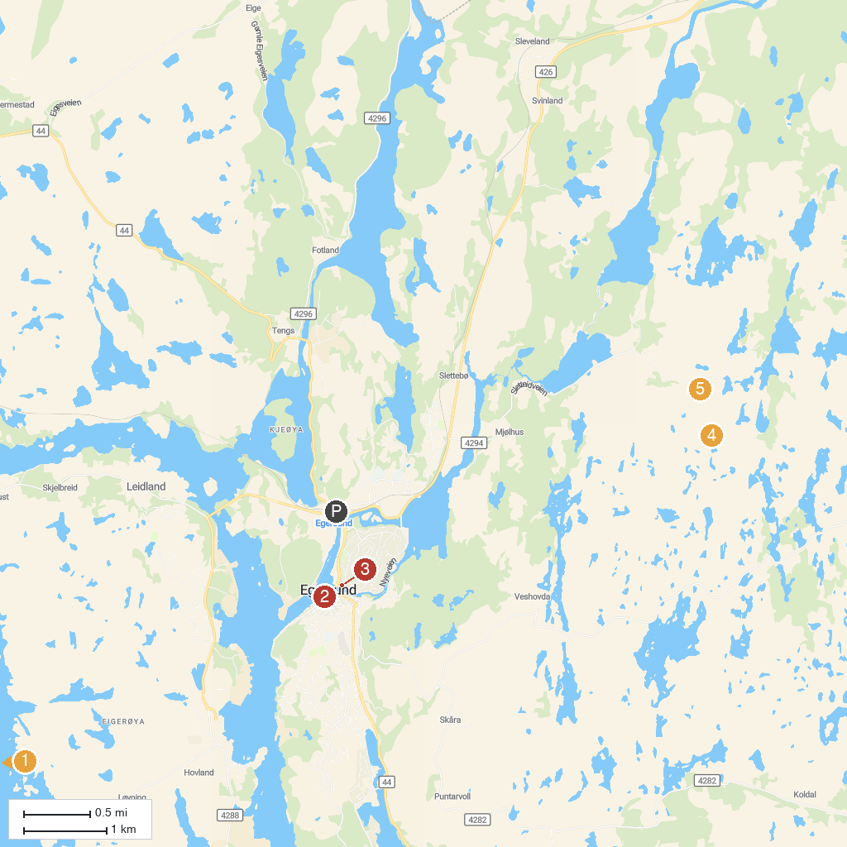
MAP KEY
1. Eigerøy Lighthouse | 4. Trollpikken
2. Egersund Church | 5. Waterfall
3. Egersund Fayancemuseum
P. Cruise port / terminal
Map © MapTiler © OpenStreetMap contributors · cruiseports.org

