Eidfjord, Vestland, Norway
A village of 900 people at the inner end of the Hardangerfjord, Eidfjord punches well above its size — it's the launch pad for Europe's most dramatic waterfall and Norway's vast high-mountain plateau.
⚓ Pier (docked) · 🕒 Typical call: 7–9 hrs · 💵 Norwegian Krone (NOK) — mostly cashless · 🗣️ Norwegian (English widely spoken) · 🌊 Hardangerfjord
✍️ MY DAY IN PORT (FILL IN)
Ship / Date
In port | arrive ______ · all aboard ______
Booked excursion
Notes / meeting point
GETTING ASHORE
- Docking: Pier — ships dock in the village center; no tendering
- Walk to center: 2–3 min flat walk from pier to cafes and shops
- Best For: Waterfalls, fjord scenery, Viking history, mountain hikes
- Don't Miss: Vøringsfossen waterfall — 182 m freefall into Måbødalen canyon
GETTING AROUND
- 🚕 Taxi: 150–300 NOK (short trips) — Local taxis are available for excursions outside town. A ride to Vøringsfossen waterfall runs around 281 NOK. Pre-bookin
TOP THINGS TO DO
- Vøringsfossen Waterfall — Norway's most visited waterfall drops 182 m into the Måbødalen canyon.
- Hardangervidda Plateau Drive — Europe's largest high-mountain plateau sits above Eidfjord at 1,100 m.
- Hereid Viking Burial Ground — Western Norway's largest Iron Age and Viking burial ground (c.
- Hardangervidda Nature Center — World-class interactive museum covering Norwegian climate, wildlife, and nature, with a stunning 225° panoramic cinema.
- Fjord Kayaking — Paddle on the glass-flat waters of the inner Hardangerfjord, surrounded by walls of rock rising over 1,000 m.
BEST WALKS
- Village & River Walk: 2 km round-trip · Flat · 30–40 min — Follow the Eio River from the pier through the village center to the old church (Gamlekyrkja, built…
- Hereid Viking Graves: 3 km round-trip · Moderate uphill · 50–60 min — A steady uphill walk leads to Western Norway's largest Iron Age and Viking burial ground, with…
WEATHER · DAYLIGHT · MONEY
Month | High °F | Low °F | Rainy days
May | 56 | 44 | 16
Jul | 69 | 56 | 20
Sep | 61 | 50 | 18
Daylight: May 4:50AM–10:07PM · Jul 4:31AM–10:42PM · Sep 6:59AM–7:52PM
cruiseports.org/eidfjord · Confirm terminal & all-aboard time with your ship

Eidfjord, Vestland, Norway — Port Map
Red = walkable sights · Amber = excursions farther out · P = cruise terminal
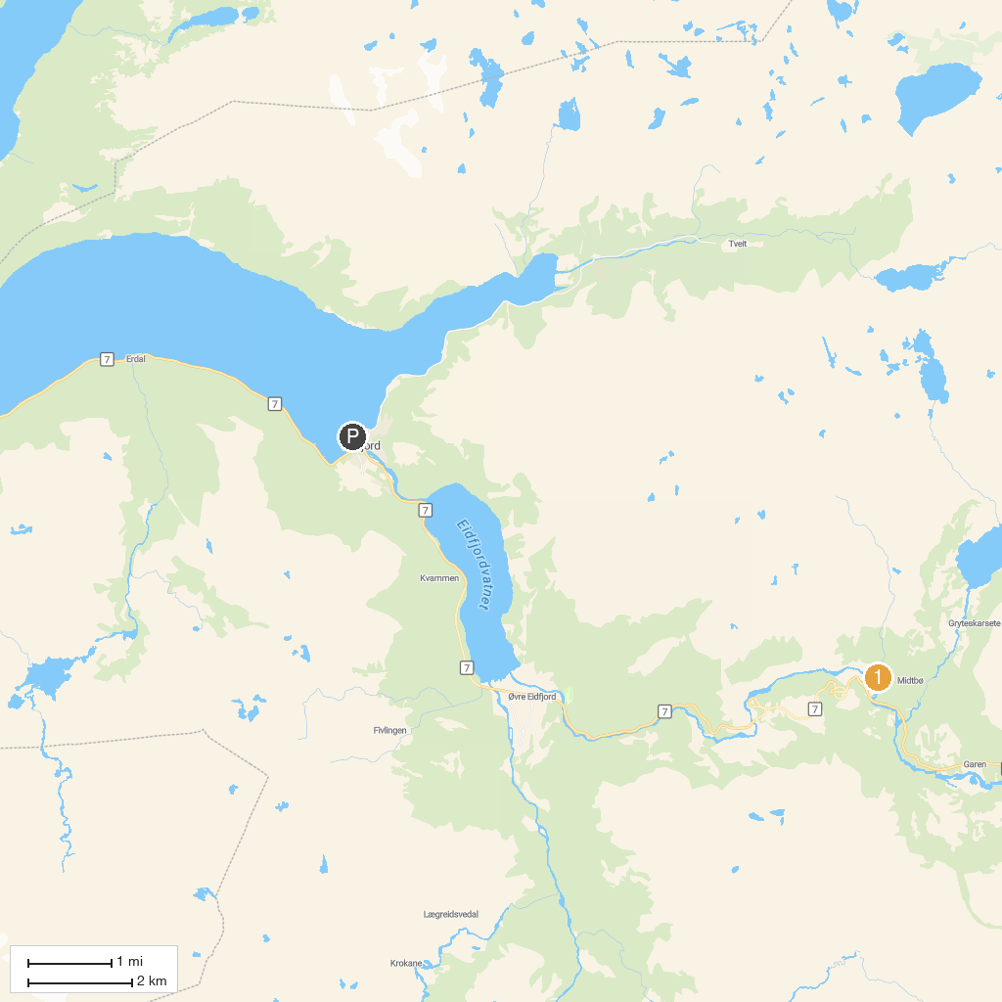
MAP KEY
1. Sysendalen ski - Maurseth | 2. Vøringsfossen
P. Cruise port / terminal
Map © MapTiler © OpenStreetMap contributors · cruiseports.org

