Eidsdal, Møre og Romsdal, Norway
A real Norwegian village at the foot of eleven hairpin bends — gateway to Geirangerfjord's UNESCO landscapes, the Eagle Road, and cowbell-quiet fjord valley life.
⚓ Tender (small pier/ferry quay) · 🕒 Typical call: 6–8 hrs · 💳 Cashless — card widely accepted · 🗣️ Norwegian (English understood) · 🏔️ UNESCO World Heritage area
✍️ MY DAY IN PORT (FILL IN)
Ship / Date
In port | arrive ______ · all aboard ______
Booked excursion
Notes / meeting point
GETTING ASHORE
- Docking: Tender to ferry quay; no dedicated cruise terminal
- Walk to village: Immediate — village surrounds the quay
- Best For: Scenic drives, Eagle Road viewpoints, fjord photography
- Don't Miss: Ørnevegen (Eagle Road) hairpin bends & Geirangerfjord views
GETTING AROUND
- 🚕 Taxi: NOK 420–500 (~$39–47 USD) one way — Local taxis connect Eidsdal to Geiranger (approx. 22 min). More flexible than the shuttle but costs more for a return tr
TOP THINGS TO DO
- Ørnevegen — Eagle Road Drive — Eleven spectacular hairpin bends climbing out of the Eidsdal valley with panoramic views over Geirangerfjord and the Seven…
- Geirangerfjord UNESCO Cruise or Bus — Descend the Eagle Road into Geiranger and take a fjord cruise past towering waterfalls and sheer cliffs.
- Gudbrandsjuvet Gorge — A dramatic river gorge in the Valldalen valley, reached via the Eidsdal–Linge ferry then about 15 km up the valley, where the…
- Eidsdal–Linge Ferry Crossing — Hop the local car ferry across Norddalsfjorden to Linge — a 10-minute crossing that drops you in the middle of the fjord with…
- Herdalssetra Mountain Farm — The historic summer mountain farm at Herdalssetra sits high above the Norddal valley, reached by a steep toll road.
BEST WALKS
- Village & Quay Stroll: 30 min · Flat · Free — From the ferry quay, walk along the waterfront past the local store and through the village.
- Start of the Eagle Road Viewpoint: 45 min · Moderate incline · Free — Walk the first hairpin bend of the Eagle Road (Ørnevegen/RV63) above the village for a taste of the…
WEATHER · DAYLIGHT · MONEY
Month | High °F | Low °F | Rainy days
May | 54 | 41 | 16
Jul | 68 | 55 | 20
Sep | 61 | 49 | 18
Daylight: May 4:35AM–10:21PM · Jul 4:11AM–11:00PM · Sep 6:57AM–7:53PM
cruiseports.org/eidsdal · Confirm terminal & all-aboard time with your ship

Eidsdal, Møre og Romsdal, Norway — Port Map
Red = walkable sights · Amber = excursions farther out · P = cruise terminal
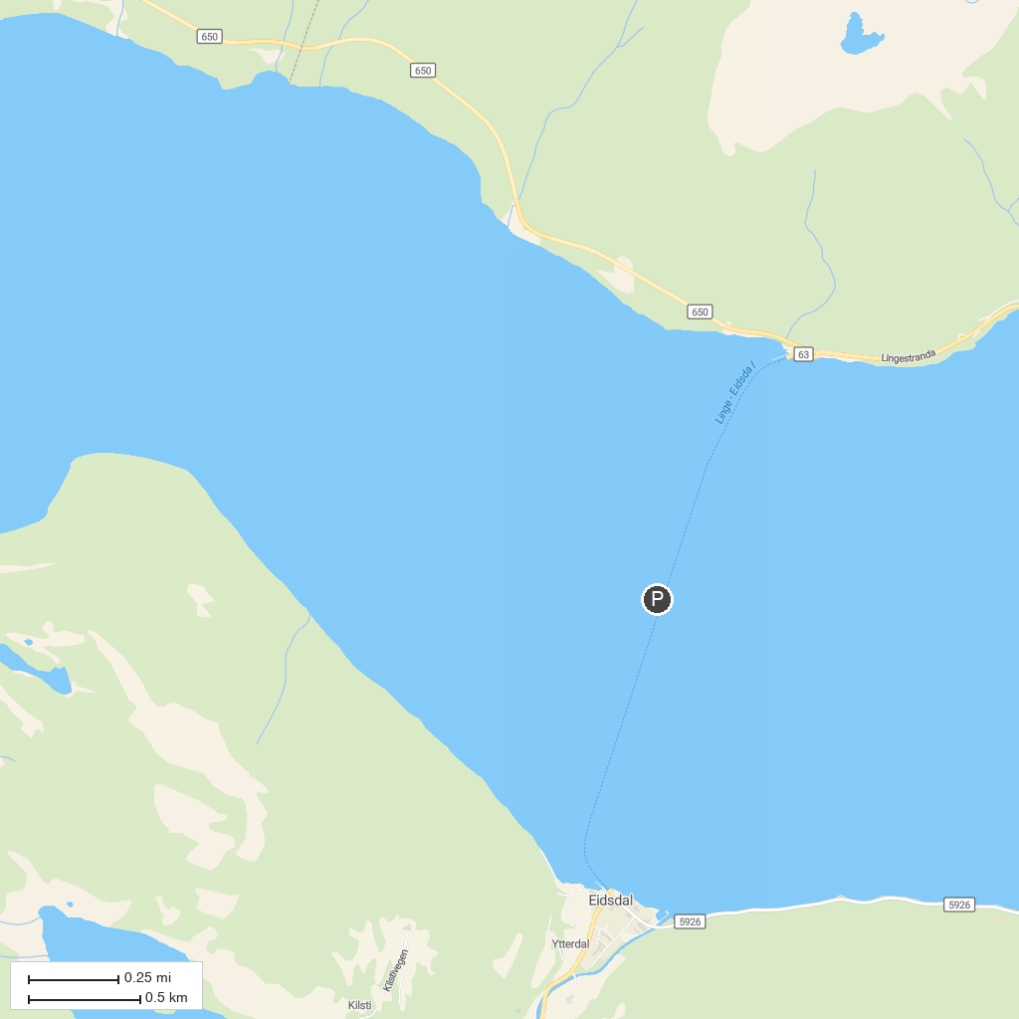
MAP KEY
1. Brudesløret (Bridal Veil) | 4. The Seven Sisters
2. Norwegian Fjord Centre | 5. Geiranger-Herdalen Landskapsvernområde
3. Ørnesvingen Viewpoint
P. Cruise port / terminal
Map © MapTiler © OpenStreetMap contributors · cruiseports.org

