El Puerto de Santa María, Andalusia, Spain
The 'City of a Hundred Palaces' sits at the tip of the Sherry Triangle — a compact, walkable Andalusian gem where Columbus planned his first voyage to the Indies, giant bodegas age amber wine in cool darkness, and a legendary seafood shack has served paper-cone prawns since 1952.
⚓ Ferry from Cádiz (30 min) · 🕒 Typical call: 6–8 hrs · 💶 Euro (€) · 🗣️ Spanish · 🍷 Sherry Triangle
✍️ MY DAY IN PORT (FILL IN)
Ship / Date
In port | arrive ______ · all aboard ______
Booked excursion
Notes / meeting point
GETTING ASHORE
- Getting Here: 30-min catamaran from Cádiz pier (~€5 each way)
- Walk to Centre: 5 min from ferry terminal
- Best For: Sherry bodegas, fresh seafood, Baroque history
- Don't Miss: Paper-cone prawns at Romerijo + a glass of Fino
GETTING AROUND
- 🚕 Taxi: €5–€10 — Taxis are available at the cruise port and throughout the city. Meter starts at ~€3.50 with ~€1.10/km; a short ride to t
- 📱 Rideshare: ✅ Uber
TOP THINGS TO DO
- Bodegas Osborne Sherry Tour — Spain's most iconic sherry house has aged wine here since 1772.
- Castillo de San Marcos & Columbus Connection — A 13th-century castle built over a 10th-century Moorish mosque — you can still see the mihrab prayer niche inside.
- Romerijo Seafood Experience — El Puerto's most beloved institution: a legendary open-air freiduría and cocedero where you queue, point at prawns, crab claws…
- Playa de la Puntilla Beach — The town's urban beach sits at the mouth of the Guadalete River, backed by a pine forest.
- Old Town Palace Walk & Tapas Crawl — Wander past crumbling 17th-century Baroque 'Palaces of the Indies Merchants' — grand mansions built by merchants who grew rich…
BEST WALKS
- Heritage Heart of El Puerto: 1.5 km · 25 min · Easy cobblestones — From the ferry terminal, walk to the Castillo de San Marcos, then up Calle Luna past merchant…
- Riverside Promenade & Romerijo: 1 km · 15 min · Flat — An easy riverside stroll from the catamaran dock along the Paseo de la Ribera, past moored fishing…
WEATHER · DAYLIGHT · MONEY
Month | High °F | Low °F | Rainy days
May | 76 | 61 | 4
Jul | 86 | 70 | 0
Sep | 82 | 67 | 4
Daylight: May 7:17AM–9:25PM · Jul 7:18AM–9:43PM · Sep 8:07AM–8:31PM
cruiseports.org/el-puerto-de-santa-maria · Confirm terminal & all-aboard time with your ship

El Puerto de Santa María, Andalusia, Spain — Port Map
Red = walkable sights · Amber = excursions farther out · P = cruise terminal
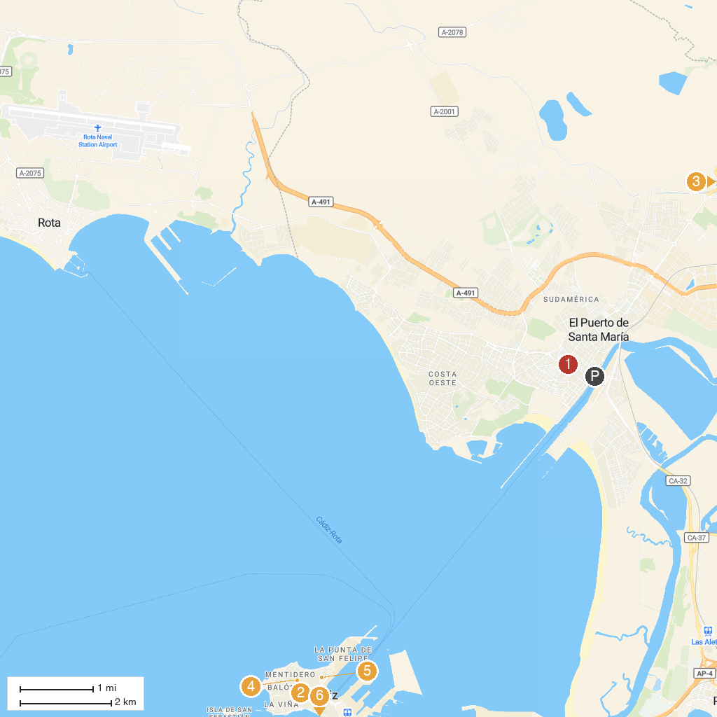
MAP KEY
1. Real Plaza de Toros | 5. Aqualand Bahía de Cádiz
2. Torre Tavira | 6. Parish of St Anthony of Padua
3. Centro de Conservación de la Biodiversidad Zoobotánico Jerez - Alberto Durán | 7. The 1812 Constitution Monument
4. Catedral de Jerez de la Frontera / Colegiata de Nuestro Señor San Salvador | 8. Teatro Romano de Cádiz
P. Cruise port / terminal
Map © MapTiler © OpenStreetMap contributors · cruiseports.org

