Elafonisos Island, Lakonia, Greece
A secret of the southern Peloponnese, Elafonisos wows small-ship cruisers with shockingly turquoise water, pink-tinged sand dunes, and one of the oldest submerged cities on Earth just offshore.
⚓ Tender port · 🕒 Typical call: 6-8 hrs · 💶 Currency: Euro · 🗣️ Language: Greek · 🏖️ Beach destination
✍️ MY DAY IN PORT (FILL IN)
Ship / Date
In port | arrive ______ · all aboard ______
Booked excursion
Notes / meeting point
GETTING ASHORE
- Docking: Tender — ships anchor; boats land at Elafonisos Town harbour
- Walk to center: Immediate — tender drops in the village waterfront
- Best For: Beaches, snorkelling, fresh seafood, quiet Greek island life
- Don't Miss: Simos Beach (ranked among Europe's best) & Pavlopetri snorkel
GETTING AROUND
- 🚕 Taxi: Meter (~€4 start) — A small number of local taxis serve the island. The village (Chora) is very close to the ferry dock, so most rides are s
TOP THINGS TO DO
- Simos Beach — Europe's Top Strand — Two horseshoe bays framing crystal-turquoise water and white-pink sand dunes protected under Natura 2000.
- Pavlopetri Snorkel — Ancient Sunken City — Just across the narrow channel lies Pavlopetri, the world's oldest known submerged city (c.3000 BC).
- ATV Island Lap — Rent an ATV at the harbour and loop the island in an hour, stopping at Lefki Beach, Panagia Bay and the sand dunes.
- Agios Spyridon Church Walk — The island's icon — a white-and-blue chapel perched on a tiny rocky islet reached by a narrow stone causeway from the harbour.
- Harbour Seafood Lunch — Waterfront tavernas serve lobster pasta (astakomakaronada), grilled octopus, and tsaitia — local pan-fried pies stuffed with…
BEST WALKS
- Harbour to Agios Spyridon: ⏱ 20 min · Easy · 📷 Photo stop — From the tender dock stroll the waterfront north, past colourful fishing boats and net-mending…
- Town & Kontogoni Beach: ⏱ 30-40 min · Easy · 🏖️ Swim stop — Head south from the port to the sandy town beach of Kontogoni — a calm, clear cove with tavernas on…
WEATHER · DAYLIGHT · MONEY
Month | High °F | Low °F | Rainy days
May | 73 | 62 | 4
Jul | 88 | 75 | 1
Sep | 82 | 72 | 4
Daylight: May 6:21AM–8:27PM · Jul 6:21AM–8:45PM · Sep 7:10AM–7:35PM
cruiseports.org/elafonisos-island · Confirm terminal & all-aboard time with your ship

Elafonisos Island, Lakonia, Greece — Port Map
Red = walkable sights · Amber = excursions farther out · P = cruise terminal
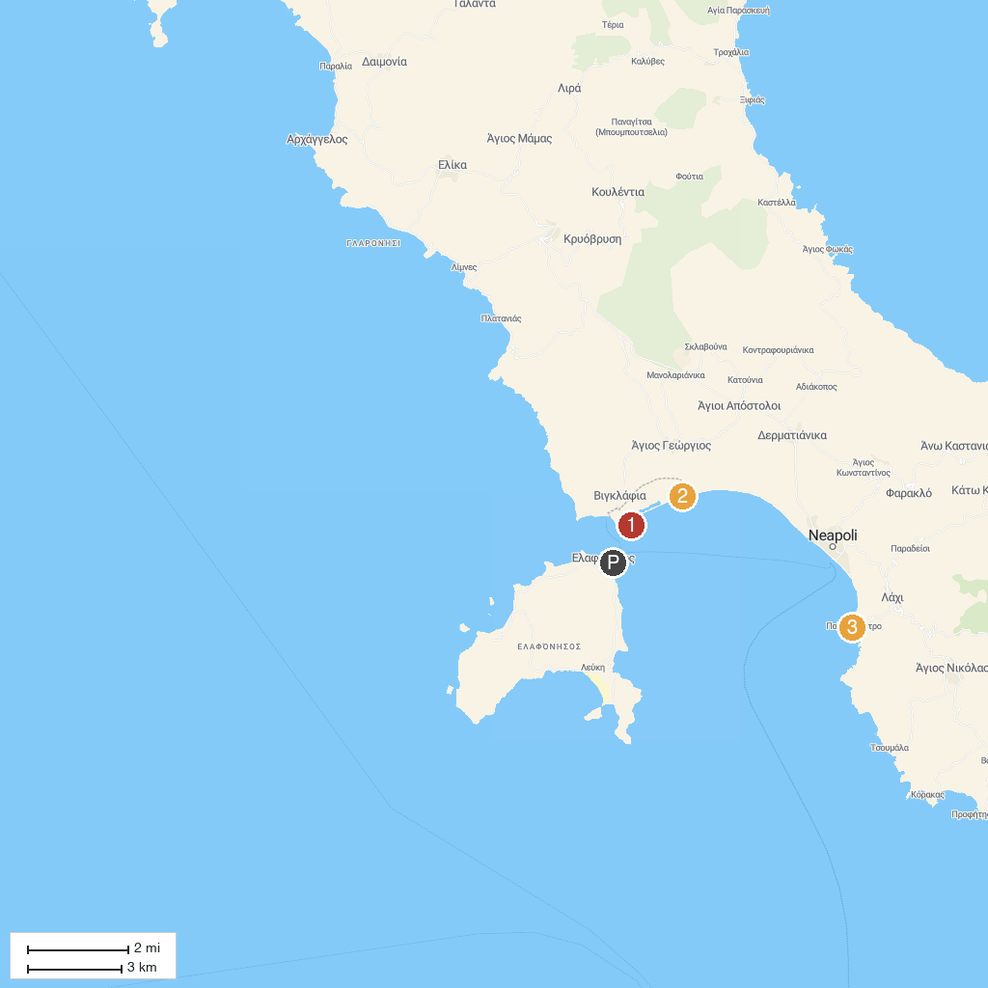
MAP KEY
1. Hamokelo Beach | 3. Amitsa Beach
2. Παραλία Μάγγανος
P. Cruise port / terminal
Map © MapTiler © OpenStreetMap contributors · cruiseports.org

