Eltville am Rhein, Rheingau, Germany
The wine, sparkling wine, and rose capital of the Rheingau, Eltville offers riverside Riesling tastings and a 14th-century Electoral Castle just minutes from where your ship ties up.
⚓ Pier (pontoon dock) · 🕒 Typical call: 4–6 hrs · 💶 Currency: Euro (€) · 🗣️ Language: German · 🍷 Wine region
✍️ MY DAY IN PORT (FILL IN)
Ship / Date
In port | arrive ______ · all aboard ______
Booked excursion
Notes / meeting point
GETTING ASHORE
- Docking: Pier — ships dock alongside the Rhine promenade; no tender
- Walk to center: 2–5 min flat walk to Electoral Castle and Old Town
- Best For: Wine lovers, history, roses, relaxed Rhine atmosphere
- Don't Miss: Riesling or Sekt at the riverside wine booth, rose gardens in the castle courtyard
GETTING AROUND
- 🚕 Taxi: €6–€10 — Taxis are available but rarely needed given the compact town. Fares start at €2.90 with ~€2.90/km; a cross-town ride run
- 📱 Rideshare: ✅ Uber
TOP THINGS TO DO
- Electoral Castle & Gutenberg Tower — The 14th-century Kurfürstliche Burg sits minutes from the pier.
- Rheingau Riesling Wine Tasting — The Rhine promenade wine booth rotates local Rheingau wineries — pour a glass of chilled Riesling or traditional-method Sekt and…
- Kloster Eberbach Abbey — A remarkably preserved 12th-century Cistercian monastery in the forested hills above Eltville.
- Vineyard Walk to Schloss Vollrads — Follow footpaths up through Rheingau Riesling vineyards to Schloss Vollrads, one of Germany's oldest wine estates, with tastings…
- Eltville Old Town Stroll — Wander the Altstadt's network of cobblestone lanes past half-timbered houses, the Gothic Parish Church of St.
BEST WALKS
- Promenade to Castle Rose Garden: 1 km · 15 min · flat — Walk upstream along the Rhine Promenade from the pier, passing the Sebastian Tower to the Electoral…
- Old Town Loop: 1.5 km · 25 min · cobblestones — From the castle, loop through the Altstadt via the Martinstor gate, along Schmittstraße past…
cruiseports.org/eltville-am-rhein · Confirm terminal & all-aboard time with your ship

Eltville am Rhein, Rheingau, Germany — Port Map
Red = walkable sights · Amber = excursions farther out · P = cruise terminal
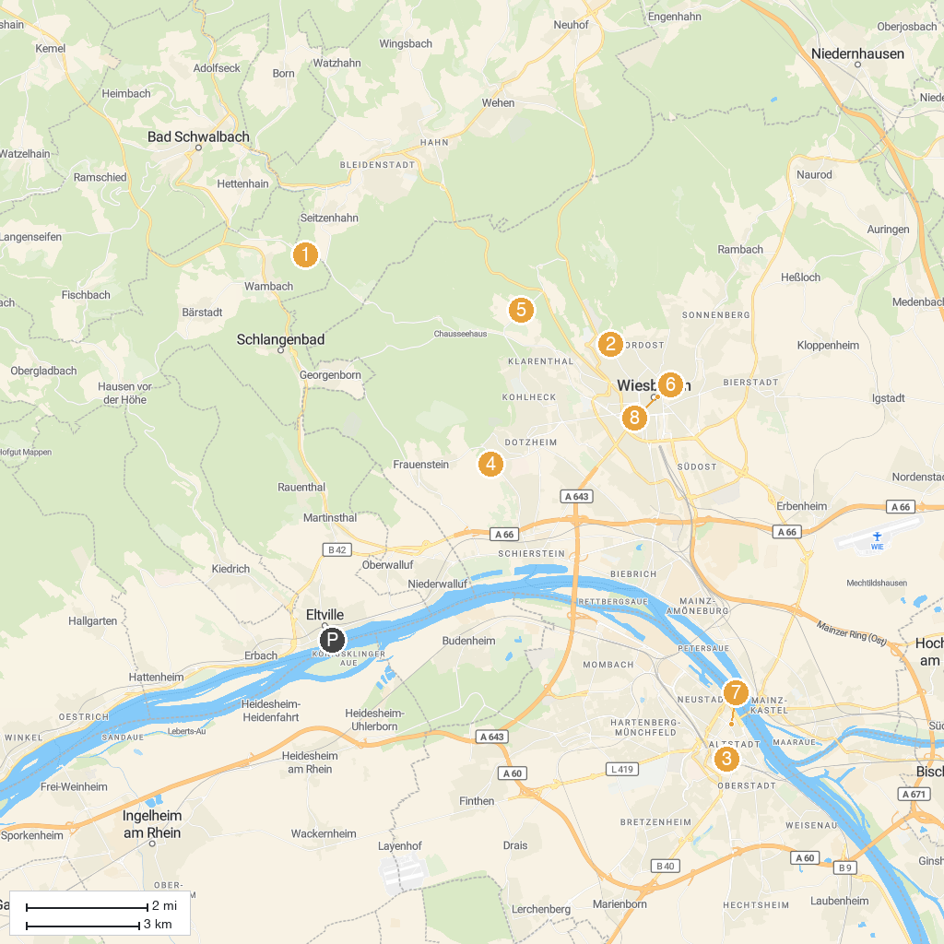
MAP KEY
1. Taunus Wunderland | 5. Zoo and garden Fasanerie
2. Nerobergbahn Wiesbaden | 6. Spielbank Wiesbaden
3. St. Stephan's Church | 7. Gutenberg Museum
4. Schloss Freudenberg | 8. Evangelical Market church Wiesbaden
P. Cruise port / terminal
Map © MapTiler © OpenStreetMap contributors · cruiseports.org

