Endicott Arm Fjord, Alaska, USA
A 30-mile deep-water fjord ending at the thundering face of Dawes Glacier — no town, no pier, just raw Alaska wilderness. This is a scenic cruising day, and one of the most dramatic on any Alaska itinerary.
⚓ Scenic cruising (no landing) · 🕒 Typical call: 4-6 hrs in fjord · 💵 USD · 🗣️ English · 🧊 Tidewater glacier + icebergs
✍️ MY DAY IN PORT (FILL IN)
Ship / Date
In port | arrive ______ · all aboard ______
Booked excursion
Notes / meeting point
GETTING ASHORE
- Docking: No pier — scenic cruising only; ship navigates fjord & rotates at glacier
- Walk to center: No shore access — experience entirely from ship decks
- Best For: Glacier viewing, wildlife spotting, iceberg photography, calving events
- Don't Miss: Catamaran glacier excursion to approach Dawes Glacier through the ice
GETTING AROUND
TOP THINGS TO DO
- Glacier Explorer Catamaran — Board a high-speed catamaran directly from your cruise ship while underway inside the fjord.
- Wildlife Watching from Deck — Bring binoculars and stake out a spot on the open decks.
- Kayaking & Wilderness Paddling — Expedition-style cruises and some specialty operators offer sea kayaking among the icebergs in Endicott Arm.
cruiseports.org/endicott-arm-fjord · Confirm terminal & all-aboard time with your ship

Endicott Arm Fjord, Alaska, USA — Port Map
Red = walkable sights · Amber = excursions farther out · P = cruise terminal
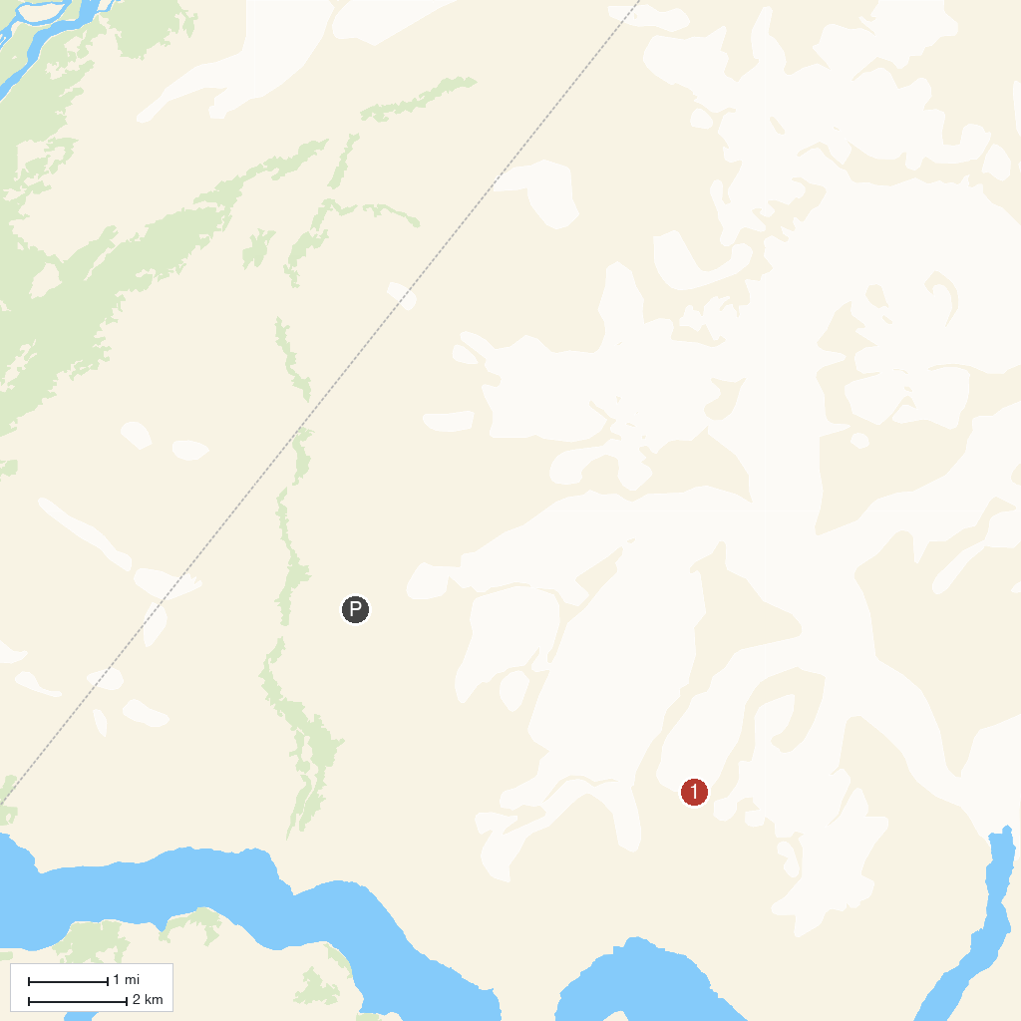
MAP KEY
1. Dawes Glacier, Endicott Arm | 2. Fords Terror, Endicott Arm
P. Cruise port / terminal
Map © MapTiler © OpenStreetMap contributors · cruiseports.org

