Ensenada, Baja California, Mexico
Ensenada punches above its weight: ships dock right at the edge of downtown, putting seafood stalls, margarita birthplace lore, and the gateway to Baja's wine country all within a short walk or cab ride.
⚓ Pier — ships dock · 🕒 Typical call: 7–9 hrs · 💵 MXN / USD widely accepted · 🗣️ Spanish (English common near port)
✍️ MY DAY IN PORT (FILL IN)
Ship / Date
In port | arrive ______ · all aboard ______
Booked excursion
Notes / meeting point
GETTING ASHORE
- Docking: Pier — no tender required; walk off directly
- Walk to center: 15–20 min flat walk or short shuttle to Calle Primera
- Best For: Wine tours, La Bufadora geyser, ATV adventures, fish tacos
- Don't Miss: Valle de Guadalupe wine country & Riviera Cultural Center
GETTING AROUND
- 🚕 Taxi: Negotiate before boarding — Taxis queue at the cruise dock and are widely available downtown. Always agree on a fare before getting in — meters are
- 📱 Rideshare: ✅ Uber
TOP THINGS TO DO
- La Bufadora Marine Geyser — One of North America's largest marine geysers blasts seawater up to 100 feet into the air through a sea cave blowhole.
- Valle de Guadalupe Wine Tour — Baja's acclaimed wine region produces the large majority of Mexico's wine (commonly cited at 70–90%).
- ATV & Off-Road at Las Cañadas — Las Cañadas Off-Road Park offers ATV trails through canyons and hills, often combined with ziplines, horseback riding, or…
- Riviera Cultural Center & Downtown Walk — The ornate Riviera del Pacífico (now Centro Social, Cívico y Cultural Riviera) was once a casino frequented by Al Capone and is…
- Fish Taco & Tequila Tasting — Ensenada is ground zero for Baja-style fish tacos.
BEST WALKS
- Malecón to Calle Primera Loop: 2–3 km · 45–60 min · Easy · Flat — Walk north along the waterfront Malecón promenade past the giant flagpole and Plaza Cívica (home to…
WEATHER · DAYLIGHT · MONEY
Month | High °F | Low °F | Rainy days
May | 67 | 57 | 3
Jul | 76 | 65 | 1
Sep | 78 | 66 | 2
Daylight: May 5:49AM–7:36PM · Jul 5:51AM–7:52PM · Sep 6:30AM–6:51PM
cruiseports.org/ensenada · Confirm terminal & all-aboard time with your ship

Ensenada, Baja California, Mexico — Port Map
Red = walkable sights · Amber = excursions farther out · P = cruise terminal
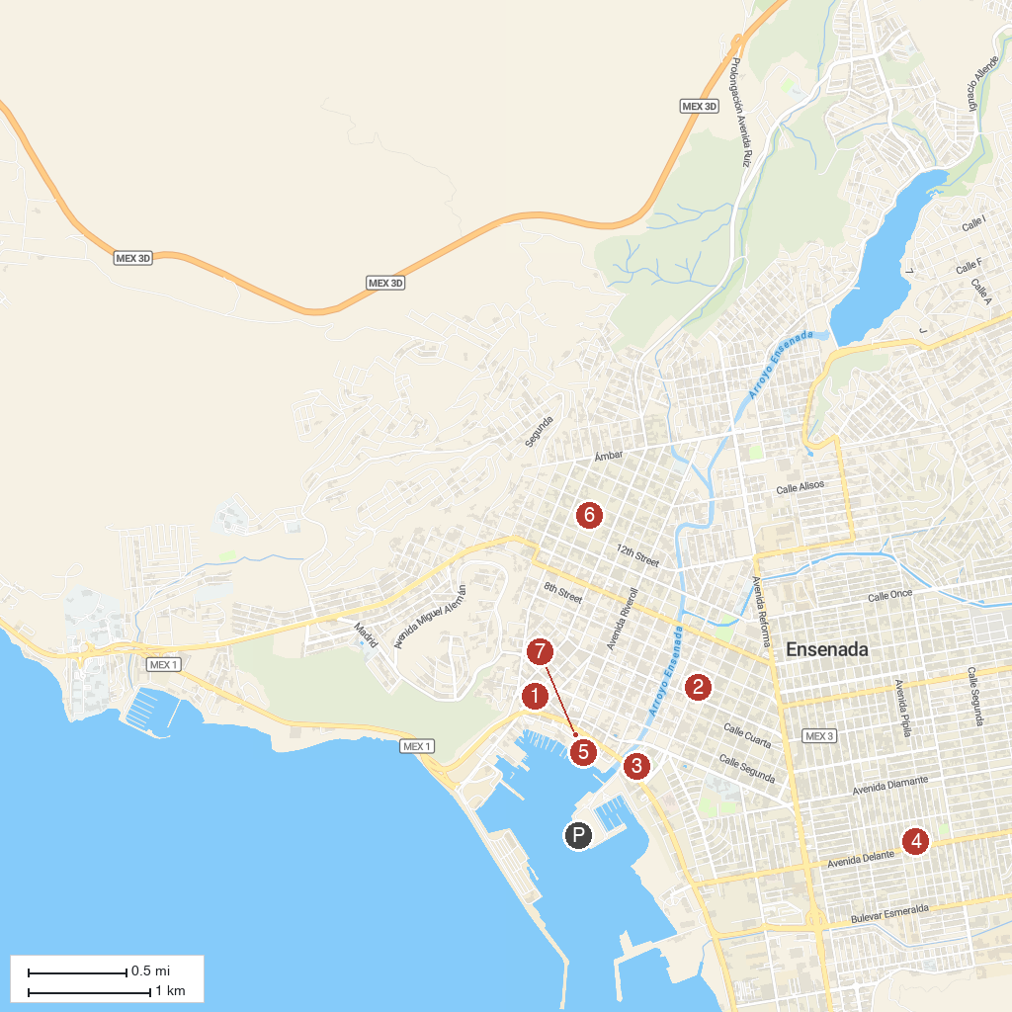
MAP KEY
1. Museo Histórico Regional de Ensenada | 5. Monumental Flag
2. Our Lady of Guadalupe Co-Cathedral | 6. Tara Garden
3. Centro Social, Cívico y Cultural, Riviera de Ensenada | 7. Plaza Cívica de la Patria
4. Nuestra Señora del Refugio
P. Cruise port / terminal
Map © MapTiler © OpenStreetMap contributors · cruiseports.org

