Épernay, Champagne, France
The world's most celebrated wine street runs directly above 110 km of chalk cellars holding 200 million bottles. Épernay is where Champagne is born — and your best chance to drink it at the source.
⚓ Barge/river dock (Marne River) · 🕒 Typical call: full day · 💶 Euro (€) · 🗣️ French
✍️ MY DAY IN PORT (FILL IN)
Ship / Date
In port | arrive ______ · all aboard ______
Booked excursion
Notes / meeting point
GETTING ASHORE
- Docking: Luxury barges moor at Épernay quay or Cumières (10 min away); large river ships coach in from Paris or Château-Thierry
- Walk to center: 10–20 min from barge dock to Avenue de Champagne; train station drop-off is 5 min
- Best For: Champagne tastings, cellar tours, vineyard walks, classic French cuisine
- Don't Miss: Underground cellar tour at Moët & Chandon or Mercier — book months in advance
GETTING AROUND
- 🚕 Taxi: €8–€20 — Local taxis serve the port area and train station. Minimum fare is €8; most short in-town rides stay under €20. Rates ar
- 📱 Rideshare: ✅ Uber, Bolt
TOP THINGS TO DO
- Moët & Chandon Cellar Tour — The world's most famous Champagne house opens its 28 km of chalk cellars to guided tours.
- Champagne Mercier Train-Ride Tour — Mercier's audio-guided electric train winds through 18 km of cellars, passing a giant oak cask that holds the equivalent of…
- Balloon Flight over the Champagne Vineyards — A tethered helium balloon at the foot of the Avenue de Champagne lifts you 150 m above the Marne Valley for 360° views over the…
- Grower Champagne & Cheese Tasting at C-Comme — Ditch the big houses for an afternoon at C-Comme, Épernay's celebrated Champagne bar.
- Pressoria Sensory Museum (Aÿ-Champagne) — A 10-minute taxi ride to neighbouring Aÿ reveals this immersive museum in a former Pommery press house.
BEST WALKS
- Avenue de Champagne Stroll: 1.5 km · Flat · 30–45 min walking — Start at the Moët & Chandon gatehouse and walk the full length of the Avenue de Champagne past…
- Town Center & Park Loop: 2 km · Flat · 45 min — From the train station, walk to the Parc de l'Hôtel de Ville for the manicured English garden and…
WEATHER · DAYLIGHT · MONEY
Month | High °F | Low °F | Rainy days
May | 65 | 48 | 12
Jul | 77 | 59 | 9
Sep | 70 | 54 | 8
Daylight: May 6:01AM–9:19PM · Jul 5:56AM–9:43PM · Sep 7:21AM–7:56PM
cruiseports.org/epernay · Confirm terminal & all-aboard time with your ship

Épernay, Champagne, France — Port Map
Red = walkable sights · Amber = excursions farther out · P = cruise terminal
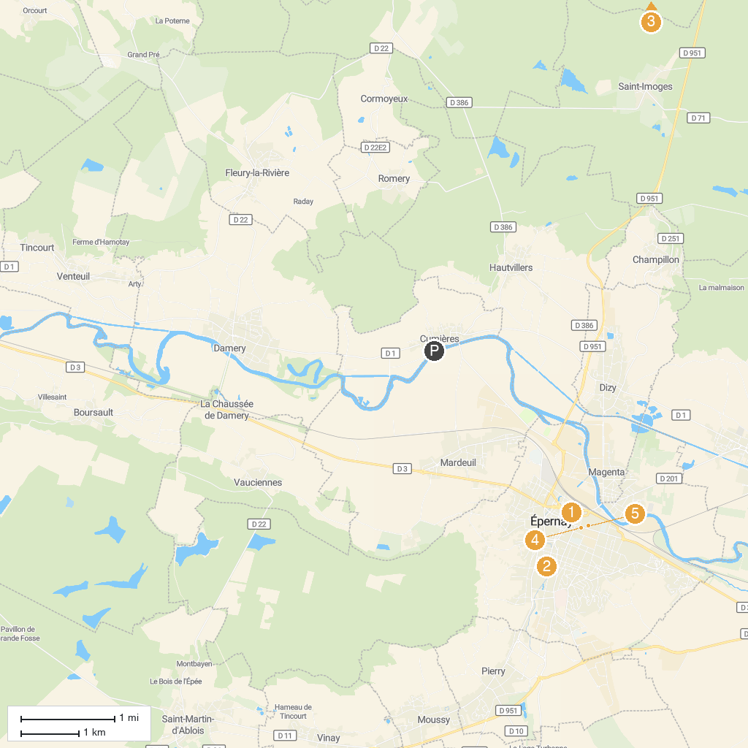
MAP KEY
1. Our Lady Church of Épernay | 4. Ecomuseums of Œuilly
2. Église Saint-Pierre et Saint-Paul d'Épernay | 5. Statue de Dom Perignon
3. Parc naturel régional de la Montagne de Reims | 6. Château Perrier
P. Cruise port / terminal
Map © MapTiler © OpenStreetMap contributors · cruiseports.org

