Erie, Pennsylvania, USA
Pennsylvania's only Great Lakes port pairs a stunning sandy peninsula with a pivotal naval history — Presque Isle's seven miles of beach and the replica flagship that won the Battle of Lake Erie are both within easy reach of the dock.
⚓ Docked (pier) · 🕒 Typical call: 6-8 hrs · 💵 USD · 🗣️ English · 🏖️ Beach day possible
✍️ MY DAY IN PORT (FILL IN)
Ship / Date
In port | arrive ______ · all aboard ______
Booked excursion
Notes / meeting point
GETTING ASHORE
- Docking: Pier — Dobbins Landing, 1 Holland St
- Walk to center: Steps from dock; downtown Erie is walkable
- Best For: Beaches, War of 1812 history, lakefront dining
- Don't Miss: US Brig Niagara & Presque Isle State Park
GETTING AROUND
- 🚕 Taxi: $10–$20 — Several local taxi companies operate in Erie. Fares vary; use TaxiFareFinder.com for estimates from Dobbins Landing.
- 📱 Rideshare: ✅ Uber, Lyft
TOP THINGS TO DO
- Presque Isle State Park — A 3,200-acre sandy peninsula with seven miles of Lake Erie beach, hiking and biking trails, lagoons, and the iconic Sunset Point.
- Erie Maritime Museum & US Brig Niagara — The museum covers Commodore Oliver Hazard Perry's decisive 1813 Battle of Lake Erie.
- Bicentennial Tower & Bayfront — Climb the 187-foot Bicentennial Tower at Dobbins Landing — its upper observation deck sits 138 feet above the bay — for panoramic…
- Lady Kate Boat Tour — A 90-minute fully narrated cruise across Presque Isle Bay and Lake Erie, passing lighthouses and the Erie skyline.
- Tom Ridge Environmental Center — At the entrance to Presque Isle, TREC has interactive exhibits on the peninsula's unique ecosystem plus a 75-foot observation…
BEST WALKS
- Bayfront Promenade to Downtown: 1.5 miles one-way · Flat · 30 min — Follow the paved promenade from Dobbins Landing west past Liberty Park and the Erie maritime…
- Presque Isle Beach Walk: Variable · Flat · Requires transport — Ride to the park entrance (~10 miles by road) and walk or bike the Karl Boyes Multi-Purpose Trail…
WEATHER · DAYLIGHT · MONEY
Month | High °F | Low °F | Rainy days
May | 64 | 51 | 14
Jul | 78 | 66 | 14
Sep | 72 | 61 | 12
Daylight: May 5:59AM–8:34PM · Jul 5:58AM–8:54PM · Sep 7:00AM–7:29PM
cruiseports.org/erie-pa · Confirm terminal & all-aboard time with your ship

Erie, Pennsylvania, USA — Port Map
Red = walkable sights · Amber = excursions farther out · P = cruise terminal
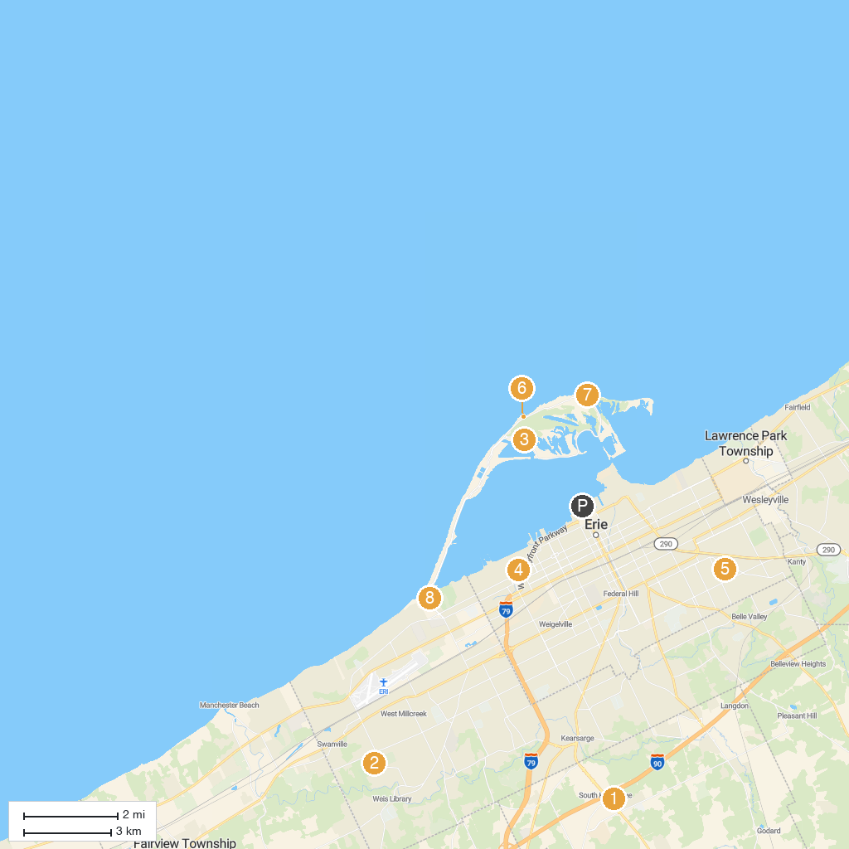
MAP KEY
1. Splash Lagoon | 5. Roma Park
2. Asbury Park | 6. Presque Isle Lighthouse
3. Presque Isle State Park | 7. Presque Isle Beach
4. Lake Erie Arboretum at Frontier Park | 8. Tom Ridge Environmental Center at Presque Isle State Park
P. Cruise port / terminal
Map © MapTiler © OpenStreetMap contributors · cruiseports.org

