Esbjerg, Jutland, Denmark
Denmark's youngest city packs industrial swagger and big nature into one port call — four colossal white figures watch the North Sea while seal pups splash nearby and Europe's oldest town waits just 30 minutes by train.
⚓ Pier port (docked) · 🕒 Typical call: 8-10 hrs · 💵 Danish Krone (DKK) — cashless city · 🗣️ Danish / English widely spoken · 🌊 UNESCO Wadden Sea gateway
✍️ MY DAY IN PORT (FILL IN)
Ship / Date
In port | arrive ______ · all aboard ______
Booked excursion
Notes / meeting point
GETTING ASHORE
- Docking: Docked at working commercial pier; shuttle bus to city centre (~10 min)
- Walk to centre: Not walkable through active port — free or paid shuttle required
- Best for: Wildlife, medieval history (Ribe), beaches (Fanø), North Sea scenery
- Don't miss: 'Man Meets the Sea' sculptures & Fisheries Museum sealarium
GETTING AROUND
- 🚕 Taxi: 80–150 DKK — Taxis are available at the ferry/cruise terminal. Base fare is ~38 DKK (day) plus ~12.50 DKK/km; a short ride to the cit
- 📱 Rideshare: ✅ Uber
TOP THINGS TO DO
- Man Meets the Sea & Fisheries Museum — Svend Wiig Hansen's four 9-metre white figures gazing out to sea are Esbjerg's defining image, set on Sædding Beach.
- Day Trip to Ribe — Denmark's Oldest Town — Founded around 700 AD, Ribe is a living medieval town with cobblestone streets, half-timbered houses, and a magnificent…
- Wadden Sea UNESCO Safari — The Wadden Sea National Park is one of the world's largest tidal wetlands — a UNESCO site teeming with grey seals, harbour seals…
- Fanø Island Ferry Escape — A 12-minute ferry hop to Fanø delivers charming thatched-roof sailor cottages, hard-packed sandy beaches wide enough for cars and…
- Esbjerg City Centre & Art Museum — Stroll Torvet — one of Denmark's finest main squares — then explore Kongensgade, the country's longest pedestrian shopping street.
BEST WALKS
- Torvet to Kongensgade & Water Tower: 1.5 km loop · 30–45 min · Flat — From Torvet (the main square with the Christian IX equestrian statue), walk down Kongensgade…
- Sædding Beach to Fisheries Museum: 1 km stroll · 20 min · Flat coastal path — After taking bus 1A to the museum, walk the short coastal path along Sædding Beach where the 'Man…
WEATHER · DAYLIGHT · MONEY
Month | High °F | Low °F | Rainy days
May | 58 | 47 | 12
Jul | 67 | 57 | 15
Sep | 63 | 54 | 14
Daylight: May 5:16AM–9:30PM · Jul 5:05AM–9:58PM · Sep 6:58AM–7:42PM
cruiseports.org/esbjerg · Confirm terminal & all-aboard time with your ship

Esbjerg, Jutland, Denmark — Port Map
Red = walkable sights · Amber = excursions farther out · P = cruise terminal
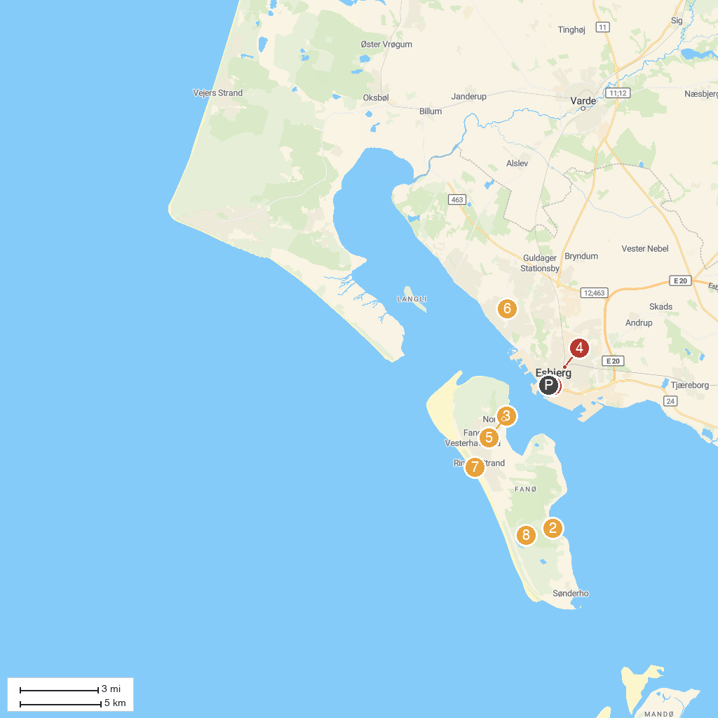
MAP KEY
1. Esbjerg Bypark | 5. Fanø Museum
2. Sønderho Gl. Fuglekøje | 6. CityJump
3. Fanø Skibsfarts- & Dragtsamling | 7. Rindby beach
4. GAME Streetmekka Esbjerg | 8. Skovlegeplads
P. Cruise port / terminal
Map © MapTiler © OpenStreetMap contributors · cruiseports.org

