Eureka, California, USA
California's Victorian seaport sits at the edge of the redwood curtain — step off the ship into a perfectly preserved 19th-century Old Town, then head inland to walk among 1,000-year-old giants.
⚓ Pier (Schneider Dock) · 🕒 Typical call: 8 hrs · 💵 USD · 🗣️ English · 🌲 Redwood country
✍️ MY DAY IN PORT (FILL IN)
Ship / Date
In port | arrive ______ · all aboard ______
Booked excursion
Notes / meeting point
GETTING ASHORE
- Docking: Pier — Schneider Dock, Old Town waterfront
- Walk to center: 5 min to Old Town; Carson Mansion 15 min
- Best For: Victorian architecture, redwood day trips, maritime history
- Don't Miss: Avenue of the Giants or Redwood Sky Walk; Madaket harbor cruise
GETTING AROUND
- 🚕 Taxi: ~$5 base + ~$3/mile — Local taxis serve the port area with a base fare plus per-mile rate. The short distance to Old Town keeps fares low; tip
- 📱 Rideshare: ✅ Uber, Lyft
TOP THINGS TO DO
- Avenue of the Giants Drive — A 31-mile scenic highway through old-growth redwoods south of Eureka, passing trees over 300 feet tall and 1,000 years old.
- Redwood Sky Walk at Sequoia Park Zoo — Walk suspension bridges over 100 feet up through the redwood canopy at Sequoia Park — California's oldest zoo (est.
- Madaket Harbor Cruise — Board the M.V.
- Blue Ox Millworks Living History Park — A working Victorian millwork shop where craftspeople use antique machinery to create ornate gingerbread architecture.
- Carson Mansion & Victorian Walking Tour — The 1886 Carson Mansion is widely regarded as the most spectacular Victorian house in America.
BEST WALKS
- Old Town & Waterfront Loop: 1.5 miles · 45 min · Flat — From Schneider Dock, follow the waterfront boardwalk north past the F Street Pier, then cut inland…
- Carson Mansion Stroll: 1.8 miles round-trip · 45 min · Flat — Head east along 2nd or 3rd Street from Old Town to reach the Carson Mansion at M Street.
WEATHER · DAYLIGHT · MONEY
Month | High °F | Low °F | Rainy days
May | 59 | 48 | 7
Jul | 64 | 52 | 2
Sep | 66 | 53 | 3
Daylight: May 5:59AM–8:27PM · Jul 5:58AM–8:46PM · Sep 6:57AM–7:24PM
cruiseports.org/eureka-ca · Confirm terminal & all-aboard time with your ship

Eureka, California, USA — Port Map
Red = walkable sights · Amber = excursions farther out · P = cruise terminal
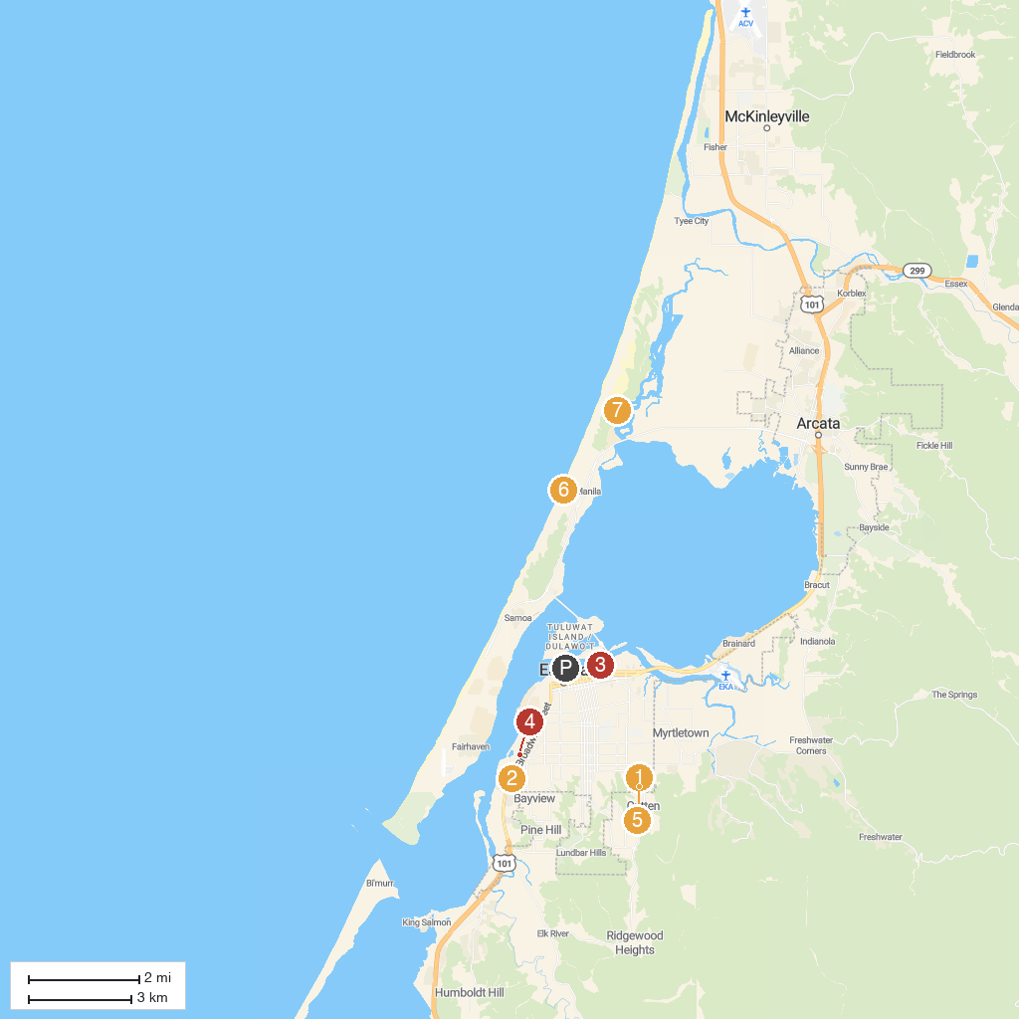
MAP KEY
1. Sequoia Park Zoo | 5. Six Rivers National Forest Headquarters
2. Fort Humboldt State Historic Park | 6. Sequoia Park
3. Mad River Beach County Park | 7. Manila Dunes
4. Halvorsen Park | 8. Ma-le'l Dunes North Unit
P. Cruise port / terminal
Map © MapTiler © OpenStreetMap contributors · cruiseports.org

