Exuma Islands, Bahamas
365 cays of neon-blue water, blindingly white sandbars, and a pace of life that makes Nassau feel like Times Square. The Exumas are the Bahamas as they were meant to be — uncommercialized, wild, and drop-dead gorgeous.
⚓ Tender (no pier) · 🕒 Typical call: 6–8 hrs · 💵 USD / Bahamian Dollar · 🗣️ English
✍️ MY DAY IN PORT (FILL IN)
Ship / Date
In port | arrive ______ · all aboard ______
Booked excursion
Notes / meeting point
GETTING ASHORE
- Docking: Tender to Government Dock, George Town
- Walk to center: You land in the center of George Town
- Best For: Beaches, sandbars, snorkeling, local food
- Don't Miss: Stocking Island water taxi + Chat 'N' Chill
GETTING AROUND
- 🚕 Taxi: $25–$45 — Fixed-zone rates (no meters) — always confirm the fare before you get in. An additional $3/person applies for groups ove
- 📱 Rideshare: ❌ not available
TOP THINGS TO DO
- Swimming Pigs of Big Major Cay — The original swimming pigs live at Big Major Cay near Staniel Cay, about 55 miles north of George Town.
- Stocking Island & Chat 'N' Chill — A $20 round-trip water taxi from the Government Dock crosses to Stocking Island's twin beaches — calm harbor side and a wild…
- Snorkel Thunderball Grotto — A cathedral-like underwater cave near Staniel Cay featured in two James Bond films.
- Sandbar Walk at Coco Plum Beach — At low tide, a vast sandbar unfolds north of George Town — you can wade hundreds of yards into the ocean with water barely above…
- Moriah Harbour Cay Kayak & Eco Tour — Paddle through the protected national park's mangroves and crystal flats, spotting baby lemon sharks, stingrays, and sea turtles…
BEST WALKS
- George Town Waterfront Loop: Easy · ~30 min · Flat — From the Government Dock, walk along the waterfront to Lake Victoria — a landlocked saltwater lake…
WEATHER · DAYLIGHT · MONEY
Month | High °F | Low °F | Rainy days
May | 86 | 78 | 28
Jul | 86 | 78 | 22
Sep | 85 | 77 | 27
Daylight: May 6:21AM–7:37PM · Jul 6:26AM–7:52PM · Sep 6:49AM–7:06PM
Representative sunrise/sunset — 2025, 15th of each month; local civil time including DST (America/Nassau). Source: Astral; not a forecast or climate average.
cruiseports.org/exuma-islands · Confirm terminal & all-aboard time with your ship

Exuma Islands, Bahamas — Port Map
Red = walkable sights · Amber = excursions farther out · P = cruise terminal
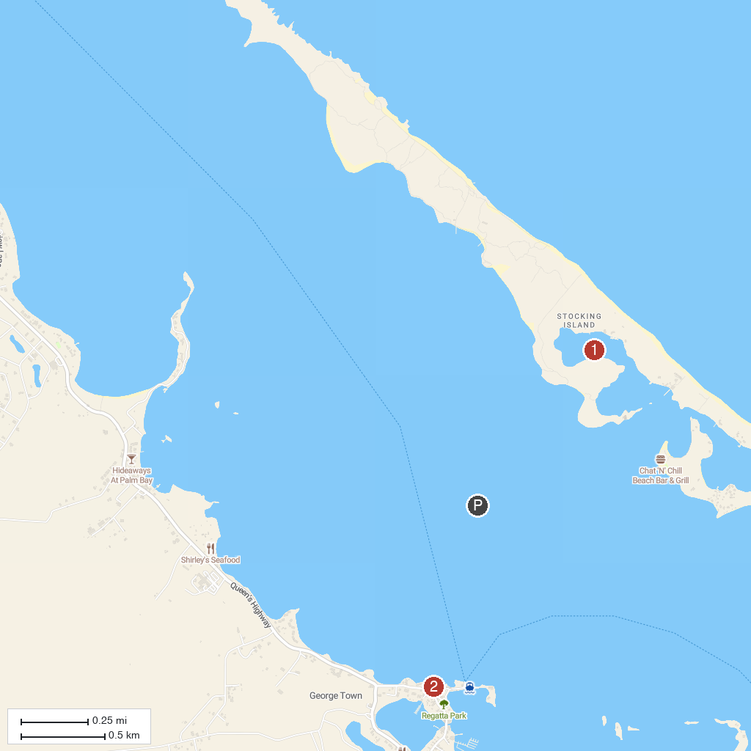
MAP KEY
1. Ocean Blue Hole, Stocking Island | 2. Government Building, George Town
P. Cruise port / terminal
Map © MapTiler © OpenStreetMap contributors · cruiseports.org

