Falmouth, Massachusetts, USA
A quintessential Cape Cod town where cranberry bogs meet Vineyard Sound — and a quick ferry puts Martha's Vineyard right in reach.
⚓ Small-ship docking (Falmouth Marina) · 🕒 Typical call: 6-8 hrs · 💵 US Dollar · 🗣️ English · 🚢 American Cruise Lines & small ships
✍️ MY DAY IN PORT (FILL IN)
Ship / Date
In port | arrive ______ · all aboard ______
Booked excursion
Notes / meeting point
GETTING ASHORE
- Docking: Small ships dock at Falmouth Town Marina or nearby marinas; no dedicated large cruise terminal
- Walk to center: ~5 min from marina to Main Street
- Best For: Martha's Vineyard day trips, cycling the Shining Sea Bikeway, seafood
- Don't Miss: Nobska Lighthouse views and the Island Queen ferry to Martha's Vineyard from Falmouth Harbor
GETTING AROUND
- 🚕 Taxi: $5–$15 — Local taxis serve the area with metered fares ($3 minimum, $0.60 per additional 0.2 mi). Short in-town trips are inexpen
- 📱 Rideshare: ✅ Uber, Lyft
TOP THINGS TO DO
- Martha's Vineyard Day Trip — Hop the ~35-minute Island Queen ferry from Falmouth Harbor to Oak Bluffs on Martha's Vineyard.
- Shining Sea Bikeway — Pedal this beloved 10.7-mile paved rail trail from North Falmouth to Woods Hole past salt marshes, cranberry bogs, and Vineyard…
- Nobska Lighthouse & Woods Hole Village — Walk or cab to the 1876 Nobska Light for sweeping views across Vineyard Sound to Martha's Vineyard.
- Old Silver Beach — One of Cape Cod's finest beaches — white sand, calm warm waters, and tide pools on the Buzzards Bay shore.
- Falmouth Museums on the Green & Historic Highfield Hall — Visit the Falmouth Museums on the Green for colonial-era history and maritime heritage, then head to the restored 1878 Highfield…
BEST WALKS
- Main Street to Village Green Stroll: 1 mile · 30 min · Easy — From the marina, walk Main Street past independent shops, bakeries, and the historic Falmouth…
- Nobska Lighthouse Walk (Woods Hole): 1.5 miles round-trip · 45 min · Easy — From Woods Hole Ferry Terminal, walk Church Street and Nobska Road out to Nobska Light.
WEATHER · DAYLIGHT · MONEY
Month | High °F | Low °F | Rainy days
May | 75 | 56 | 14
Jul | 86 | 68 | 13
Sep | 80 | 61 | 7
Daylight: May 6:25AM–8:42PM · Jul 6:25AM–9:00PM · Sep 7:19AM–7:44PM
cruiseports.org/falmouth-ma · Confirm terminal & all-aboard time with your ship

Falmouth, Massachusetts, USA — Port Map
Red = walkable sights · Amber = excursions farther out · P = cruise terminal
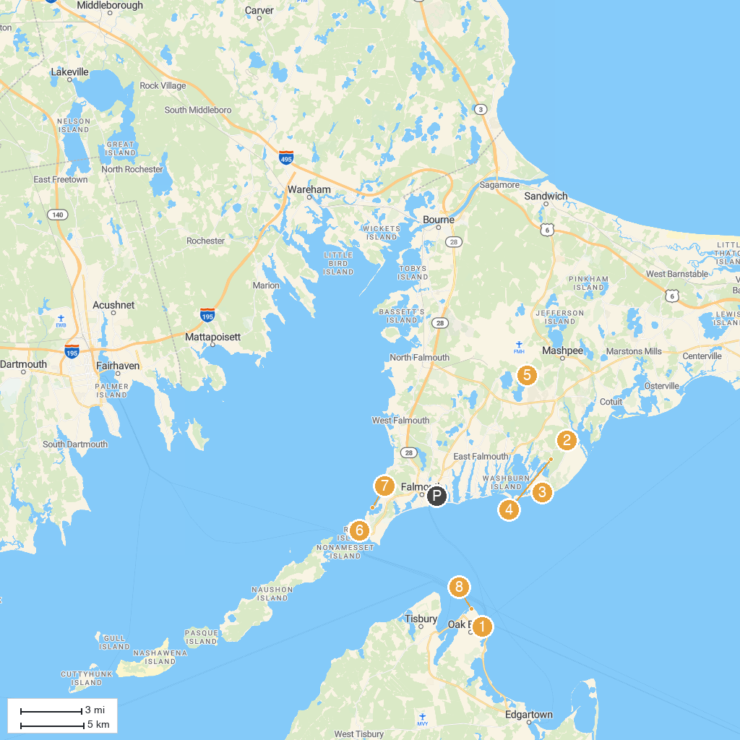
MAP KEY
1. Flying Horses Carousel a Vineyard Preservation Trust Property | 5. Johns Pond Park
2. Cape Cod Children's Museum | 6. Woods Hole Science Aquarium
3. South Cape Beach State Park | 7. The Knob
4. Mashpee National Wildlife Refuge | 8. East Chop Lighthouse
P. Cruise port / terminal
Map © MapTiler © OpenStreetMap contributors · cruiseports.org

