Farsund, Agder, Norway
Where privateers once prowled the Skagerrak, Farsund now offers sandy beaches, a lighthouse you can climb, and a slice of 1950s Americana in the Norwegian countryside.
⚓ Pier (deepwater quay) · 🕒 Typical call: 7-9 hrs · 💵 Norwegian Krone (NOK) — card-only culture · 🗣️ Norwegian (English widely spoken) · 🏖️ Best beaches in Southern Norway
✍️ MY DAY IN PORT (FILL IN)
Ship / Date
In port | arrive ______ · all aboard ______
Booked excursion
Notes / meeting point
GETTING ASHORE
- Docking: Pier — deepwater quay, ~10-min walk to Torvet (town square)
- Walk to center: 10 min from main pier; smaller ships dock right at town quay
- Best For: Beaches, cycling the Lista peninsula, WWII history, quiet charm
- Don't Miss: Lista Fyr lighthouse & the American enclave of Vanse village
GETTING AROUND
- 🚕 Taxi: 200–265 NOK (~$18–25 USD) — Local taxis are available for trips to out-of-town sights like Lista Lighthouse and the peninsula. The TaxiLink app cove
- 📱 Rideshare: ❌ not available
TOP THINGS TO DO
- Lista Lighthouse Climb — The 34-metre stone lighthouse at Lista Fyr has guided ships since 1836.
- Nordberg Fort (WWII Coastal Artillery) — One of Norway's best-preserved German coastal fortifications from WWII.
- Vanse & 'Little America' — Eight kilometres from port, the village of Vanse has a unique link to Brooklyn — early-to-mid 20th-century emigrants returned…
- Lista Beach Day — The Lista peninsula holds some of Southern Norway's finest sandy beaches.
- Loshavn Village Walk — A beautifully preserved old port village ~4 km south of Farsund, with 18th-century wooden houses among the finest-preserved on…
BEST WALKS
- Harbour & White-House Town Walk: 1.5 km · 30 min · Easy — From the pier, stroll along Bryggeslengen (the waterfront promenade) into Torvet (town square).
- Gervoll Woods & Suspension Bridge: 3 km · 45 min · Easy — A 20-minute walk from the pier leads to Gervollskogen, a peaceful park with forest paths, a small…
WEATHER · DAYLIGHT · MONEY
Month | High °F | Low °F | Rainy days
May | 56 | 44 | 12
Jul | 65 | 54 | 16
Sep | 60 | 52 | 16
Daylight: May 5:07AM–9:51PM · Jul 4:53AM–10:23PM · Sep 7:03AM–7:51PM
cruiseports.org/farsund · Confirm terminal & all-aboard time with your ship

Farsund, Agder, Norway — Port Map
Red = walkable sights · Amber = excursions farther out · P = cruise terminal
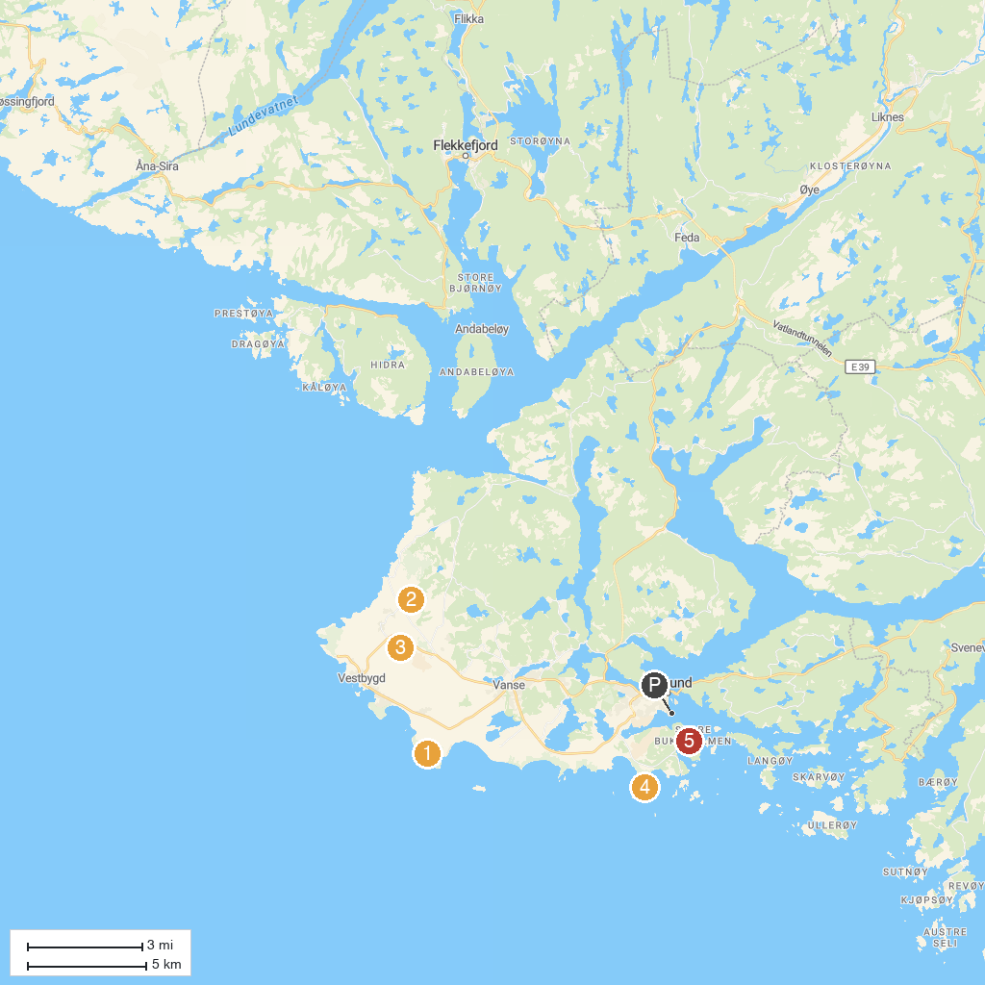
MAP KEY
1. Marka skyte- og øvingsfelt | 4. Einarsneset
2. Nordberg fort | 5. Paradisbukta
3. Flipside Skatepark
P. Cruise port / terminal
Map © MapTiler © OpenStreetMap contributors · cruiseports.org

