Fetești, Ialomița, Romania
A quiet Danube river town on the Borcea branch, Fetești serves as a key embarkation and transfer port for river cruises — and the jumping-off point for Bucharest, the Black Sea, and the engineering marvel of the Anghel Saligny Bridge.
⚓ Pier (direct dock) · 🕒 Typical call: 8–10 hrs · 💵 Romanian Leu (RON) · 🗣️ Romanian · 🚌 Excursion-focused port
✍️ MY DAY IN PORT (FILL IN)
Ship / Date
In port | arrive ______ · all aboard ______
Booked excursion
Notes / meeting point
GETTING ASHORE
- Docking: Direct pier on the Borcea branch of the Danube — no tendering
- Walk to center: ~2.5 km to Fetești town; mostly industrial — not a scenic walk
- Best For: Bucharest day trips, Black Sea coast, Danube bridge history
- Don't Miss: The Anghel Saligny Bridge — Europe's longest bridge complex when built in 1895
GETTING AROUND
- 🚕 Taxi: 5–15 RON (~1–3 USD) for short hops in town — Local metered taxis are the primary transport option. Romania taxis typically charge ~2.5 RON base plus ~2 RON/km; flag
TOP THINGS TO DO
- Bucharest City Highlights — Romania's capital rewards a day trip with grand boulevards, the colossal Palace of the Parliament, and the charming Village Museum.
- Constanța & the Black Sea — Romania's ancient Black Sea port is an hour away.
- Anghel Saligny Bridge Walk — The 1895 railway bridge spanning the Danube was the longest bridge complex in Europe at completion.
- Danube Riverbank Stroll — A quiet walk along the Borcea branch offers views of local fishermen and the flat Bărăgan Plain wetlands — genuine, unhurried…
BEST WALKS
- Riverbank & Saligny Bridge View: 1–2 km · Flat · Free — From the cruise quay, walk along the Borcea riverbank toward the Anghel Saligny Bridge.
- Into Fetești Town: ~2.5 km · Flat but industrial · Taxi recommended — The town center has St.
WEATHER · DAYLIGHT · MONEY
Month | High °F | Low °F | Rainy days
May | 72 | 54 | 10
Jul | 85 | 66 | 8
Sep | 78 | 59 | 4
Daylight: May 5:41AM–8:29PM · Jul 5:38AM–8:50PM · Sep 6:47AM–7:18PM
cruiseports.org/fetesti · Confirm terminal & all-aboard time with your ship

Fetești, Ialomița, Romania — Port Map
Red = walkable sights · Amber = excursions farther out · P = cruise terminal
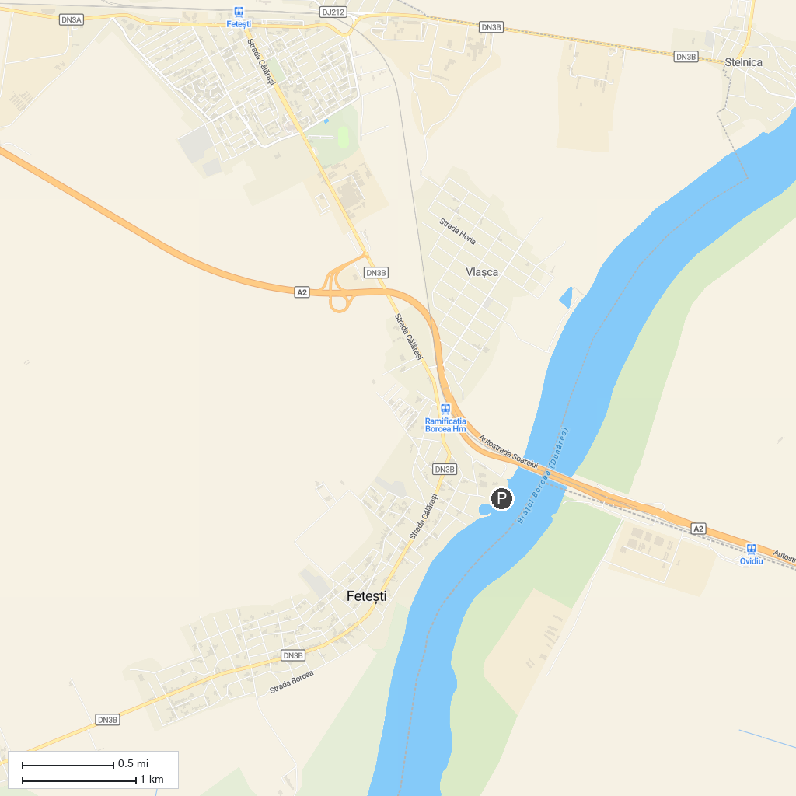
MAP KEY
1. Muzeul de Artă "Dinu și Sevasta Vintilă" | 2. The "Capidava" Fortress
P. Cruise port / terminal
Map © MapTiler © OpenStreetMap contributors · cruiseports.org

