Flensburg, Schleswig-Holstein, Germany
Germany's northernmost city blends Baltic seafaring grit with Danish hygge. Think rum-soaked merchant courtyards, a living harbour of classic sailing ships, and fish buns so good there's always a queue.
⚓ Pier (small ships) / Tender (larger ships) · 🕒 Typical call: 6-8 hrs · 💶 Euro (€) · 🗣️ German & Danish spoken
✍️ MY DAY IN PORT (FILL IN)
Ship / Date
In port | arrive ______ · all aboard ______
Booked excursion
Notes / meeting point
GETTING ASHORE
- Docking: Small ships dock at Harniskai or Schiffbrücke; larger vessels anchor and tender in
- Walk to centre: 0–20 min depending on berth; Historic Harbour is right on the waterfront
- Best For: History buffs, food lovers, easy independent exploring
- Don't Miss: Rote Straße merchant courtyards and a Fischbrötchen at Ben's Fischhütte
GETTING AROUND
- 🚕 Taxi: €5–€8 — Standard taxis queue near the port. The short trip to the city center costs little more than the base fare (€3.90–€4.20
- 📱 Rideshare: ✅ Uber
TOP THINGS TO DO
- Historic Harbour & Rum Museum — Wander among classic wooden sailing ships and the 1908 steamship Alexandra at the Historischer Hafen, then duck into the Maritime…
- Rote Straße Merchant Courtyards — Duck into the hidden Kaufmannshöfe (merchants' courtyards) off Rote Straße — colourful 17th-century trading courtyards now home…
- Fischbrötchen & Local Food Trail — Join the inevitable queue at Ben's Fischhütte at the Historic Harbour for a freshly made fish bun — herring or salmon in a crusty…
- Solitüde Beach — A sandy fjord beach on the eastern shore with a pier, playground, and an Italian restaurant with views across to Denmark.
- Museumsberg Flensburg — A hilltop museum complex overlooking the fjord, covering regional art and cultural history from the German-Danish borderlands.
BEST WALKS
- Harbour to Old Town Loop: 3–4 km · 1.5–2 hrs · Easy, flat — Start at the Historic Harbour among the classic sailing ships, walk south along the waterfront to…
- Waterfront Promenade to Ostseebad Beach: 4–5 km one way · 45–60 min · Easy, flat — Follow the fjord promenade north from the harbour to the Ostseebad historic bathing area on the…
WEATHER · DAYLIGHT · MONEY
Month | High °F | Low °F | Rainy days
May | 61 | 46 | 11
Jul | 70 | 57 | 13
Sep | 65 | 53 | 12
Daylight: May 5:15AM–9:22PM · Jul 5:05AM–9:50PM · Sep 6:55AM–7:38PM
cruiseports.org/flensburg · Confirm terminal & all-aboard time with your ship

Flensburg, Schleswig-Holstein, Germany — Port Map
Red = walkable sights · Amber = excursions farther out · P = cruise terminal
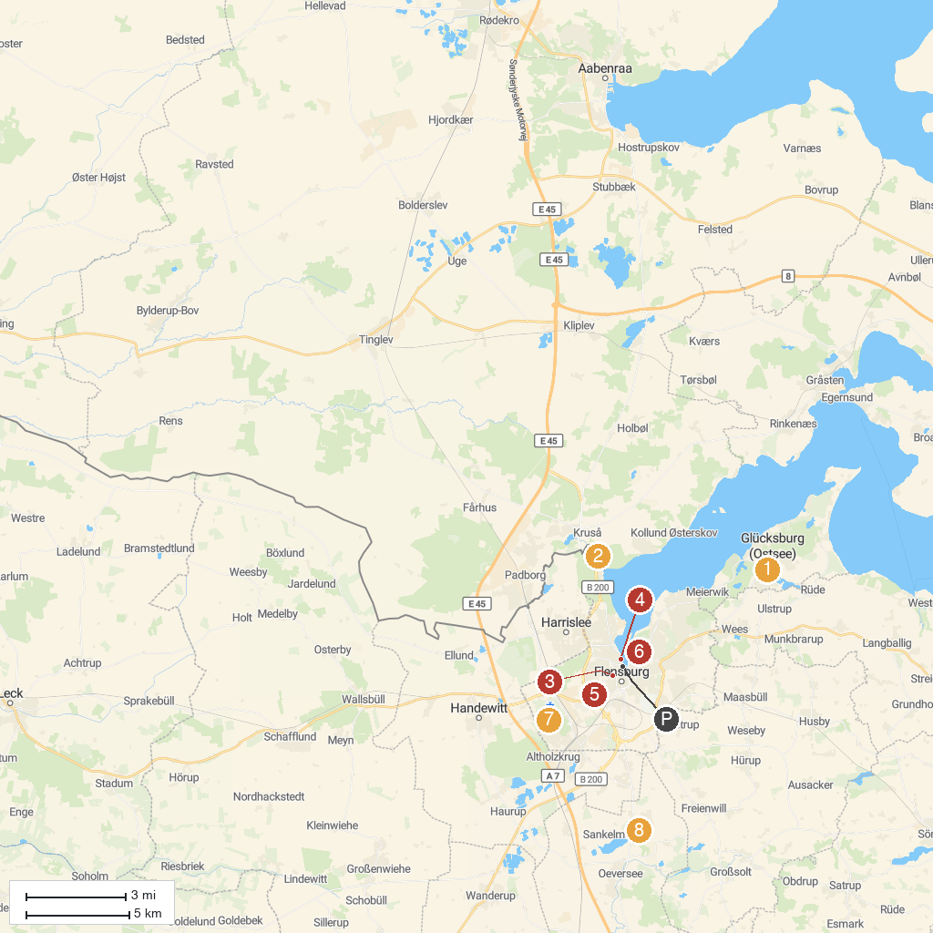
MAP KEY
1. Glücksburg Castle | 5. Mystery House - Flensburg
2. Industriemuseum Kupfermühle | 6. Wasserturm Flensburg
3. Eiszeit-Haus | 7. Foundation country Schäferhaus
4. Flensburger Schifffahrtsmuseum | 8. Arnkielpark
P. Cruise port / terminal
Map © MapTiler © OpenStreetMap contributors · cruiseports.org

