Florence, Alabama, USA
Where the Tennessee River bends through the Shoals, Florence delivers an outsized dose of American music history, Native heritage, and architectural surprise — all within easy reach of the dock.
⚓ Docked (riverfront pier) · 🕒 Typical call: 8–10 hrs · 💵 USD · 🗣️ English · 🎵 Blues & soul music heritage
✍️ MY DAY IN PORT (FILL IN)
Ship / Date
In port | arrive ______ · all aboard ______
Booked excursion
Notes / meeting point
GETTING ASHORE
- Docking: Ships tie up at the Florence riverfront / Wilson Lake area on the Tennessee River
- Walk to center: ~10 min walk to downtown Florence from the riverfront
- Best For: Music history, Frank Lloyd Wright architecture, Native American heritage
- Don't Miss: W.C. Handy Home & Museum and Rosenbaum House
GETTING AROUND
- 🚕 Taxi: Varies — Local taxi services are available in Florence for point-to-point trips. No fixed meter rates published; fares are compar
- 📱 Rideshare: ✅ Uber, Lyft
TOP THINGS TO DO
- W.C. Handy Home & Museum — The restored log cabin birthplace of W.C.
- Rosenbaum House (Frank Lloyd Wright) — The only Frank Lloyd Wright–designed home in Alabama, built in 1939 (and expanded by Wright in 1948) and still largely original.
- Indian Mound & Museum — A large Mississippian-era burial mound right in downtown Florence, dating to around 1200 CE.
- Muscle Shoals Music Heritage — A short drive takes you to nearby Muscle Shoals, where FAME Studios and Muscle Shoals Sound Studio recorded hits for Aretha…
- Pope's Tavern Museum — A stagecoach inn from the early 1800s that served as a hospital for both Union and Confederate soldiers during the Civil War.
BEST WALKS
- Downtown Florence Heritage Walk: 1.5 miles · Easy · 45–60 min — From the riverfront, walk north on Court Street into downtown.
- Rosenbaum House & Back: Drive or rideshare · 1–1.5 hrs total — Take a quick rideshare or taxi 5 minutes west to the Rosenbaum House on Riverview Drive.
WEATHER · DAYLIGHT · MONEY
Month | High °F | Low °F | Rainy days
May | 72 | 53 | 14
Jul | 89 | 67 | 5
Sep | 79 | 60 | 9
Daylight: May 5:47AM–7:47PM · Jul 5:49AM–8:04PM · Sep 6:34AM–6:56PM
Representative sunrise/sunset — 2025, 15th of each month; local civil time including DST (America/Chicago). Source: Astral; not a forecast or climate average.
cruiseports.org/florence-al · Confirm terminal & all-aboard time with your ship

Florence, Alabama, USA — Port Map
Red = walkable sights · Amber = excursions farther out · P = cruise terminal
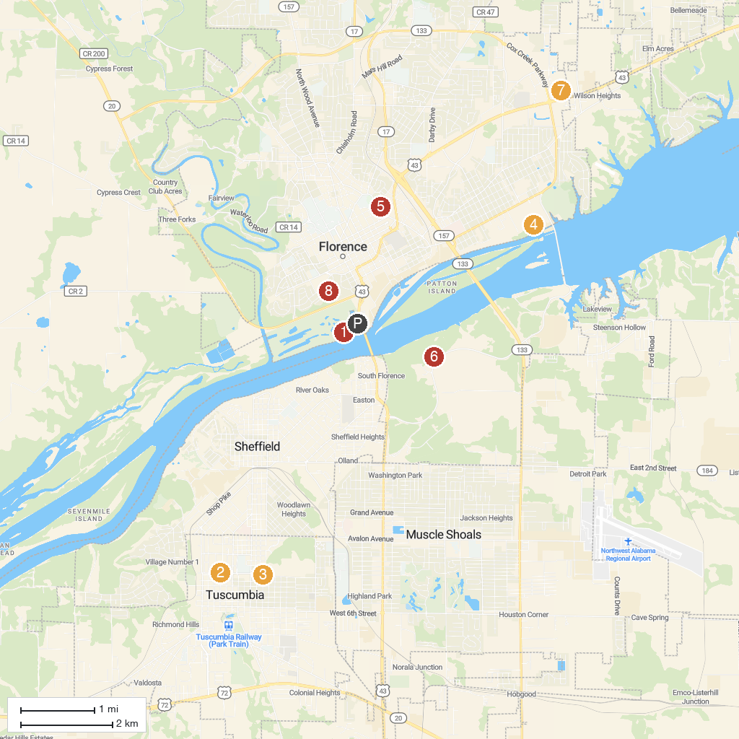
MAP KEY
1. McFarland Park | 5. Martin Park
2. Helen Keller Birthplace | 6. TVA Muscle Shoals Trails Complex
3. Tuscumbia Parks and Recreation | 7. Sky Zone Trampoline Park
4. Interactive Play Fountain At River Heritage Park | 8. Frank Lloyd Wright - Rosenbaum House Museum
P. Cruise port / terminal
Map © MapTiler © OpenStreetMap contributors · cruiseports.org

