Flores Island, Azores, Portugal
The wildest island in Europe's wildest archipelago. Flores delivers volcanic drama — crater lakes, neon-green valleys, towering waterfalls — with almost zero tourist infrastructure. That's the point.
⚓ Tender port · 🕒 Typical call: 7–9 hrs · 💶 Euro (€) · 🗣️ Portuguese · 🌿 UNESCO Biosphere Reserve
✍️ MY DAY IN PORT (FILL IN)
Ship / Date
In port | arrive ______ · all aboard ______
Booked excursion
Notes / meeting point
GETTING ASHORE
- Docking: Tender — Lajes das Flores pier has been storm-damaged since 2019 (Hurricane Lorenzo); a major new-port reconstruction is underway, projected to complete around 2030
- Walk to center: 10–15 min uphill from tender dock into Lajes das Flores village
- Best For: Nature lovers, hikers, photographers, and anyone who wants the unplugged Azores experience
- Don't Miss: Poço Ribeira do Ferreiro — a waterfall amphitheater that belongs in a nature documentary
GETTING AROUND
- 🚕 Taxi: €23–€29 — Taxis serve the port but do not queue on-site — book by phone in advance. "Pick Me Up in Flores" (pickmeupinflores.com)
- 📱 Rideshare: ❌ not available
TOP THINGS TO DO
- Poço Ribeira do Ferreiro & Waterfall Circuit — Flores's signature sight: a dramatic green amphitheater where a dozen waterfalls plunge into a serene lagoon.
- Crater Lakes — Lagoa Negra & Lagoa Comprida — Twin volcanic calderas filled with inky blue-green water, sitting side by side in the center of the island.
- Canyoning on Flores — Flores is considered one of Europe's top canyoning destinations — deep gorges, multi-drop waterfalls, and natural slides through…
- Fajã Grande & West Coast Drive — The westernmost village in Europe, tucked beneath massive cliff faces draped in waterfalls.
- RIB Boat to Corvo Island — Tiny Corvo — the smallest island in the Azores — is visible from Flores and reachable in about 45 minutes by rigid inflatable boat.
BEST WALKS
- Lajes das Flores Village & Natural Pools: 1–2 hrs · Easy · No transport needed — From the tender dock, walk uphill into Lajes das Flores: explore the small church, local cafes, and…
WEATHER · DAYLIGHT · MONEY
Month | High °F | Low °F | Rainy days
May | 63 | 58 | 17
Jul | 72 | 67 | 15
Sep | 72 | 68 | 17
Daylight: May 6:51AM–9:11PM · Jul 6:50AM–9:30PM · Sep 7:46AM–8:12PM
cruiseports.org/flores-island-azores · Confirm terminal & all-aboard time with your ship

Flores Island, Azores, Portugal — Port Map
Red = walkable sights · Amber = excursions farther out · P = cruise terminal
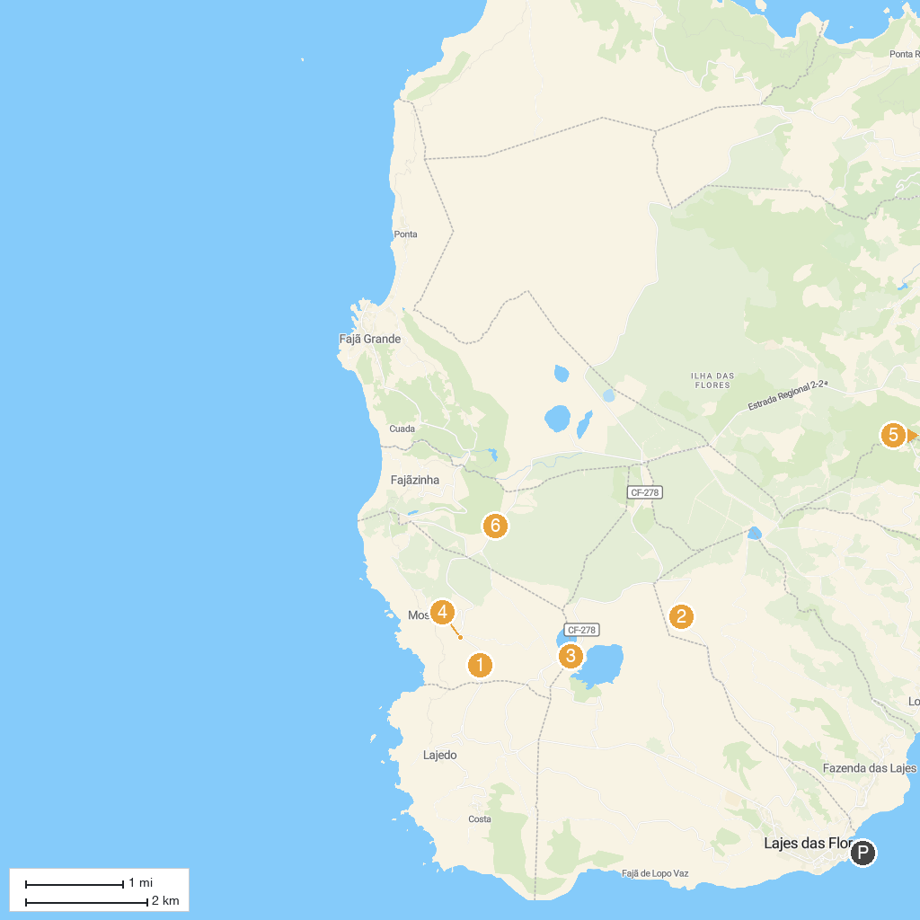
MAP KEY
1. Rocha dos Bordões | 4. Rocha dos Bordões Viewpoint
2. Miradouro Lagoas Rasa e Funda | 5. Miradouro da Fajã do Conde
3. Miradouro Caldeira Rasa e Funda | 6. Miradouro Craveiro Lopes
P. Cruise port / terminal
Map © MapTiler © OpenStreetMap contributors · cruiseports.org

