Florida Islands, Central Province, Solomon Islands
A time-capsule archipelago where a listing cruise ship rusts in a jungle bay, WWII history lies scattered in the shallows, and tiny Tulagi — once the British colonial capital — slumbers in the Pacific heat.
⚓ Tender only (no pier) · 🕒 Typical call: 6–8 hrs · 💵 Solomon Islands Dollar (SBD) — no ATMs ashore · 🗣️ English & Solomon Islands Pijin · 🤿 Expedition & small-ship itineraries
✍️ MY DAY IN PORT (FILL IN)
Ship / Date
In port | arrive ______ · all aboard ______
Booked excursion
Notes / meeting point
GETTING ASHORE
- Docking: Tender — ships anchor in Tulagi Harbour or Purvis Bay
- Walk to centre: 5 min from tender jetty to Raiders Hotel hub
- Best For: WWII history, shipwreck photography, snorkelling
- Don't Miss: MS World Discoverer wreck in Roderick Bay
GETTING AROUND
- 📱 Rideshare: ❌ not available
TOP THINGS TO DO
- MS World Discoverer Wreck, Roderick Bay — The German expedition ship struck an uncharted reef in 2000 and was beached here, listing at 45°.
- Gavutu & Tanambogo WWII Islands — These twin islets were a fortified Japanese seaplane base stormed by US Marines on 7–9 August 1942.
- Tulagi Town & British Residency Ruins — Walk Tulagi's quiet main road, then hike to the ruins of the old British Commissioner's Residence on the ridge — the views over…
- Mboli Passage Boat Tour — A scenic ride through the narrow mangrove-lined saltwater channel that separates Nggela Sule from Nggela Pile — feels like…
- House Reef Snorkelling, Tulagi — Raiders Hotel's house reef begins just metres from shore — pristine coral gardens with abundant reef fish, accessible directly…
BEST WALKS
- Tulagi Town Loop: 1–1.5 hrs | Easy flat walk | ~2 km — From the public jetty, walk the main road past local shops, the small market (buy a fresh coconut…
- British Residency Ridge Hike: 45 min return | Moderate uphill | Panoramic views — A steep but short track behind Tulagi town leads to the ruins of the old British Residency…
WEATHER · DAYLIGHT · MONEY
Month | High °F | Low °F | Rainy days
May | 84 | 78 | 25
Jul | 83 | 78 | 21
Sep | 84 | 78 | 21
Daylight: May 6:24AM–6:06PM · Jul 6:36AM–6:14PM · Sep 6:13AM–6:15PM
cruiseports.org/florida-islands · Confirm terminal & all-aboard time with your ship

Florida Islands, Central Province, Solomon Islands — Port Map
Red = walkable sights · Amber = excursions farther out · P = cruise terminal
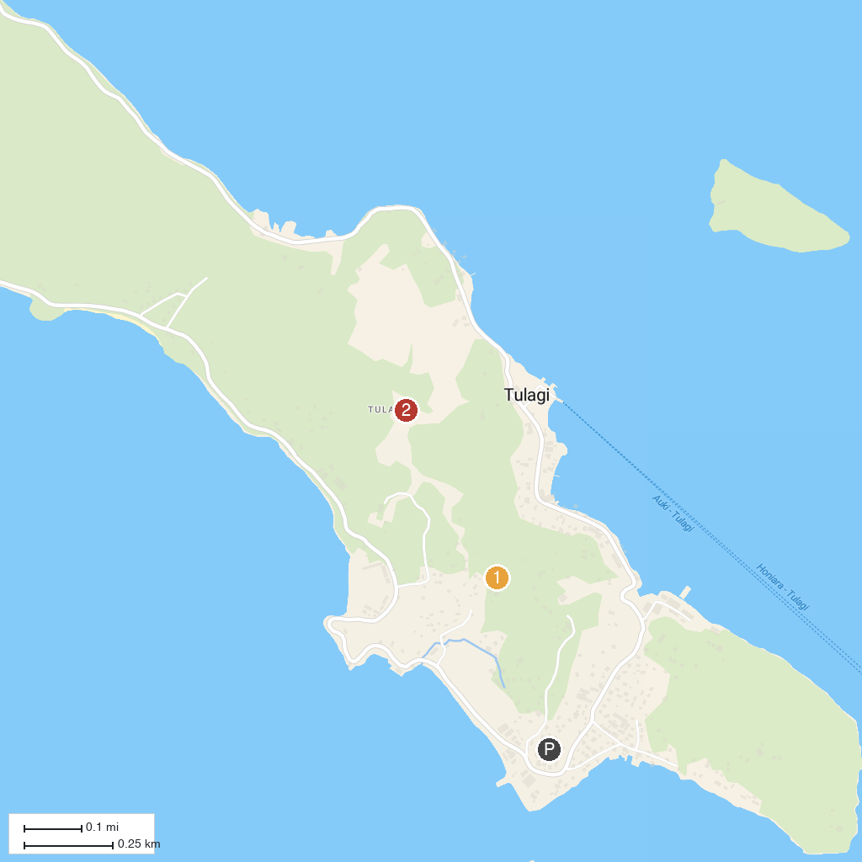
MAP KEY
1. Tulagi WWII Wrecks, Florida Islands | 2. Tulagi Historical Sites
P. Cruise port / terminal
Map © MapTiler © OpenStreetMap contributors · cruiseports.org

