Fogo Island, São Filipe, Cape Verde
The fire island of Cape Verde. An active 2,829 m volcano, a caldera you can drive into, colonial sobrado mansions in São Filipe, and wine and coffee grown in volcanic ash.
⚓ Tender (no pier) · 🕒 Typical call: 6-8 hrs · 💵 Cape Verdean Escudo (CVE) · 🗣️ Portuguese & Cape Verdean Creole · 🧭 Mostly expedition & small ships
✍️ MY DAY IN PORT (FILL IN)
Ship / Date
In port | arrive ______ · all aboard ______
Booked excursion
Notes / meeting point
GETTING ASHORE
- Docking: Tender to Vale de Cavaleiros quay, ~3 km north of São Filipe
- Walk to center: ~3 km to São Filipe old town; short taxi or 30-40 min walk
- Best For: Volcano hiking, the Chã das Caldeiras caldera, colonial architecture, volcanic wine
- Don't Miss: Chã das Caldeiras crater and the sobrados of São Filipe
GETTING AROUND
- 🚕 Taxi: Negotiate before riding — Yellow taxis are readily available in São Filipe at the port and town plaza. Fares are unmetered — always agree on a pri
TOP THINGS TO DO
- Chã das Caldeiras & Pico do Fogo — Drive up into Chã das Caldeiras, the village inside the volcanic caldera at ~1,700 m, ringed by the black lava fields of the…
- São Filipe Old Town & Sobrados Walk — Wander Bila Baxo, the historic heart of São Filipe, with cobbled streets and 19th-century 'sobrados' — elegant two-storey…
- Fogo Volcanic Wine & Coffee Tasting — Vines and coffee grow in the mineral-rich volcanic ash of Chã das Caldeiras, 1,500-2,000 m up.
- Parque Natural do Fogo Scenic Drive — The protected Parque Natural do Fogo wraps the volcano and caldera, with dramatic lava landscapes, endemic plants, and sweeping…
- Cape Verdean Food & Market — Sample cachupa — Cape Verde's national slow-cooked hominy-and-bean stew — along with fresh fish and tropical fruit.
BEST WALKS
- São Filipe Old Town & Clifftop: 2 km · 1-1.5 hrs · Easy — Stroll the cobbled streets of Bila Baxo past colourful sobrado mansions and the town church, then…
- Chã das Caldeiras Lava Walk: 2-3 km · 1-1.5 hrs · Easy to moderate — If your excursion brings you up to the caldera, walk across the 2014-2015 lava field in Chã das…
WEATHER · DAYLIGHT · MONEY
Month | High °F | Low °F | Rainy days
May | 81 | 70 | 0
Jul | 83 | 74 | 1
Sep | 84 | 75 | 4
Daylight: May 6:09AM–6:58PM · Jul 6:16AM–7:11PM · Sep 6:26AM–6:39PM
cruiseports.org/fogo-island · Confirm terminal & all-aboard time with your ship

Fogo Island, São Filipe, Cape Verde — Port Map
Red = walkable sights · Amber = excursions farther out · P = cruise terminal
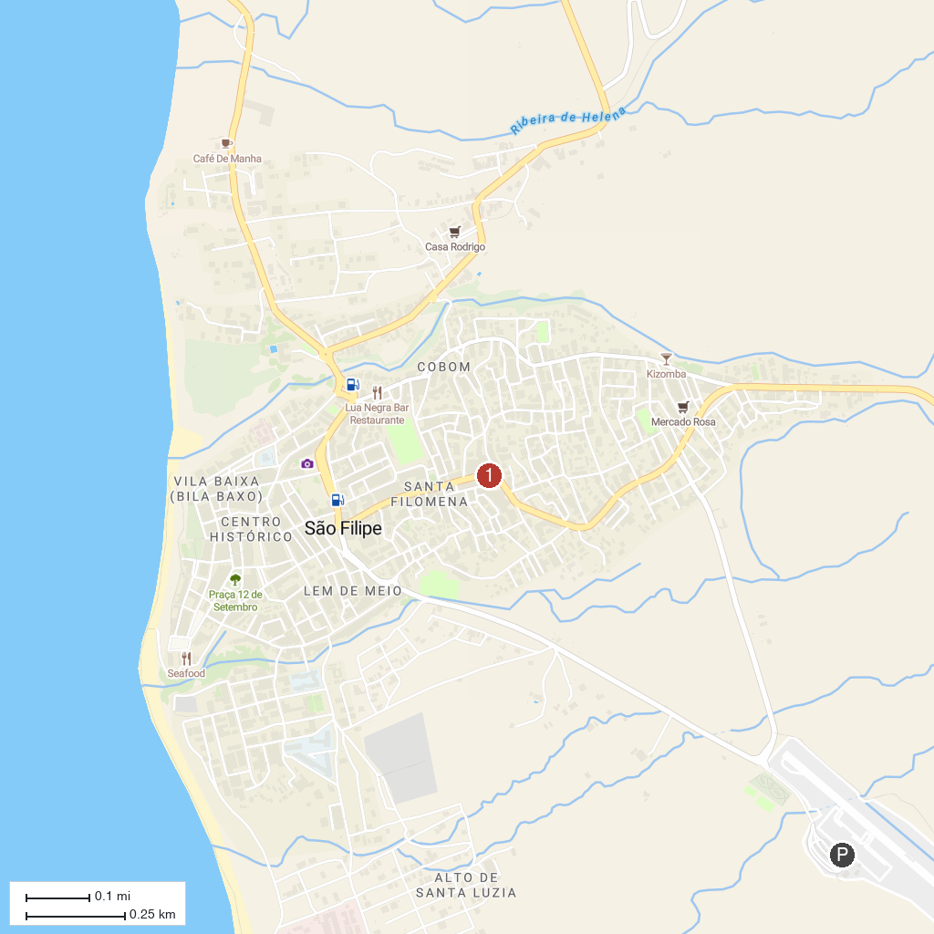
MAP KEY
1. Pico do Fogo | 3. São Filipe Old Town
2. Chã das Caldeiras, Fogo
P. Cruise port / terminal
Map © MapTiler © OpenStreetMap contributors · cruiseports.org

