Fort-de-France, Martinique, France
France in the tropics — cobblestone squares meet AOC rum distilleries, a Byzantine library shipped from the 1889 World's Fair, and a 20-minute ferry to some of the best beaches in the Lesser Antilles.
⚓ Pier (docked) · 🕒 Typical call: 7-9 hrs · 💶 Currency: Euro (€) · 🗣️ Language: French / Creole · 🍹 AOC Rhum Agricole
✍️ MY DAY IN PORT (FILL IN)
Ship / Date
In port | arrive ______ · all aboard ______
Booked excursion
Notes / meeting point
GETTING ASHORE
- Docking: Pier — Pointe Simon (city center) or Tourelles (~1 mile east)
- Walk to center: 2-5 min from Pointe Simon; 15-20 min from Tourelles
- Best For: French-Creole food, rum tastings, colonial history, beach ferry day
- Don't Miss: Ferry to Pointe du Bout beach, Bibliothèque Schoelcher, Balata Gardens
GETTING AROUND
- 🚕 Taxi: ~€10 from Tourelles terminal — Metered taxis wait at the pier exit with posted fares. The Tourelles terminal is a short 5-min ride to the center (~€10)
- 📱 Rideshare: ❌ not available
TOP THINGS TO DO
- Balata Gardens & Canopy Walkway — World-class botanical garden 15 min north of the city in the rainforest, with thousands of tropical plants and suspension bridges…
- Fort Saint-Louis Guided Tour — Active French naval fort dating from the 17th century, a 10-min walk from Pointe Simon.
- Ferry to Pointe du Bout Beaches — Hop the Vedettes Madinina ferry from the waterfront to Les Trois-Îlets and discover calm, turquoise resort beaches at Anse Mitan…
- Grand Marché & Rum Distillery — Browse the covered spice market for vanilla, Creole spices, and local rum, then visit a nearby AOC Rhum Agricole distillery.
- Scenic Island Drive: North Martinique & Mount Pelée — Full-day tour through lush rainforest to the volcano that destroyed the town of Saint-Pierre in 1902 — once called the 'Pompeii…
BEST WALKS
- Downtown Fort-de-France City Loop: 2-3 hrs · Flat · ~2.5 miles · Free — From the pier, walk to La Savane park (12 acres, decapitated Josephine statue), then to the…
- Fort Saint-Louis & La Française Beach: 1-2 hrs · Easy · ~1 mile · Free (fort entry ~€8) — Head west from Pointe Simon along the waterfront to Fort Saint-Louis, the active 17th-century naval…
WEATHER · DAYLIGHT · MONEY
Month | High °F | Low °F | Rainy days
May | 86 | 77 | 16
Jul | 85 | 78 | 23
Sep | 87 | 78 | 21
Daylight: May 5:36AM–6:24PM · Jul 5:43AM–6:37PM · Sep 5:53AM–6:05PM
cruiseports.org/fort-de-france · Confirm terminal & all-aboard time with your ship

Fort-de-France, Martinique, France — Port Map
Red = walkable sights · Amber = excursions farther out · P = cruise terminal
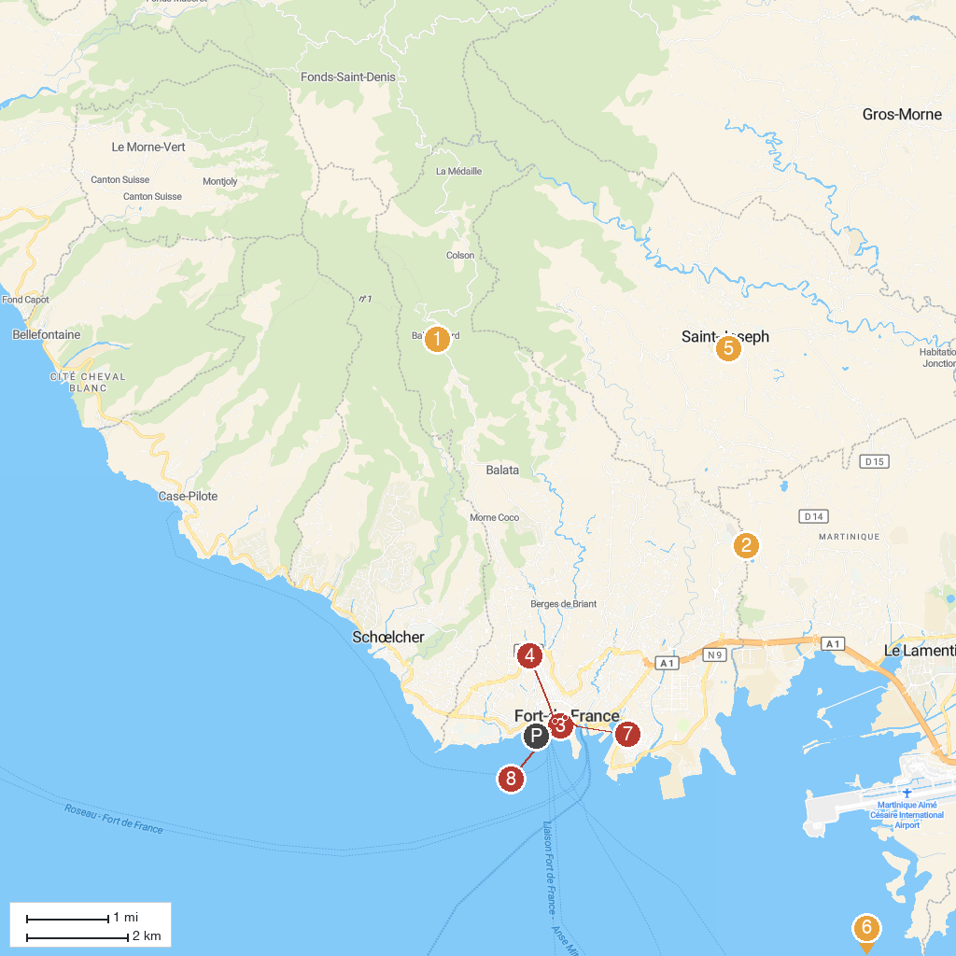
MAP KEY
1. Jardin de Balata | 5. Église catholique Saint-Joseph à Saint-Joseph
2. La Favorite Distillery | 6. Mangofil
3. Departmental Museum of Archaeology and Prehistory of Martinique | 7. Bibliothèque Schœlcher
4. St. Louis Catholic Cathedral | 8. Malecon
P. Cruise port / terminal
Map © MapTiler © OpenStreetMap contributors · cruiseports.org

