Fort Lauderdale, Florida, USA
The cruise capital of the world — Port Everglades handles over 4.7 million passengers a year, FLL airport is three miles from the gangway, and Fort Lauderdale's beach, 300+ miles of navigable canals, and vibrant Las Olas dining scene are right on your doorstep.
⚓ Docked (Port Everglades — no tendering) · 🕒 Embark/disembark homeport · 💵 US Dollar (USD) · 🗣️ English (Spanish widely spoken)
✍️ MY DAY IN PORT (FILL IN)
Ship / Date
In port | arrive ______ · all aboard ______
Booked excursion
Notes / meeting point
GETTING ASHORE
- Docking: Port Everglades — pier dock; confirm your sailing’s cruise terminal
- Airport: FLL — 3 miles, ~10-15 min Uber
- Best For: Beach · Everglades · Las Olas dining · Water Taxi
- Don't Miss: Fort Lauderdale Beach + Water Taxi hop-on/hop-off
GETTING AROUND
- 🚕 Taxi: $28–$35 — Regulated Broward County taxis from Port Everglades to downtown Fort Lauderdale. Flat rates may be available; ask before
- 📱 Rideshare: ✅ Uber, Lyft
TOP THINGS TO DO
- Fort Lauderdale Beach — A wide, clean Atlantic beach stretching for miles just east of the port — the classic Florida turnaround day.
- Everglades Airboat Tour — The real Florida is 30–45 minutes west — Everglades Holiday Park and Sawgrass Recreation Park both offer airboat rides through…
- Las Olas Boulevard — Fort Lauderdale's dining, gallery, and boutique strip runs from downtown to the beach.
- Fort Lauderdale Water Taxi — Hop-on/hop-off boats crisscross Fort Lauderdale's 300+ miles of inland canals.
- Riverwalk & Museum Row — The New River Riverwalk links the Museum of Discovery and Science (interactive exhibits + IMAX), the Broward Center for the…
BEST WALKS
- Fort Lauderdale Beach Promenade: ~3 km · 1 hr · easy · flat — The paved beachfront Promenade along A1A runs from the Las Olas intersection north toward Sunrise…
- Las Olas Boulevard stroll: ~1.5 km · 45 min · easy — Walk Las Olas Blvd from SE 6th Ave toward the beach — galleries, coffee shops, restaurants, and…
- New River Riverwalk: ~2 km · 1 hr · easy — The paved Riverwalk follows the New River from downtown past the Broward Center, Museum of…
WEATHER · DAYLIGHT · MONEY
Month | High °F | Low °F | Rainy days
May | 83 | 73 | 16
Jul | 87 | 77 | 25
Sep | 86 | 76 | 24
Daylight: May 6:34AM–7:59PM · Jul 6:38AM–8:14PM · Sep 7:06AM–7:24PM
ESSENTIAL TRAVEL QUALIFICATIONS
Water Taxi: current adult all-day price unverified; check with operator before booking. Confirm cruise terminal on boarding documents.
cruiseports.org/fort-lauderdale · Confirm terminal & all-aboard time with your ship

Fort Lauderdale, Florida, USA — Port Map
Red = walkable sights · Amber = excursions farther out · P = cruise terminal
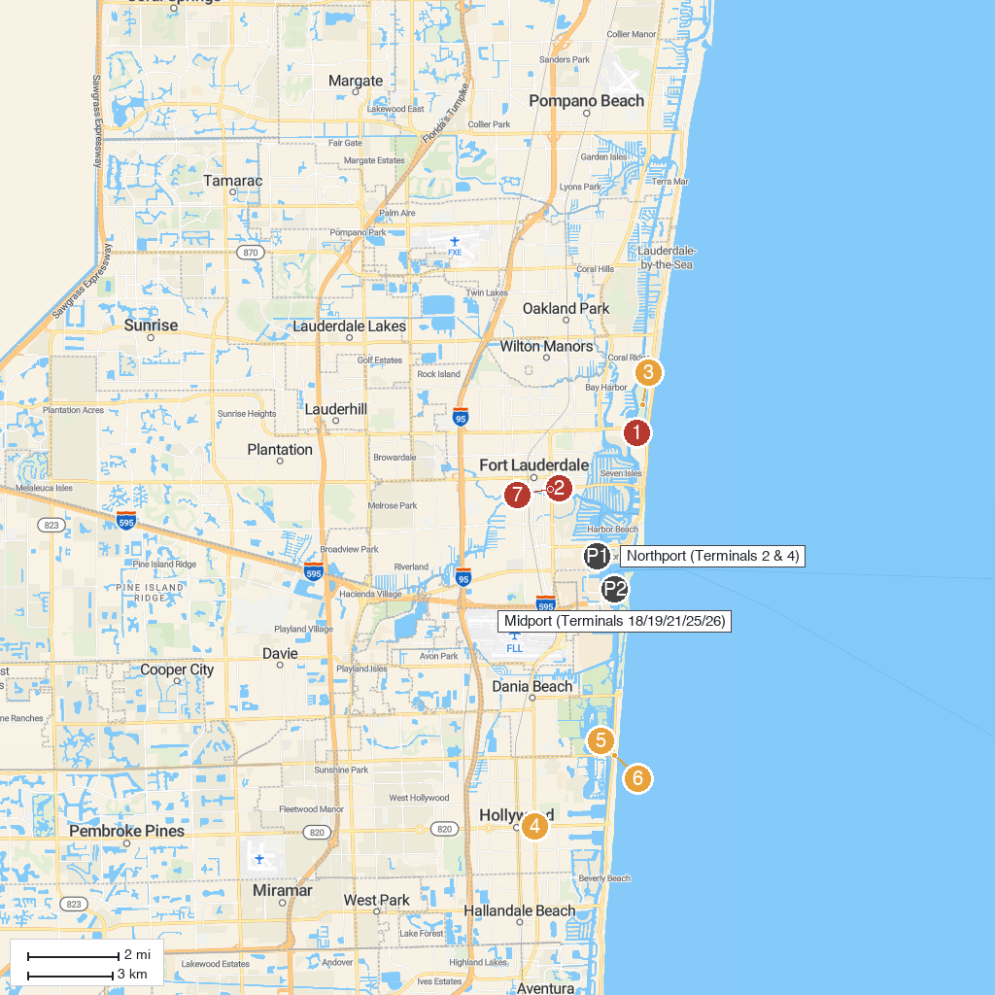
MAP KEY
1. Bonnet House Museum & Gardens | 5. Anne Kolb Nature Center
2. Riverwalk Fort Lauderdale | 6. Hollywood North Beach Park
3. Hugh Taylor Birch State Park | 7. Stranahan House
4. ArtsPark at Young Circle
P. Cruise port / terminal
Map © MapTiler © OpenStreetMap contributors · cruiseports.org

