Fort Myers Beach, Florida, USA
Seven miles of powdery quartz sand, a vibrant fishing fleet, and one of Florida's most resilient communities — Fort Myers Beach punches well above its size for a small-ship port day.
⚓ Small-ship dock (Salty Sam's / Moss Marina) · 🕒 Typical call: 6-8 hrs · 💵 USD · 🗣️ English · 🦐 Famous for Gulf shrimp
✍️ MY DAY IN PORT (FILL IN)
Ship / Date
In port | arrive ______ · all aboard ______
Booked excursion
Notes / meeting point
GETTING ASHORE
- Docking: Small ships dock at Salty Sam's Marina or Moss Marina, San Carlos Island — no tendering required
- Walk to center: ~1.2 miles to Times Square / main beach (steep bridge crossing — take the LeeTran trolley, $0.75)
- Best For: Beach relaxation, wildlife cruises, seafood, shelling at Lovers Key
- Don't Miss: Gulf shrimp right off the boat at Dixie Fish Company and the Mound House archaeological site
GETTING AROUND
- 🚕 Taxi: $50–$75 for 2-3 passengers — Local taxis and private shuttle services are available. Confirm pricing directly with the provider; additional fees may
- 📱 Rideshare: ✅ Uber, Lyft
TOP THINGS TO DO
- Dolphin & Wildlife Eco-Cruise — Board a two-hour narrated boat tour from Salty Sam's Marina into Estero Bay and the Gulf to spot wild bottlenose dolphins…
- Mound House Archaeological Site — Explore the oldest standing structure on Estero Island, built atop a 2,000-year-old Calusa shell mound.
- Lovers Key State Park Beach Day — Take the trolley south to this pristine barrier island park with two miles of undeveloped Gulf beach, excellent shelling, kayak…
- Gulf Shrimp & Seafood at the Docks — San Carlos Island hosts one of the largest commercial shrimp fleets in the U.S.
- Matanzas Pass Preserve Walk — A free 60-acre sanctuary on the bayside of the island with a boardwalk trail through mangroves and oak hammocks.
BEST WALKS
- Marina to Times Square Beach Walk: 1.2 mi • 25 min • Flat then bridge climb — Walk from Salty Sam's Marina across the Matanzas Pass Bridge to Times Square — the pedestrian heart…
- Bowditch Point Park Nature Loop: 1.5 mi loop • 35 min • Easy trails — At the northern tip of Estero Island, this 17-acre park offers walking trails where the bay meets…
WEATHER · DAYLIGHT · MONEY
Month | High °F | Low °F | Rainy days
May | 86 | 71 | 13
Jul | 88 | 77 | 25
Sep | 86 | 76 | 22
Daylight: May 6:40AM–8:07PM · Jul 6:44AM–8:22PM · Sep 7:13AM–7:31PM
cruiseports.org/fort-myers-beach-fl · Confirm terminal & all-aboard time with your ship

Fort Myers Beach, Florida, USA — Port Map
Red = walkable sights · Amber = excursions farther out · P = cruise terminal
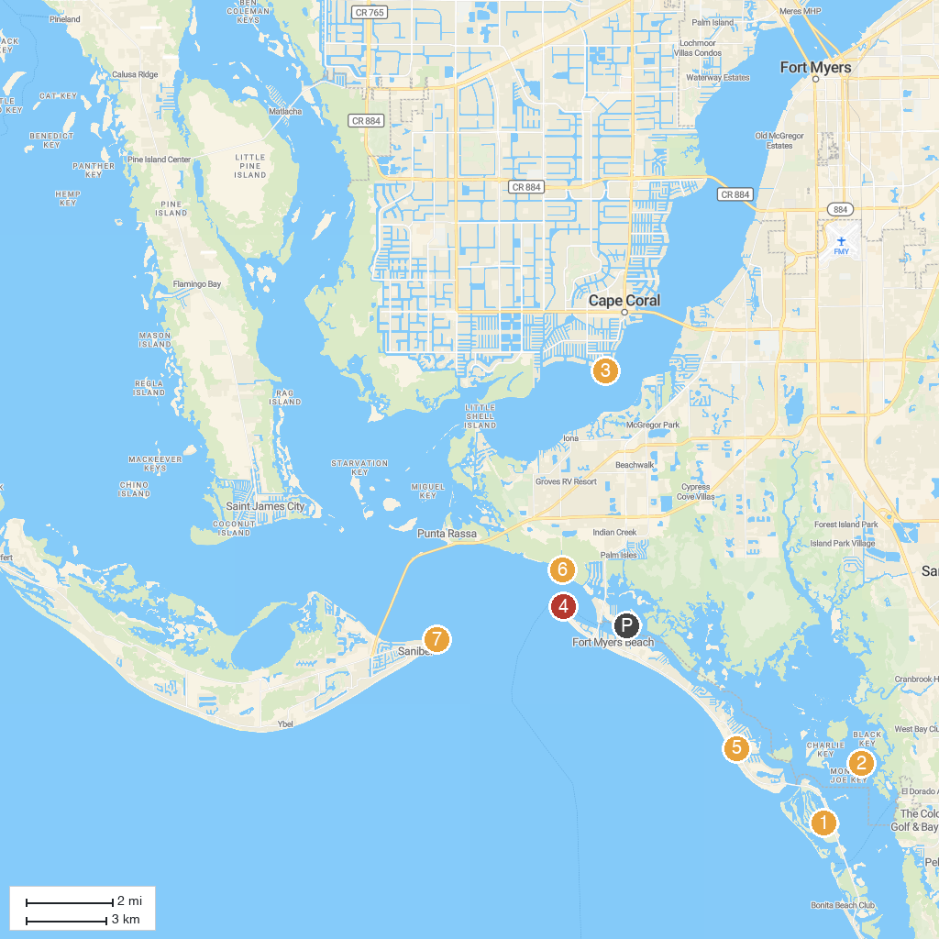
MAP KEY
1. Lovers Key State Park | 5. Mid Island Water Sports at The Wyndham
2. Estero Bay Aquatic Preserve | 6. San Carlos Bay - Bunche Beach Preserve
3. Yacht Club Community Park | 7. Sanibel Lighthouse
4. Bowditch Point Park | 8. Jaycee Park
P. Cruise port / terminal
Map © MapTiler © OpenStreetMap contributors · cruiseports.org

