Fort William, Scottish Highlands, Scotland
The Outdoor Capital of the UK sits beneath Britain's highest mountain, where a tender ride onto Loch Linnhe pontoons drops you steps from a Highland town bristling with Jacobite history, a famous steam railway, and single-malt whisky.
⚓ Tender port · 🕒 Typical call: 7-9 hrs · 💷 British Pound (GBP) · 🗣️ English / Scottish Gaelic · 🏔️ Outdoor & scenic
✍️ MY DAY IN PORT (FILL IN)
Ship / Date
In port | arrive ______ · all aboard ______
Booked excursion
Notes / meeting point
GETTING ASHORE
- Docking: Tender — ships anchor in Loch Linnhe; boats land at the Fort William Pontoons (West End Car Park; installed 2016, extended 2022 & 2023)
- Walk to center: 1-2 min from tender pontoon to High Street (flat, paved)
- Best For: Scenery, Jacobite train fans, whisky lovers, hikers, Harry Potter itineraries
- Don't Miss: Jacobite Steam Train (book months ahead) or watch it cross Glenfinnan Viaduct from below
GETTING AROUND
- 🚕 Taxi: £5–£10 (short trips) — Several local taxi companies serve the town including West Highland Taxis, Nevis Taxis, and Cloudy's Taxi. Ranks are nea
TOP THINGS TO DO
- Jacobite Steam Train to Mallaig — Board the "Hogwarts Express" at Fort William station for a 42-mile journey through the Highlands, crossing the Glenfinnan Viaduct…
- Nevis Range Mountain Gondola — The UK's only mountain gondola carries you 650m up Aonach Mòr for panoramic views of the Great Glen and Ben Nevis.
- Glencoe Highland Excursion — Drive 30 minutes south to Scotland's most dramatic glen — volcanic peaks, sweeping moorland, and the site of the 1692 Macdonald…
- Ben Nevis Distillery Tour & Tasting — Founded in 1825 at the foot of Ben Nevis, this working single-malt distillery offers guided tours and drams of its distinctive…
- Glenfinnan Viaduct Viewpoint (DIY) — If you can't get Jacobite tickets, take the coach or hire a taxi to the Glenfinnan Monument & Viaduct viewpoint.
BEST WALKS
- High Street & Town Centre Stroll: 0.5 miles · 20-30 min · Flat — From the pontoons, walk up to the High Street for the West Highland Museum (free; Jacobite relics)…
- Old Inverlochy Castle Walk: 2.4 miles round-trip · 50-60 min · Flat/easy — Head north from the town center along the River Lochy to the ruins of a 13th-century castle…
WEATHER · DAYLIGHT · MONEY
Month | High °F | Low °F | Rainy days
May | 57 | 45 | 17
Jul | 64 | 53 | 20
Sep | 60 | 50 | 18
Daylight: May 5:03AM–9:31PM · Jul 4:50AM–10:01PM · Sep 6:52AM–7:37PM
cruiseports.org/fort-william · Confirm terminal & all-aboard time with your ship

Fort William, Scottish Highlands, Scotland — Port Map
Red = walkable sights · Amber = excursions farther out · P = cruise terminal
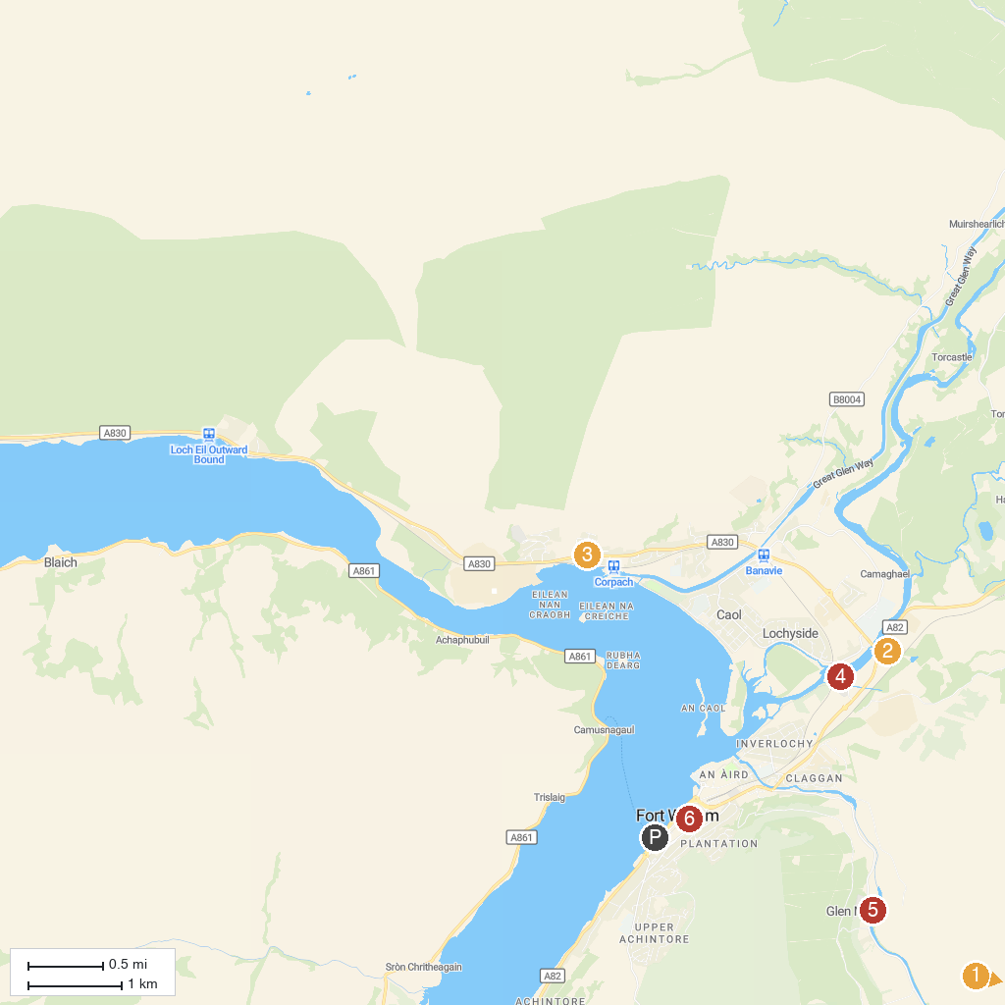
MAP KEY
1. Ben Nevis Weather Station | 5. Old Inverlochy Castle
2. Ben Nevis Distillery | 6. Ben Nevis Visitor Centre
3. Commando Memorial | 7. St Andrew's Church
4. Treasures of the Earth
P. Cruise port / terminal
Map © MapTiler © OpenStreetMap contributors · cruiseports.org

