Fortaleza, Brazil
Sun, Sand, and Urban Energy
Urban Beach · Handicraft Markets · Dune Adventures · Coastal City
✍️ MY DAY IN PORT (FILL IN)
Ship / Date
In port | arrive ______ · all aboard ______
Booked excursion
Notes / meeting point
GETTING ASHORE
- Best Time to Visit: June to September (avoiding the rainy season)
- Local Specialty: Baião de Dois (rice and beans with cheese)
- Key Landmark: Praia do Futuro (Future Beach)
- Transport: Uber or licensed taxi from the airport/hotels
GETTING AROUND
- 🚕 Taxi: R$20–40 — Metered taxis are available at the port gate for the ~6 km ride to the city center. Confirm fare before departing; night
- 📱 Rideshare: ✅ Uber
- 🚌 Hop-on hop-off: ✅
TOP THINGS TO DO
- Central Market & Handicraft Shopping — Visit the Mercado Central de Fortaleza to shop for traditional Ceará lace, leather goods, and local snacks.
- Beach Buggy Adventure to Cumbuco Beach — Take a high-speed buggy ride through the white sand dunes of Cumbuco Beach, stopping at lagoons for a refreshing dip and enjoying…
- Praia do Futuro (Future Beach) — Relax at one of the many high-end 'beach huts' (barracas) at Praia do Futuro, known for terms of luxury and excellent seafood…
- City Center & Dragão do Mar Center of Art and Culture — Explore the Dragão do Mar Center of Art and Culture, a hub for museums, galleries, and theaters, and visit the nearby historic…
BEST WALKS
- Mucuripe Fish Market Walk: Port Area — A short walk from the ship to the Mercado do Peixe, where you can see local fishermen bringing in…
- Beira Mar Promenade Walk: Urban Beach — A scenic stroll along the Beira Mar avenue, where you can walk past the ocean views, browse local…
- Praia do Futuro Exploration: Beach — A short walk between the various luxury beach huts at Praia do Futuro, allowing you to experience…
WEATHER · DAYLIGHT · MONEY
Month | High °F | Low °F | Rainy days
May | 85 | 76 | 22
Jul | 85 | 75 | 11
Sep | 86 | 77 | 3
Daylight: May 5:32AM–5:28PM · Jul 5:42AM–5:37PM · Sep 5:26AM–5:31PM
cruiseports.org/fortaleza · Confirm terminal & all-aboard time with your ship

Fortaleza, Brazil — Port Map
Red = walkable sights · Amber = excursions farther out · P = cruise terminal
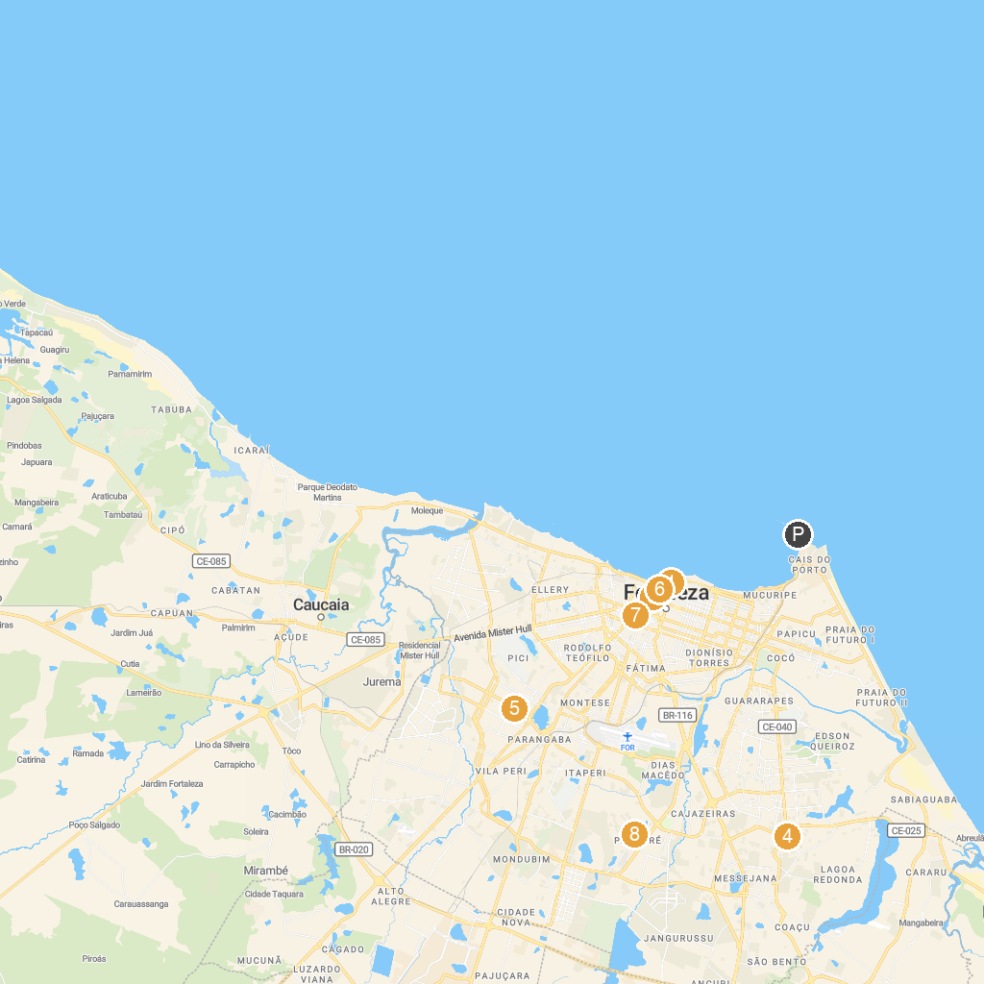
MAP KEY
1. Centro Dragão do Mar de Arte e Cultura | 5. Ecopoint
2. Catedral Metropolitana de Fortaleza | 6. Mercado Central de Fortaleza
3. Museu do Ceará (Palacete Senador Alencar) | 7. House of Baron Camocim
4. Casa de José de Alencar | 8. Sargento Prata City Zoo
P. Cruise port / terminal
Map © MapTiler © OpenStreetMap contributors · cruiseports.org

