Foula Island, Shetland, Scotland
Edge of the world, edge of the Atlantic. Foula is a 3-mile scrap of rock supporting 30 people, half a million seabirds, and some of Britain's most vertiginous cliffs — reached only by tender, weather permitting.
⚓ Tender only (no cruise berth) · 🕒 Typical call: 4–6 hrs · 💷 Currency: GBP (cash only) · 🗣️ Language: English · 🐦 Best May–Aug for seabirds
✍️ MY DAY IN PORT (FILL IN)
Ship / Date
In port | arrive ______ · all aboard ______
Booked excursion
Notes / meeting point
GETTING ASHORE
- Docking: Tender to Ham Voe pier — weather-dependent; cancellations common
- Walk to centre: ~30 min (1.5 mi) from pier to Hametoun; cliffs 2–3 miles on rough terrain
- Best For: Birdwatching, dramatic hiking, remote island atmosphere
- Don't Miss: Da Kame cliffs (1,220 ft sheer drop) and the bonxie colony
GETTING AROUND
- 🚕 Taxi: N/A — There are no taxis, hire cars, public buses, or commercial shuttles on Foula. Visitors should plan to explore entirely o
- 📱 Rideshare: ❌ not available
TOP THINGS TO DO
- Da Kame Cliff Walk — The island's crown jewel: a 1,220-foot sheer sandstone wall dropping straight into the Atlantic.
- Bonxie & Puffin Colony — Foula hosts one of the world's largest Great Skua (bonxie) colonies alongside thousands of nesting puffins, guillemots…
- Hametoun & Post Office — The island's tiny settlement at Hametoun is roughly a 1.5-mile (30-minute) walk south from the pier along the single-track road.
- Gaada Stack & North Coast — A striking natural sandstone sea arch on the island's north end, about 2 miles from the pier.
- Shetland Pony Spotting — Foula is home to a genetically distinct strain of Shetland ponies that roam freely across the island.
BEST WALKS
- Ham Voe to Hametoun: 1.5 miles · Easy · 30 min each way — Flat walk south along the island's single-track road from the pier to the small settlement.
- Ham Voe to Da Kame Cliffs: 2.5 miles · Strenuous · 1.5–2 hrs each way — Head west from the pier, climbing steeply over boggy peat moorland to the cliff edge above Da Kame.
WEATHER · DAYLIGHT · MONEY
Month | High °F | Low °F
May | 51 | 43
Jul | 58 | 51
Sep | 56 | 49
Daylight: May 4:29AM–9:41PM · Jul 4:11AM–10:15PM · Sep 6:36AM–7:28PM
Representative sunrise/sunset — 2025, 15th of each month; local civil time including DST (Europe/London). Source: Astral; not a forecast or climate average.
Regional Shetland temperature reference from Lerwick, about 50 km away; exposed Foula conditions may differ. Nearby-station regional proxy: Lerwick, 49.824 km from Foula; not exact Foula observations or 30-year normals. 2014–2023: 120 observed native monthly reports, ten per calendar month; mean daily highs/lows, not independently verified complete daily data. Rainy-day counts unavailable. Meteostat / DWD CLIMAT. CC BY 4.0: https://creativecommons.org/licenses/by/4.0/ Attribution: Meteostat and DWD CLIMAT; adapted by averaging 2014–2023 monthly means and converting units. Changes: Ten monthly means per calendar month averaged; Celsius converted to Fahrenheit once and rounded. No endorsement implied.
cruiseports.org/foula-island-scotland · Confirm terminal & all-aboard time with your ship

Foula Island, Shetland, Scotland — Port Map
Red = walkable sights · Amber = excursions farther out · P = cruise terminal
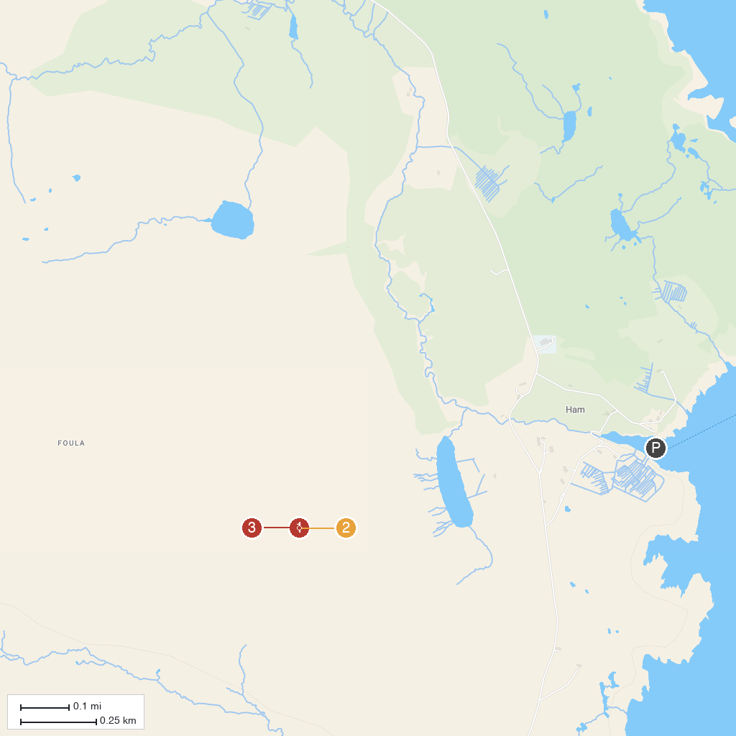
MAP KEY
1. The Kame | 3. Ham Voe
2. Da Sneug
P. Cruise port / terminal
Map © MapTiler © OpenStreetMap contributors · cruiseports.org

