Fredrikstad, Østfold, Norway
Cobbled streets, star-shaped ramparts, and centuries-old wooden houses — Fredrikstad's Gamlebyen, founded in 1567, is a living fortress town you can actually wander into. Cross the Glomma on a free ferry and you're there.
⚓ Pier (most ships) · 🕒 Typical call: 7-9 hrs · 💳 Cashless — card everywhere · 🗣️ Norwegian (English widely spoken) · 🏰 Historic fortified town
✍️ MY DAY IN PORT (FILL IN)
Ship / Date
In port | arrive ______ · all aboard ______
Booked excursion
Notes / meeting point
GETTING ASHORE
- Docking: Pier — Tollboden quay (city-center, smaller ships) or Øra Quay (larger ships, 4 km out)
- Walk to Gamlebyen: 10-min walk + free Byfergen ferry from city-center quay; shuttle bus from Øra
- Best For: History, architecture, Scandinavian culture, photography
- Don't Miss: Walking the star-shaped ramparts of Gamlebyen and a bowl of fresh shrimp on the riverfront
GETTING AROUND
- 🚕 Taxi: ~100–150 NOK (city center) — Local taxis are available near the port. Base fare is ~60 NOK; a short ride to the city center or Old Town typically cos
- 📱 Rideshare: ✅ Uber
TOP THINGS TO DO
- Gamlebyen Walking Tour — Explore Northern Europe's best-preserved fortified town — cobbled lanes, 18th-century wooden houses, ramparts with moats, and…
- Oldtidsveien — Ancient Road — Drive the Old Times Way between Fredrikstad and Sarpsborg, home to Norway's densest collection of Bronze Age and Viking…
- Hvaler Archipelago & Ytre Hvaler National Park — Island-hop through a maze of rocky islets, swim off smooth granite ledges, kayak sheltered channels, or join a wildlife boat tour…
- Glassblowing at Galleriet Glasshytta — Watch master glassblowers at work in Gamlebyen's own studio — free to enter and observe, and you can buy pieces directly from the…
- Foten Beach — Blue Flag sandy beach with smooth granite rocks, a diving platform, volleyball, and a café.
BEST WALKS
- Gamlebyen Ramparts Loop: 1.5 km · 30-40 min · Easy — Cross to the Old Town on the Byfergen, enter through the main gate, and walk the full perimeter of…
- Riverfront Promenade: 1.5 km · 20-30 min · Flat — Stroll the Bryggepromenaden on the modern city side — wooden boardwalk, restaurants, marina, and…
WEATHER · DAYLIGHT · MONEY
Month | High °F | Low °F | Rainy days
May | 59 | 45 | 10
Jul | 69 | 57 | 12
Sep | 61 | 51 | 12
Daylight: May 4:44AM–9:42PM · Jul 4:27AM–10:15PM · Sep 6:45AM–7:35PM
cruiseports.org/fredrikstad · Confirm terminal & all-aboard time with your ship

Fredrikstad, Østfold, Norway — Port Map
Red = walkable sights · Amber = excursions farther out · P = cruise terminal
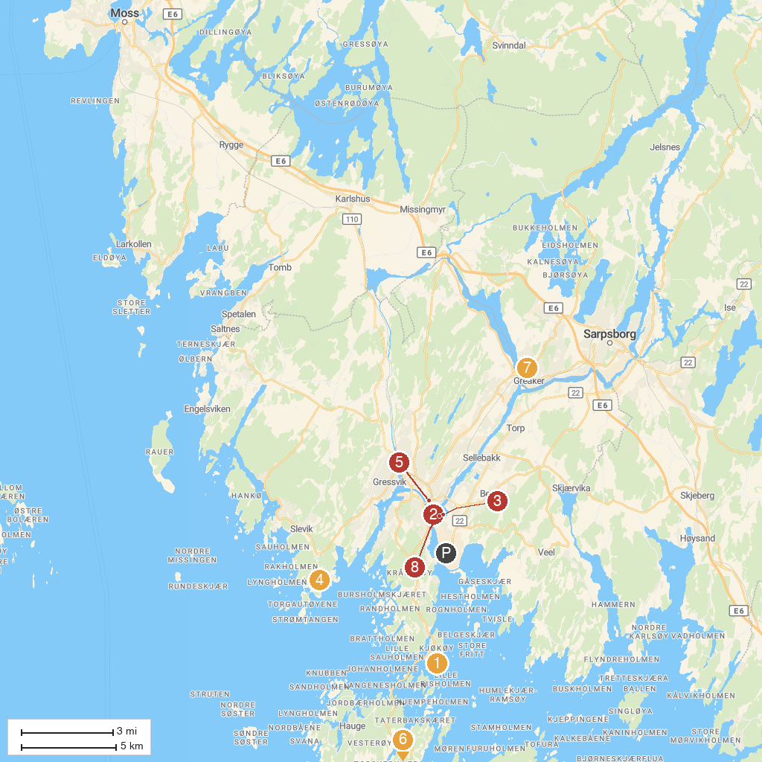
MAP KEY
1. Kjøkøy fort | 5. Fredrikstad Domkirke
2. Isegran fort | 6. Brottet amphitheater
3. Old Town Model Train Center | 7. Greåker fort
4. Torgauten fort | 8. Fredrikstad Museum
P. Cruise port / terminal
Map © MapTiler © OpenStreetMap contributors · cruiseports.org

