Fremantle, Western Australia, Australia
"Freo" is the rare port where the ship docks steps from a world-heritage prison, a cannon-firing colonial fort, and the birthplace of Australian craft beer. Perth is 30 minutes by train if you want a city fix.
⚓ Pier — Fremantle Passenger Terminal, Victoria Quay · 🕒 Typical call: 8–12 hrs (some overnights) · 💵 Australian Dollar (AUD) — nearly cashless, tap & pay everywhere · 🗣️ English · ☀️ UV very high — hat and sunscreen essential
✍️ MY DAY IN PORT (FILL IN)
Ship / Date
In port | arrive ______ · all aboard ______
Booked excursion
Notes / meeting point
GETTING ASHORE
- Docking: Pier — Fremantle Passenger Terminal, Victoria Quay (Berths C & D). No tender.
- Walk to centre: 10–15 min to High Street / Town Hall; WA Maritime Museum is right next to the terminal.
- Best For: History buffs, foodies, craft beer fans, day-trippers to Rottnest Island
- Don't Miss: Fremantle Prison tour, Rottnest Island quokkas (ferry from Victoria Quay), fish & chips at Fishing Boat Harbour
GETTING AROUND
- 🚕 Taxi: AUD $45–65 — Taxis are available outside the terminal. Roughly 20 km to Perth city center; metered fare typically AUD $45–65 dependin
- 📱 Rideshare: ✅ Uber, DiDi
- 🚌 Hop-on hop-off: ✅
TOP THINGS TO DO
- Fremantle Prison Tour — UNESCO World Heritage convict prison built in the 1850s and in use until 1991.
- Rottnest Island Quokka Day Trip — Hop on the 30-minute ferry from Victoria Quay to Rottnest Island, home of the famously selfie-friendly quokka.
- Fremantle Markets & West End Heritage Walk — Explore the 1897 Fremantle Markets (open Fri–Sun only — verify your port day), then stroll the West End's intact Victorian…
- Fishing Boat Harbour & Craft Beer Trail — Walk south to Fremantle Fishing Boat Harbour for legendary fish and chips at Cicerello's or Kailis', then hit Little Creatures…
- Perth City Day Trip by Train — Walk to Fremantle Train Station (5–10 min) and take the Fremantle Line to Perth CBD — 30 minutes, ~$6 AUD.
BEST WALKS
- Victoria Quay to West End Heritage Loop: 2.5 km · ~45 min · Easy — flat pavement — From the terminal walk past the WA Maritime Museum, through Esplanade Park, up to the Round House…
- Waterfront to Fishing Boat Harbour: 3 km one-way · ~35 min · Easy — flat coastal path — Head south from the terminal along the harbour foreshore past Bathers Beach (good for a swim)…
WEATHER · DAYLIGHT · MONEY
Month | High °F | Low °F | Rainy days
May | 68 | 55 | 9
Jul | 63 | 52 | 14
Sep | 65 | 52 | 8
Daylight: May 6:58AM–5:27PM · Jul 7:16AM–5:30PM · Sep 6:16AM–6:08PM
cruiseports.org/fremantle · Confirm terminal & all-aboard time with your ship

Fremantle, Western Australia, Australia — Port Map
Red = walkable sights · Amber = excursions farther out · P = cruise terminal
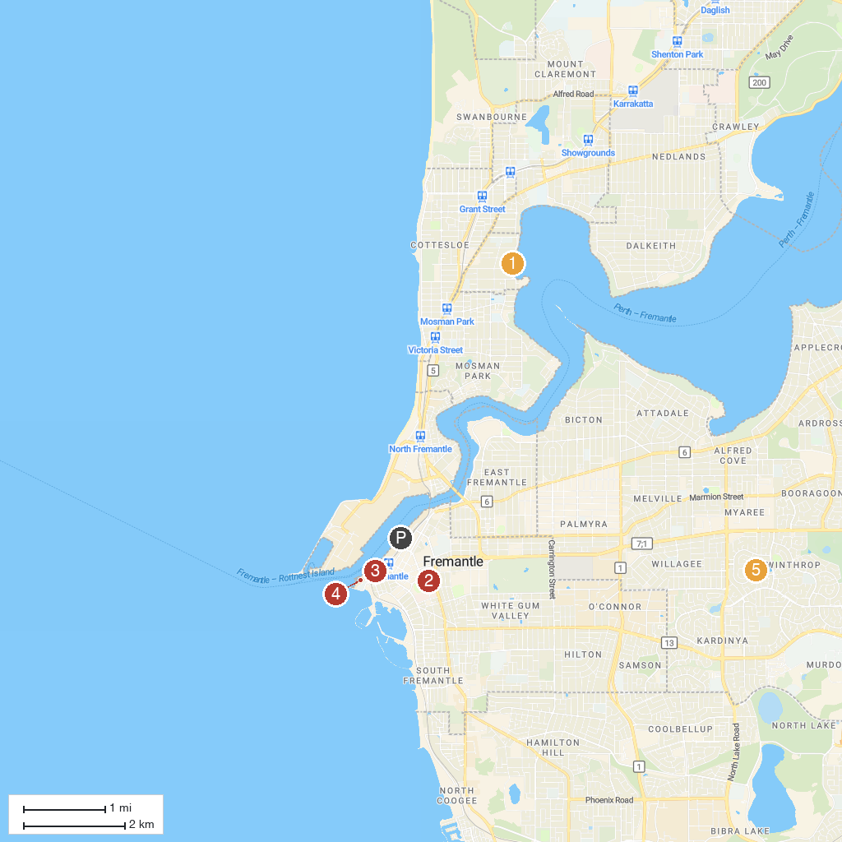
MAP KEY
1. Freshwater Bay | 5. WA Maritime Museum
2. Fremantle Prison | 6. Robert Smith Park
3. E Shed Markets | 7. St George's Cathedral
4. Wembley Golf Course | 8. Saint Mary's Cathedral
P. Cruise port / terminal
Map © MapTiler © OpenStreetMap contributors · cruiseports.org

