Funchal, Madeira, Portugal
Draped across volcanic hillsides above the Atlantic, Funchal rewards cruisers with flower-lined streets, a thrilling wicker toboggan ride down from Monte, and the freshest tuna steaks you'll eat anywhere.
⚓ Docked (cruise terminal) · 🕒 Typical call: 8-10 hrs · 💶 Currency: Euro (€) · 🗣️ Language: Portuguese · 🌺 Best months: Apr–Jun, Sep–Nov
✍️ MY DAY IN PORT (FILL IN)
Ship / Date
In port | arrive ______ · all aboard ______
Booked excursion
Notes / meeting point
GETTING ASHORE
- Docking: Ships dock at the Pontinha cruise pier (Port of Funchal), which can berth several large ships at once — a 15-20 min walk to the Old Town.
- Walk to Center: 15-20 min stroll east along the waterfront promenade to the Old Town (Zona Velha) and Mercado dos Lavradores.
- Best For: Gardens, levada walks, wine tasting, the Monte toboggan, and relaxed Atlantic island atmosphere.
- Don't Miss: Cable car up to Monte, then the famous wicker-basket toboggan ride back down — a Funchal rite of passage.
GETTING AROUND
- 🚕 Taxi: ~€7–8 — Fixed-fare taxis (yellow with blue stripe) wait at the cruise terminal. The fare to the city center is approximately €7.
- 📱 Rideshare: ✅ Uber, Bolt
- 🚌 Hop-on hop-off: ✅ City Sightseeing / Yellow Bus · from 25
TOP THINGS TO DO
- Monte Cable Car & Wicker Toboggan — Ride the Teleférico do Funchal gondola from the Old Town up to Monte, visit the Church of Our Lady of Monte, then descend in a…
- Levada Walk — Rabaçal & 25 Fountains — Madeira's levadas (irrigation channels) thread through ancient laurisilva forest.
- Mercado dos Lavradores & Old Town Walk — Funchal's covered farmers' market bursts with tropical fruits, flowers, and Madeiran specialities.
- Quinta das Cruzes & Monte Palace Gardens — The Monte Palace Tropical Garden houses a remarkable collection of azulejo tile panels, koi ponds, and exotic plants across…
- Madeira Wine Lodge Tasting — Madeira wine is one of the world's most distinctive fortified wines — and it's made right here.
BEST WALKS
- Waterfront Promenade to Zona Velha: 2.5 km · Flat · 30-40 min · Easy — Head east from the Pontinha terminal along Avenida do Mar past the marina, the city gardens, and…
- Old Town to Cathedral & Wine Lodges: 1.5 km · Mostly flat · 20-30 min · Easy — From the Mercado dos Lavradores, walk west along Rua do Aljube to the Sé Cathedral (Funchal's…
WEATHER · DAYLIGHT · MONEY
Month | High °F | Low °F | Rainy days
May | 68 | 59 | 7
Jul | 76 | 65 | 3
Sep | 75 | 66 | 11
Daylight: May 7:09AM–8:59PM · Jul 7:11AM–9:16PM · Sep 7:51AM–8:13PM
cruiseports.org/funchal · Confirm terminal & all-aboard time with your ship

Funchal, Madeira, Portugal — Port Map
Red = walkable sights · Amber = excursions farther out · P = cruise terminal
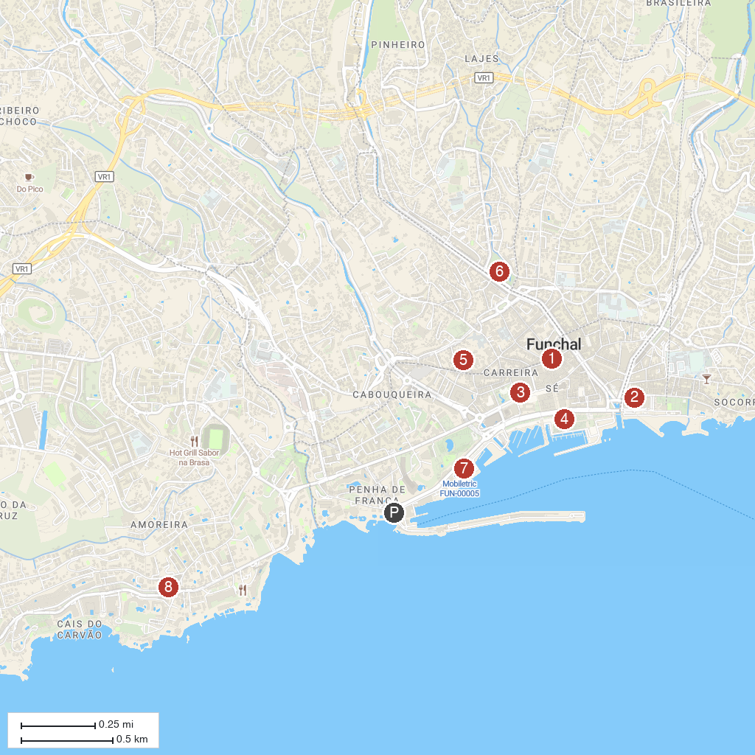
MAP KEY
1. Praça do Município | 5. Holy Trinity Church
2. Museu de Electricidade Casa da Luz | 6. Jardim de Santa Luzia
3. Blandy's Wine Lodge | 7. CR7 Museum
4. Praça do Povo | 8. Madeira Explorers - Tourism Leisure Ltd
P. Cruise port / terminal
Map © MapTiler © OpenStreetMap contributors · cruiseports.org

