Galveston, Texas, USA
Texas's only major cruise port blends Victorian grandeur with Gulf Coast grit — stroll The Strand's gaslit streets, grab fresh Gulf shrimp, and soak in a city that's been rebuilt, and re-loved, more than once.
⚓ Docked (no tender) · 🕒 Homeport — full day · 💵 USD · 🗣️ English
✍️ MY DAY IN PORT (FILL IN)
Ship / Date
In port | arrive ______ · all aboard ______
Booked excursion
Notes / meeting point
GETTING ASHORE
- Docking: Always docked — four cruise terminals on Harborside Drive
- Walk to Strand: 10–15 min from T25/T28 · 20–25 min from T10
- Best For: History, Victorian architecture, Gulf seafood, beach day
- Don't Miss: Tall Ship ELISSA at the Texas Seaport Museum
GETTING AROUND
- 🚕 Taxi: Flat rates available; confirm with driver — Taxis are readily available at all Port of Galveston cruise terminals. Many companies offer flat rates to/from the port.
- 📱 Rideshare: ✅ Uber, Lyft
TOP THINGS TO DO
- Tall Ship ELISSA & Texas Seaport Museum — Board the 1877 iron-hulled sailing ship ELISSA — one of the oldest afloat — and tour the adjacent maritime museum telling…
- The Strand Historic District — Wander the gaslit Victorian streetscape — 19th-century iron-front buildings housing galleries, boutiques, antique shops, and the…
- Galveston Bay Dolphin Watch — Short boat tour from Pier 21 into Galveston Bay to spot wild bottlenose dolphins in their natural habitat.
- Gulf Beach Day — Hit Stewart Beach or East Beach for sun, sand, and warm Gulf waters.
- Moody Gardens — Three glass pyramids housing an aquarium, rainforest, and discovery museum — plus a ropes course and zip line.
BEST WALKS
- Pier 21 to The Strand Loop: 1.2 miles · ~25 min · Flat · From T25/T28 — Start at Pier 21 beside the ship — visit the Texas Seaport Museum and ELISSA, then walk west along…
- Seawall Promenade Stroll: 1–3 miles · Flat · Requires rideshare to reach — The 10-mile Seawall Urban Park runs along the Gulf shore.
WEATHER · DAYLIGHT · MONEY
Month | High °F | Low °F | Rainy days
May | 80 | 73 | 15
Jul | 87 | 81 | 14
Sep | 84 | 78 | 16
Daylight: May 6:27AM–8:04PM · Jul 6:30AM–8:19PM · Sep 7:04AM–7:23PM
ESSENTIAL TRAVEL QUALIFICATIONS
Confirm terminal and designated rideshare zone for your sailing. Disney primarily Terminal 28; Princess selected Terminal 25 sailings (port information checked 3 October 2026); boarding documents control.
cruiseports.org/galveston · Confirm terminal & all-aboard time with your ship

Galveston, Texas, USA — Port Map
Red = walkable sights · Amber = excursions farther out · P = cruise terminal
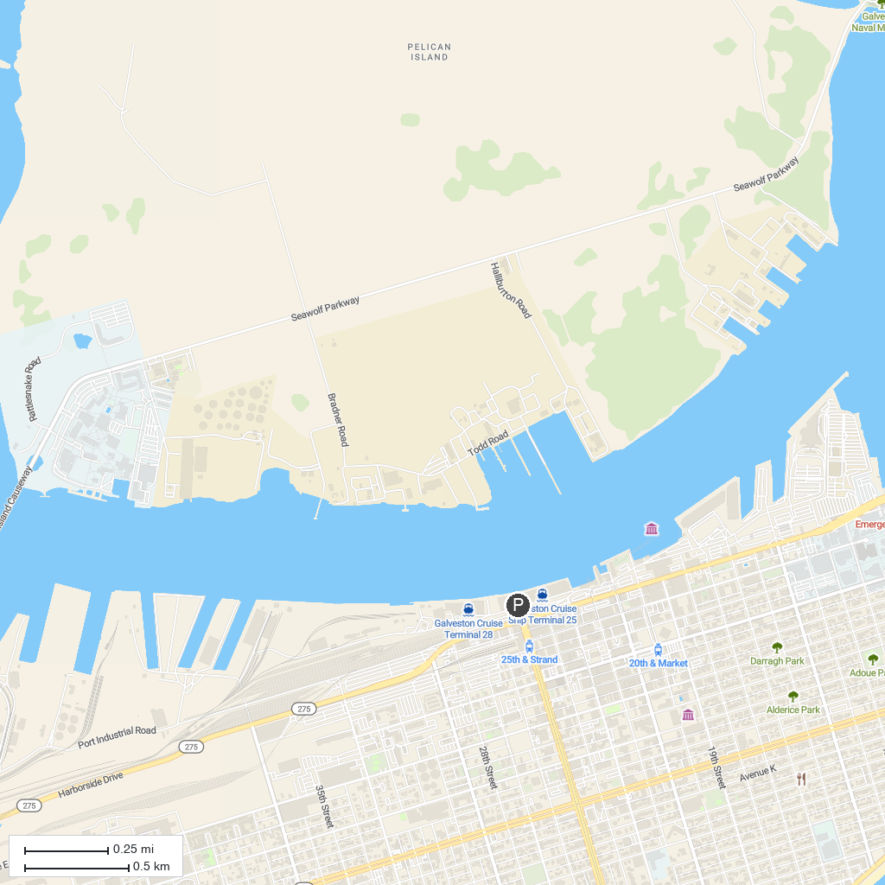
MAP KEY
1. Jack Brooks Park | 5. Paul Hopkins Park
2. Carbide Park | 6. Texas City Museum
3. Rainbow Park | 7. Runge Park
4. Bay Street Park | 8. Carver Park
P. Cruise port / terminal
Map © MapTiler © OpenStreetMap contributors · cruiseports.org

