Gambier Islands, French Polynesia
One of the most remote ports in French Polynesia, the Gambier Islands reward expedition cruisers with a stunning lagoon, 19th-century stone ruins, and the world's finest black pearls.
⚓ Tender port (no pier) · 🕒 Typical call: 6–8 hrs · 💵 CFP Franc (XPF) — no ATMs, bring cash · 🗣️ French / Mangarevan
✍️ MY DAY IN PORT (FILL IN)
Ship / Date
In port | arrive ______ · all aboard ______
Booked excursion
Notes / meeting point
GETTING ASHORE
- Docking: Tender to Rikitea wharf — no cruise pier
- Walk to center: 2 min from tender wharf to village centre
- Best For: Black pearl shopping, historic ruins, lagoon excursions
- Don't Miss: St. Michael's Cathedral interior with pearl-inlaid altar
GETTING AROUND
TOP THINGS TO DO
- St. Michael's Cathedral & Historic Ruins — The 1848 coral-stone cathedral dominates Rikitea and can be explored in 30–45 minutes.
- Mount Duff Summit Hike — A strenuous 441m ascent through pine forest and grassland rewards hikers with a 360° panorama of the entire Gambier lagoon and…
- Black Pearl Farm Tour — Visit a working perliculture farm and see how Gambier's prized black pearls are grafted and harvested.
- Lagoon Island Hopping (Aukena & Taravai) — Boat tours visit uninhabited outer islands in the lagoon.
- Motu Beach Day — The volcanic main island has limited beaches, but the outer coral islets offer white-sand, turquoise-water beaches accessible by…
BEST WALKS
- Rikitea Village & Cathedral Walk: 45 min · Easy · Flat — From the wharf, walk through the village to St.
- Mount Duff Trailhead Approach: 20 min walk to trailhead · then 1.5 hrs up — Follow the main road south from the wharf to reach the start of the Mount Duff trail.
WEATHER · DAYLIGHT · MONEY
Month | High °F | Low °F | Rainy days
May | 76 | 74 | 15
Jul | 73 | 71 | 12
Sep | 72 | 70 | 12
Daylight: May 6:26AM–5:25PM · Jul 6:40AM–5:31PM · Sep 5:56AM–5:53PM
cruiseports.org/gambier-islands · Confirm terminal & all-aboard time with your ship

Gambier Islands, French Polynesia — Port Map
Red = walkable sights · Amber = excursions farther out · P = cruise terminal
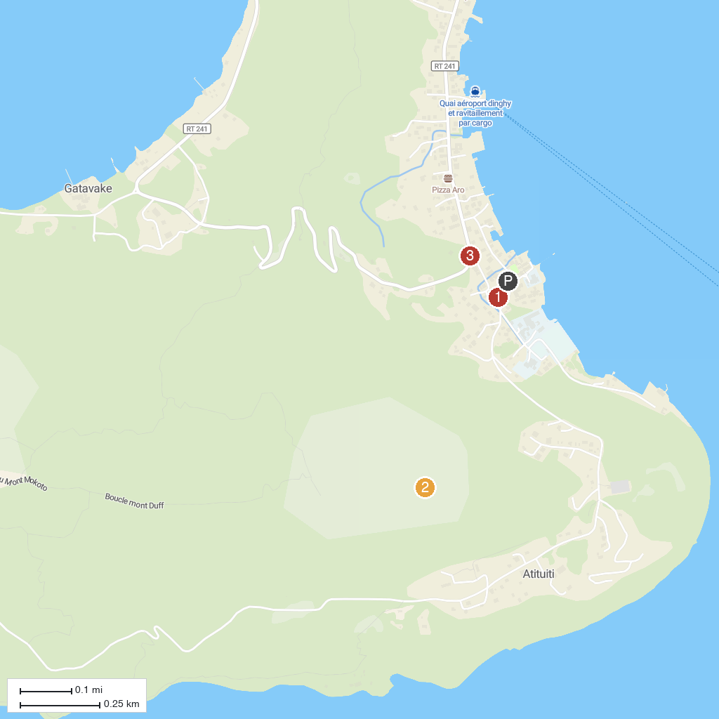
MAP KEY
1. Cathédrale Saint-Michel de Rikitea | 3. Fort Saint-Hilaire
2. Mont Duff
P. Cruise port / terminal
Map © MapTiler © OpenStreetMap contributors · cruiseports.org

