Gananoque, Ontario, Canada
Pronounced GAN-uh-NOCK-way, this Victorian river town sits at the heart of the 1,864-island archipelago straddling the US-Canada border — a rare port where the ship docks steps from the boat tours, the museum, and the pub.
⚓ Pier (municipal marina) · 🕒 Typical call: 6-8 hrs · 💵 Canadian Dollar (USD widely accepted) · 🗣️ English · 🏝️ Small-ship / river cruise
✍️ MY DAY IN PORT (FILL IN)
Ship / Date
In port | arrive ______ · all aboard ______
Booked excursion
Notes / meeting point
GETTING ASHORE
- Docking: Pier — small ships berth at Gananoque Municipal Marina, waterfront
- Walk to centre: 0 min to waterfront; 10-15 min to King St downtown
- Best For: Thousand Islands boat tours, Boldt Castle day trip, lazy river-town strolling
- Don't Miss: A 1-3 hr islands cruise from the dock next to your ship — the whole region makes sense from the water
GETTING AROUND
- 🚕 Taxi: Ask the operator for the current fare — Local taxis serve the town and surroundings. T.I. Taxi (613-382-2777) and A1 Taxi (613-382-3777) are the main operators;
- 📱 Rideshare: ✅ Uber
TOP THINGS TO DO
- Thousand Islands Boat Tour — 1-to-3-hour narrated sightseeing cruises wind through the archipelago, past historic cottages, private islands, and the…
- Boldt Castle Day Trip — George Boldt's unfinished Gilded Age castle on Heart Island is one of the most romantic ruins in North America.
- 1000 Islands History Museum — An engaging, well-curated museum covering Indigenous heritage, the War of 1812, the river's natural history, and the lavish…
- Helicopter Tour — Thousand Islands from Above — Bucket-list aerial views of the islands, castles, and the Canada-US border winding through the river.
- Thousand Islands Playhouse — Canada's Dockside Theatre — a professional company staging matinees in a converted 1909 canoe club (the former Gananoque Canoe…
BEST WALKS
- Waterfront to Downtown Loop: 2.5 km · 45-60 min · Easy — From the marina, stroll through Joel Stone Heritage Park past the historic cannons and beach, then…
- Thousand Islands Parkway Trail (riverside): Up to 5 km one-way · Easy · Paved — A paved multi-use path starts near the marina and runs parallel to the St.
WEATHER · DAYLIGHT · MONEY
Month | High °F | Low °F | Rainy days
May | 64 | 47 | 11
Jul | 78 | 65 | 12
Sep | 70 | 58 | 9
Daylight: May 5:37AM–8:25PM · Jul 5:35AM–8:45PM · Sep 6:44AM–7:14PM
cruiseports.org/gananoque-on · Confirm terminal & all-aboard time with your ship

Gananoque, Ontario, Canada — Port Map
Red = walkable sights · Amber = excursions farther out · P = cruise terminal
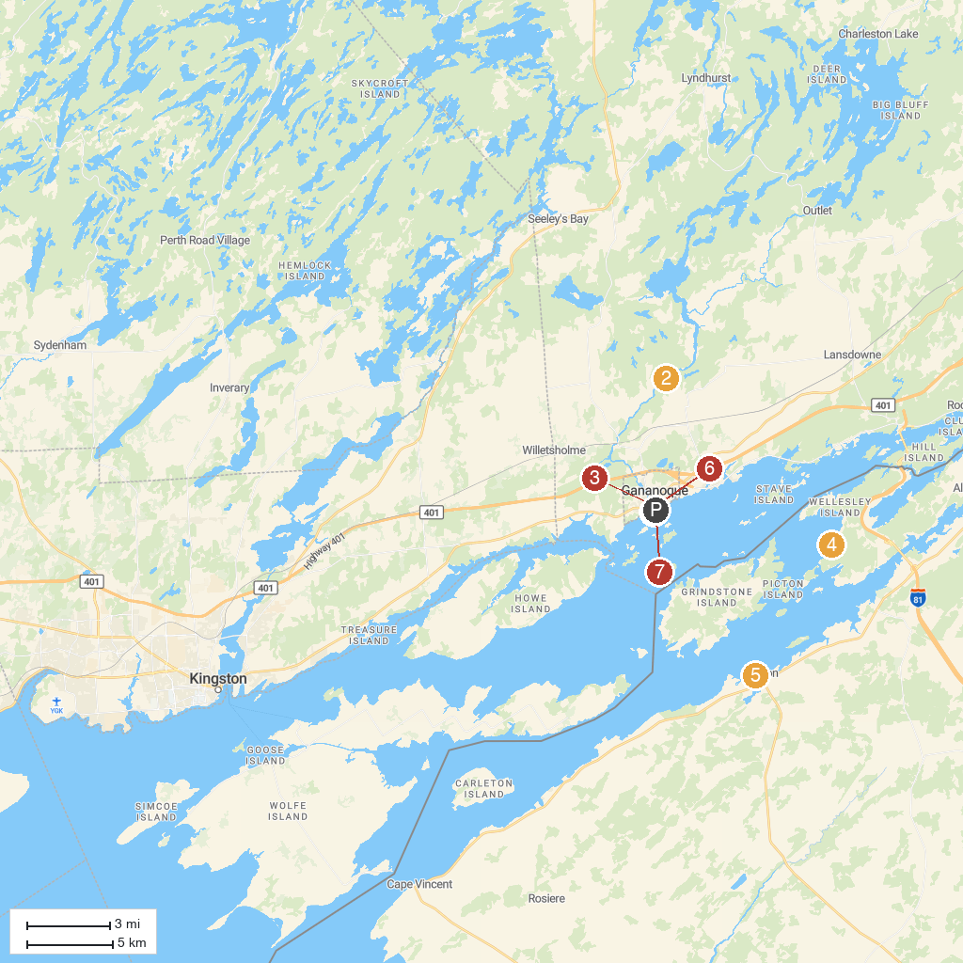
MAP KEY
1. 1000 Islands Kayaking Co | 5. Rock Island Lighthouse State Park
2. Marble Rock Conservation Area | 6. Antique Boat Museum
3. Confederation Park | 7. St. John the Evangelist Catholic Church
4. Minna Anthony Common Nature Center | 8. 1000 Islands History Museum
P. Cruise port / terminal
Map © MapTiler © OpenStreetMap contributors · cruiseports.org

