Gaspé, Quebec, Canada
At the tip of the Gaspésie Peninsula, where the Appalachians meet the Gulf of St. Lawrence, Gaspé is Canada's historic starting point — a compact town flanked by national park wilderness and one of the world's great natural arches.
⚓ Mostly dock at Sandy Beach (some tender) · 🕒 Typical call: 7-9 hrs · 💵 Canadian Dollar (CAD) · 🗣️ French (English widely spoken in tourism)
✍️ MY DAY IN PORT (FILL IN)
Ship / Date
In port | arrive ______ · all aboard ______
Booked excursion
Notes / meeting point
GETTING ASHORE
- Docking: Most ships dock at Sandy Beach wharf (6 km from town); some anchor and tender to Jacques-Cartier Marina downtown
- Walk to centre: 10–15 min shuttle from Sandy Beach dock; 0 min if tendering to the downtown marina
- Best For: History, wildlife, dramatic scenery, whale watching
- Don't Miss: Percé Rock (book ship excursion) or Forillon National Park
GETTING AROUND
- 🚕 Taxi: Est. CAD $15–$25 — Local taxis (e.g., Taxi Porlier) are available at the pier. The town center is roughly 6 km away; fares are unmetered so
TOP THINGS TO DO
- Percé Rock & Bonaventure Island — One of the world's great natural arches — a monolithic rock rising from the Gulf — and the island next door hosts North America's…
- Forillon National Park — Where the Appalachian Mountains plunge into the sea.
- Birthplace of Canada Heritage Site — Gaspé marks where Jacques Cartier planted his cross in 1534, claiming the land for France.
- Gespeg Mi'gmaq Interpretation Site — A reconstructed 17th-century Mi'gmaq village 10 minutes from the pier.
- Whale & Seal Watching — The waters off Forillon and Gaspé Bay are a prime whale-watching destination.
BEST WALKS
- Downtown Waterfront Heritage Walk: 2 km · ~45 min · Flat — From the downtown waterfront, stroll east along the boardwalk to the Jacques-Cartier monument and…
- Rue de la Reine Shopping & Café Loop: 1 km · ~20 min · Slight uphill — Head one block up from the waterfront to Gaspé's main commercial street for local craft shops, a…
WEATHER · DAYLIGHT · MONEY
Month | High °F | Low °F | Rainy days
May | 55 | 38 | 12
Jul | 74 | 59 | 14
Sep | 65 | 50 | 11
Daylight: May 4:36AM–7:53PM · Jul 4:31AM–8:16PM · Sep 5:55AM–6:29PM
cruiseports.org/gaspe · Confirm terminal & all-aboard time with your ship

Gaspé, Quebec, Canada — Port Map
Red = walkable sights · Amber = excursions farther out · P = cruise terminal
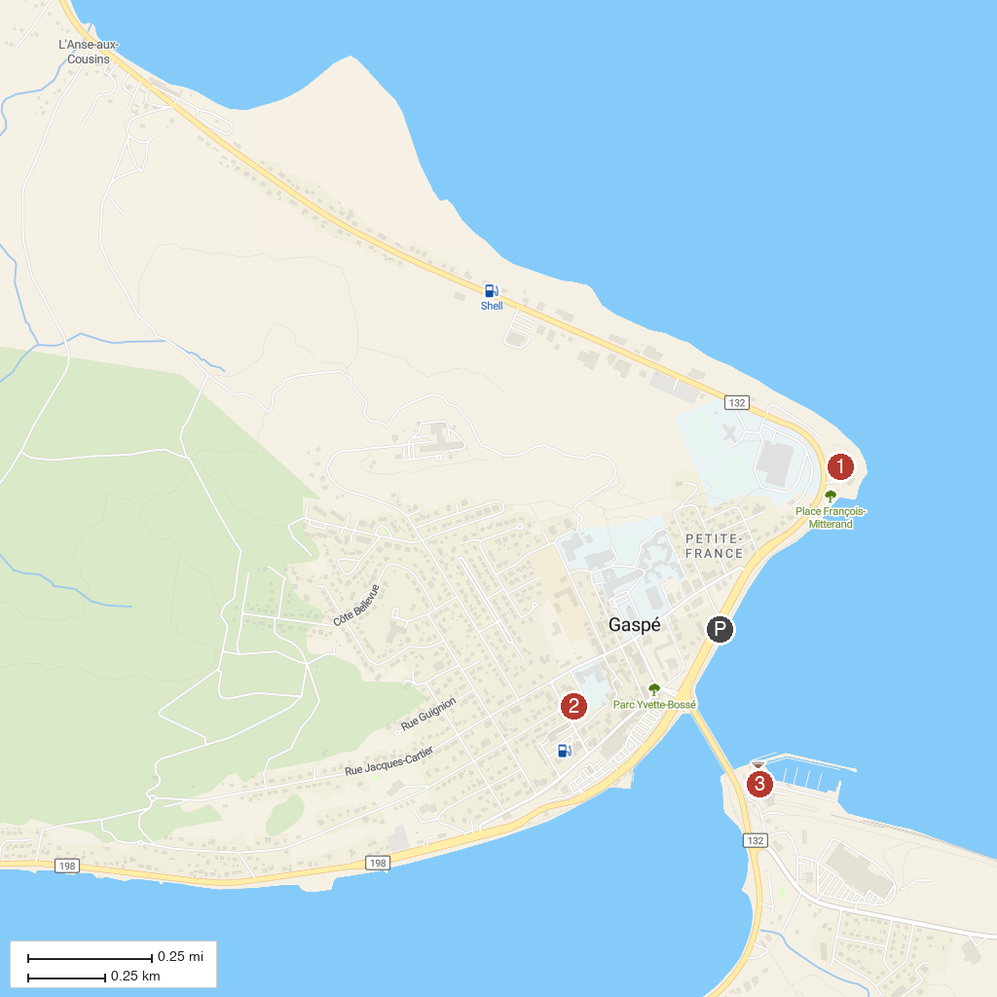
MAP KEY
1. Musée de la Gaspésie | 3. Jacques-Cartier Marina
2. Cathédrale du Christ-Roi
P. Cruise port / terminal
Map © MapTiler © OpenStreetMap contributors · cruiseports.org

