Genoa, Liguria, Italy
Italy's great port city wears its seafaring past openly — a labyrinth of UNESCO-listed caruggi (medieval lanes), magnificent Renaissance palaces, and a waterfront reinvented around one of Europe's finest aquariums. Add the birthplace of Christopher Columbus and the invention of pesto, and a day here earns its keep.
⚓ Docked — cruise terminal · 🕒 Typical call: 8-10 hrs · 💶 Euro (€) · 🗣️ Italian
✍️ MY DAY IN PORT (FILL IN)
Ship / Date
In port | arrive ______ · all aboard ______
Booked excursion
Notes / meeting point
GETTING ASHORE
- Docking: Ships dock at Stazione Marittima, right in the city centre — no tender
- Walk to centre: 5-10 min walk to the Old Port (Porto Antico) and historic lanes
- Best For: UNESCO old town, world-class aquarium, Italian street food & pesto
- Don't Miss: Via Garibaldi palaces, Acquario di Genova, pesto trofie at a caruggi trattoria
GETTING AROUND
- 🚕 Taxi: €10–€18 — Official white taxis are metered and abundant at the terminal. The ride to the city center takes roughly 7–8 minutes. Fi
- 📱 Rideshare: ❌ not available
- 🚌 Hop-on hop-off: ✅ City Sightseeing Genoa
TOP THINGS TO DO
- Portofino & Santa Margherita Ligure — The postcard Italian Riviera village of Portofino is about 35 km east.
- UNESCO Via Garibaldi & Ducal Palace Walk — Via Garibaldi (Strada Nuova) is lined with 16th-century palaces — several are open as museums (Palazzo Rosso, Palazzo Bianco…
- Acquario di Genova — One of Europe's largest aquariums, right at the Porto Antico beside the cruise terminal.
- Caruggi Food & Pesto Experience — Wander the tangle of medieval lanes (caruggi) sampling Ligurian street food: focaccia fresh from the oven, farinata (chickpea…
- Cinque Terre Day Trip — The five cliff-hung villages of Cinque Terre are about 90 km southeast — reachable by train (change at La Spezia) or organised…
BEST WALKS
- Porto Antico to Via Garibaldi: 2.5 km · ~45 min · Easy–moderate — Start at the Acquario di Genova on the waterfront, walk through the Piazza Caricamento to the…
- Caruggi Loop — Cathedral & Columbus: 2 km · ~40 min · Moderate (cobbles & inclines) — From the port, duck into the medieval caruggi.
- Castelletto Viewpoint (Lift): Short walk + lift · ~30 min — Take the Ascensore Castelletto (a public lift) from Piazza del Portello up to the Spianata…
WEATHER · DAYLIGHT · MONEY
Month | High °F | Low °F | Rainy days
May | 69 | 57 | 15
Jul | 82 | 70 | 8
Sep | 77 | 64 | 10
Daylight: May 5:57AM–8:44PM · Jul 5:54AM–9:05PM · Sep 7:03AM–7:34PM
cruiseports.org/genoa · Confirm terminal & all-aboard time with your ship

Genoa, Liguria, Italy — Port Map
Red = walkable sights · Amber = excursions farther out · P = cruise terminal
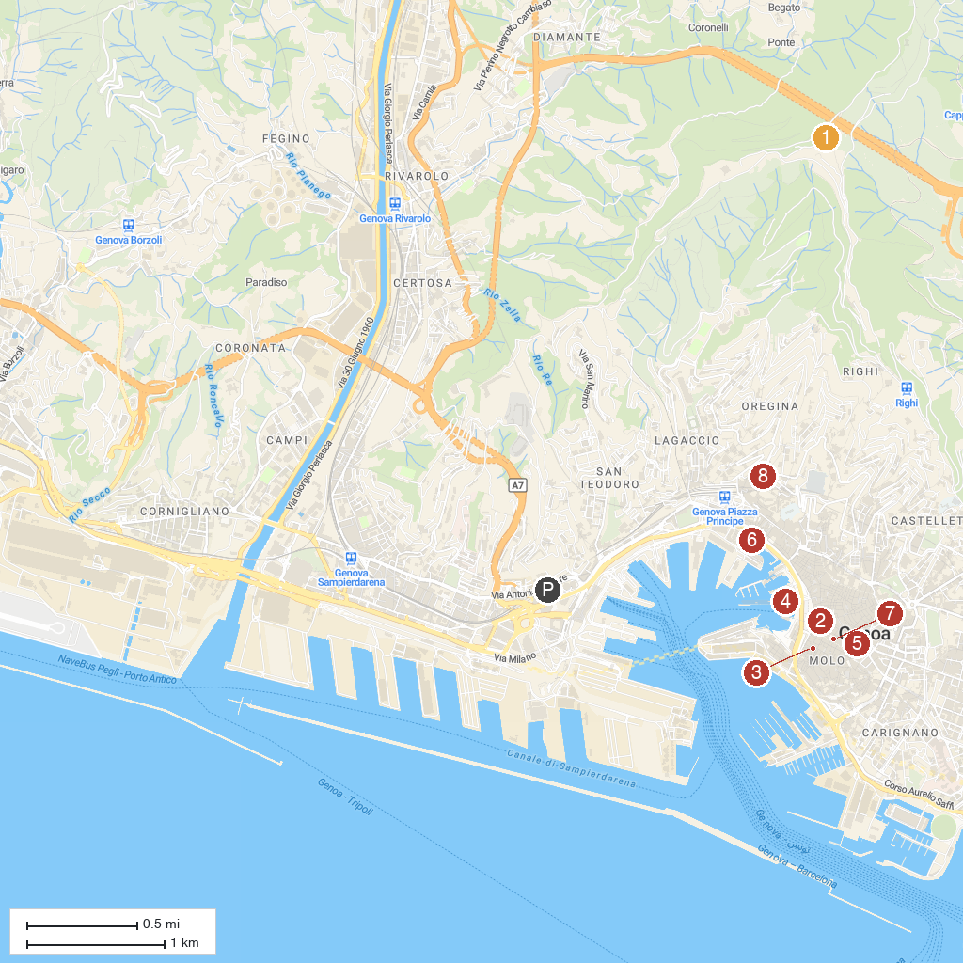
MAP KEY
1. Forte Sperone | 5. Doge's Palace
2. Chiesa di San Pietro in Banchi | 6. Galata Museo del Mare
3. Chiesa di San Giorgio | 7. Cattedrale di San Lorenzo
4. Acquario di Genova | 8. D'Albertis Castle
P. Cruise port / terminal
Map © MapTiler © OpenStreetMap contributors · cruiseports.org

