Genthin, Saxony-Anhalt, Germany
A sleepy Saxony-Anhalt canal town where laundry-detergent heritage meets Romanesque brick architecture — and the only sounds are birdsong and barge engines.
⚓ Pier (canal wall) · 🕒 Typical call: 4–6 hrs · 💶 Currency: Euro · 🗣️ Language: German
✍️ MY DAY IN PORT (FILL IN)
Ship / Date
In port | arrive ______ · all aboard ______
Booked excursion
Notes / meeting point
GETTING ASHORE
- Docking: Tied directly to canal wall — no tender needed
- Walk to center: ~10–15 min (800 m) from pier to Marktplatz
- Best For: History fans, day cyclists, German small-town atmosphere
- Don't Miss: Jerichow Monastery — one of Germany's oldest Romanesque brick buildings
GETTING AROUND
- 🚕 Taxi: €4.50 base + meter — Local taxis are available in Genthin. The town is small so fares to the city center should be modest; base fare is €4.50
- 📱 Rideshare: ❌ not available
TOP THINGS TO DO
- Jerichow Monastery — Founded in 1144, Kloster Jerichow is one of the oldest and most significant Romanesque brick buildings in northern Germany.
- Persil Town Walk & Kreismuseum — Genthin built its identity around Henkel's Persil factory.
- Elbe-Havel Canal Cycling — Germany's flat canal-side cycling paths are excellent around Genthin.
- Water Tower & Town Center Stroll — The 48-metre brick Wasserturm (built 1935) is Genthin's defining landmark.
BEST WALKS
- Canal Quay to Marktplatz: 1.5 km round trip · 25–35 min · Easy — Walk south from the ship along Jerichower Straße, past the Water Tower park, to the central…
- Canal Towpath North: 2–6 km one-way · 30–90 min · Easy/flat — Follow the canal towpath northward from the dock for as far as your time allows.
WEATHER · DAYLIGHT · MONEY
Month | High °F | Low °F | Rainy days
May | 66 | 49 | 9
Jul | 76 | 60 | 11
Sep | 69 | 54 | 8
Daylight: May 5:15AM–9:00PM · Jul 5:07AM–9:26PM · Sep 6:46AM–7:25PM
cruiseports.org/genthin · Confirm terminal & all-aboard time with your ship

Genthin, Saxony-Anhalt, Germany — Port Map
Red = walkable sights · Amber = excursions farther out · P = cruise terminal
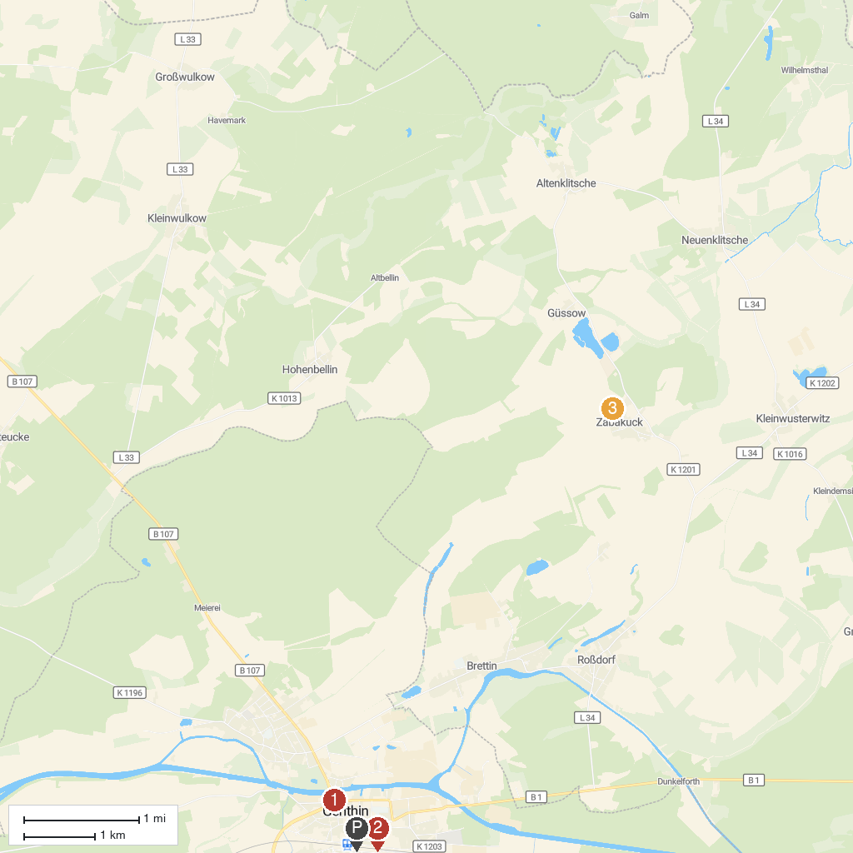
MAP KEY
1. Wasserturm Genthin | 3. Zabakuck Zoo
2. Kreismuseum des Jerichower Land - Landkreis Jerichower Land
P. Cruise port / terminal
Map © MapTiler © OpenStreetMap contributors · cruiseports.org

