Giurgiu, Giurgiu County, Romania
On the Danube's left bank, facing Bulgaria across the famous Friendship Bridge, Giurgiu is your key to Romania — from Bucharest's communist grandeur to Dracula's castles deep in the Carpathians.
⚓ Docked (river pier) · 🕒 Typical call: 8-10 hrs · 💵 Romanian Leu (RON) · 🗣️ Romanian · 🏛️ History & culture
✍️ MY DAY IN PORT (FILL IN)
Ship / Date
In port | arrive ______ · all aboard ______
Booked excursion
Notes / meeting point
GETTING ASHORE
- Docking: Docked at Șoseaua Portului river pier — no tendering
- Walk to center: ~10 min walk to Clock Tower and town center
- Best For: Bucharest day trips, Transylvania excursions, Ottoman history
- Don't Miss: Bucharest's Palace of Parliament — the world's 2nd-largest administrative building
GETTING AROUND
- 🚕 Taxi: 8–12 RON (~€2–3) — Taxis are available at the port and charge ~4 RON/km daytime. The city center (Piața Unirii) is roughly 2 km away.
- 📱 Rideshare: ✅ Uber, Bolt
TOP THINGS TO DO
- Bucharest City Highlights — Romania's capital rewards a full day: the colossal Palace of Parliament (world's 2nd-largest administrative building and heaviest…
- Bran Castle & Brașov — The Gothic hilltop castle associated with Dracula mythology plus the gorgeous medieval city of Brașov in the Carpathian foothills…
- Peleș Castle & Sinaia — The Neo-Renaissance royal summer palace in the Carpathians is Romania's most visited castle — ornate rooms, mountain air, and the…
- Comana Natural Park & Monastery — One of Romania's largest wetland reserves, 30 km from Giurgiu.
- Giurgiu Town Walk: Ottoman Legacy — Stroll the octagonal old town — a Ottoman defensive design — to the 1771 Clock Tower, Giurgiu Fortress ruins, St.
BEST WALKS
- Port to Old Town Loop: 1.5 km · 20-30 min · Easy — Walk from the port entrance along the Danube promenade to the Clock Tower, then loop through the…
- Danube Promenade & Friendship Bridge View: 2 km · 30 min · Easy — Head south along the riverbank promenade for clear views of the Giurgiu-Rousse Friendship Bridge…
WEATHER · DAYLIGHT · MONEY
Month | High °F | Low °F | Rainy days
May | 73 | 55 | 10
Jul | 86 | 67 | 8
Sep | 79 | 59 | 4
Daylight: May 5:50AM–8:35PM · Jul 5:48AM–8:55PM · Sep 6:55AM–7:26PM
cruiseports.org/giurgiu · Confirm terminal & all-aboard time with your ship

Giurgiu, Giurgiu County, Romania — Port Map
Red = walkable sights · Amber = excursions farther out · P = cruise terminal
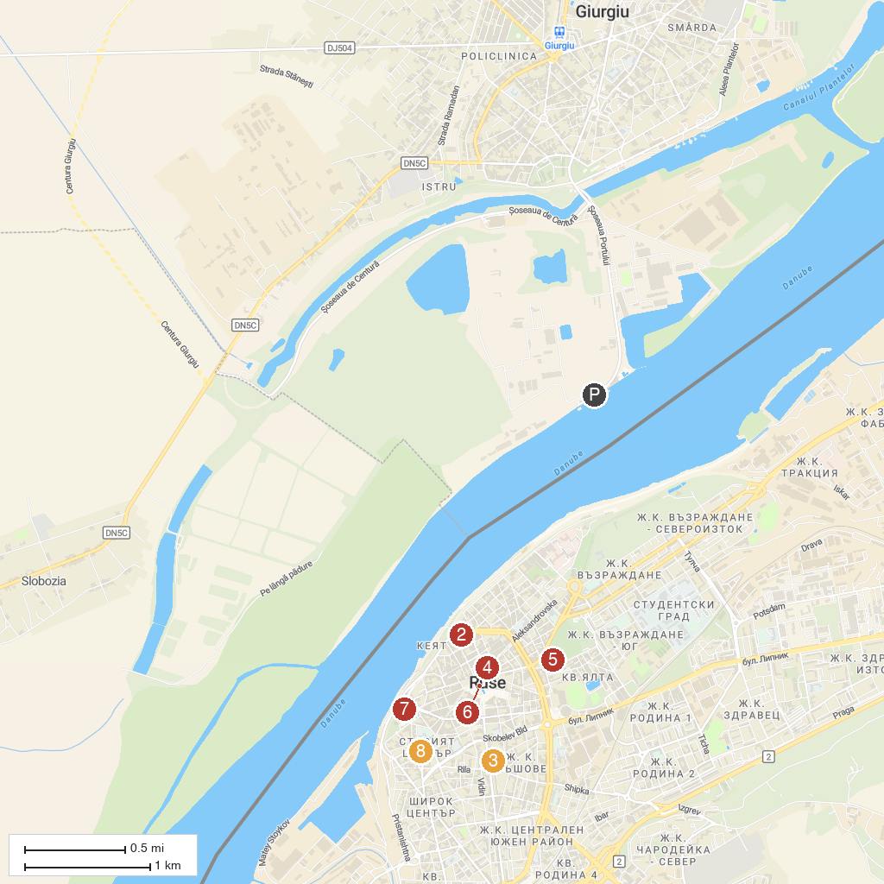
MAP KEY
1. Giurgiu Port | 5. Pantheon of National Revival Heroes
2. Museum of urban life Kaliopa House | 6. Monument of Liberty
3. Art Gallery | 7. “Sexaginta Prista” Port of the sixty ships fortress
4. Municipal Tourist Information Center | 8. Regional Historical Museum
P. Cruise port / terminal
Map © MapTiler © OpenStreetMap contributors · cruiseports.org

