Gizo, Western Province, Solomon Islands
A raw, authentic slice of the South Pacific — world-class diving in the Coral Triangle, WWII wreck sites, and the island where JFK's crew swam to safety. Expedition ships love it for good reason.
⚓ Tender port (ships anchor offshore) · 🕒 Typical call: 6–8 hrs · 💵 Solomon Islands Dollar (SBD); USD/AUD accepted · 🗣️ English & Solomon Islands Pijin · 🤿 Dive & snorkel destination
✍️ MY DAY IN PORT (FILL IN)
Ship / Date
In port | arrive ______ · all aboard ______
Booked excursion
Notes / meeting point
GETTING ASHORE
- Docking: Tender — ships anchor, boats land at Gizo Town Wharf
- Walk to center: 0 min — wharf is in town center
- Best For: Diving, WWII history, Kennedy Island, local markets
- Don't Miss: Kennedy Island boat trip & the open-air market at the wharf
GETTING AROUND
- 🚕 Taxi: SBD 25–35 (~USD 3–4) per trip — Shared taxis are the main motorized transport in Gizo. Fares are not metered — agree on a price before you get in. Short
TOP THINGS TO DO
- Kennedy Island & PT-109 Story — Hire a local banana boat to Plum Pudding (Kennedy) Island, where JFK and his PT-109 crew swam after their torpedo boat was sunk…
- WWII Wreck Diving — The Toa Maru, a sunken Japanese merchant ship, and other wrecks sit in warm, clear water teeming with marine life.
- Coral Triangle Snorkel Safari — The waters around Gizo sit inside the Coral Triangle, the global center of marine biodiversity.
- Fatboys or Sanbis Resort Day Trip — Two private island resorts a short boat ride from Gizo offer overwater bars, white sand, and house reefs.
- Gizo Market & Wood Carving Shopping — The waterfront market buzzes with locals arriving by canoe from surrounding islands.
BEST WALKS
- Gizo Waterfront Stroll: ~1 km · 20 min · Flat · Free — Walk the main street from the town wharf past the open-air market, the BSP bank, local shops, and…
- Up to St. Peter's Cathedral: ~10 min walk · Easy · Free — A short walk from the wharf brings you to St.
WEATHER · DAYLIGHT · MONEY
Month | High °F | Low °F | Rainy days
May | 83 | 80 | 26
Jul | 82 | 79 | 26
Sep | 82 | 79 | 25
Daylight: May 6:36AM–6:21PM · Jul 6:48AM–6:29PM · Sep 6:26AM–6:29PM
cruiseports.org/gizo · Confirm terminal & all-aboard time with your ship

Gizo, Western Province, Solomon Islands — Port Map
Red = walkable sights · Amber = excursions farther out · P = cruise terminal
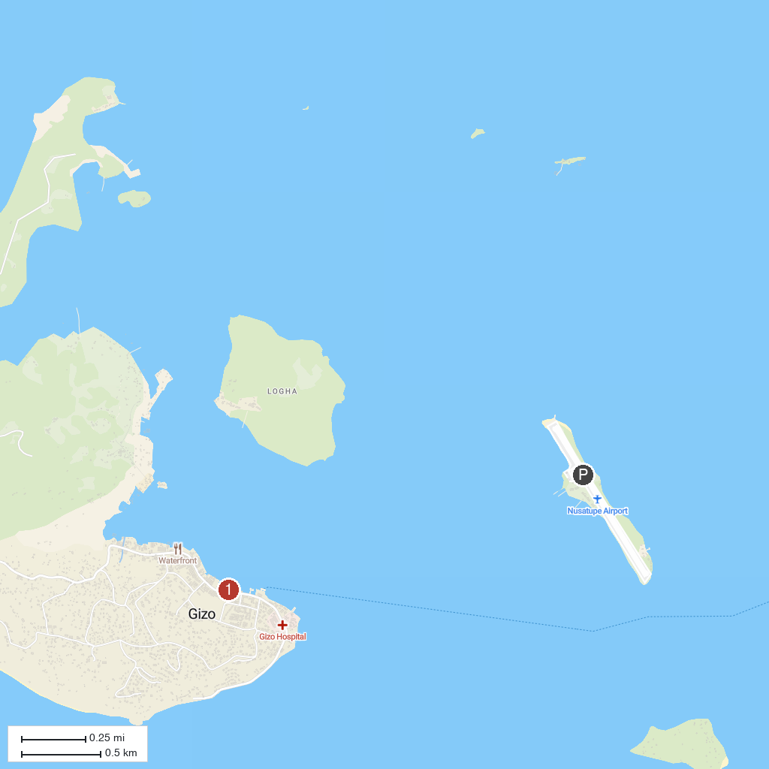
MAP KEY
1. Gizo Market | 2. Skull Island
P. Cruise port / terminal
Map © MapTiler © OpenStreetMap contributors · cruiseports.org

