Glacier Bay, Alaska, USA
One of Alaska's most spectacular scenic cruising days — your ship glides past calving tidewater glaciers while NPS rangers narrate the show and humpback whales breach off the bow.
🛳️ Scenic cruising only (no shore access from large ships) · 🕒 Typical call: 8-10 hrs · 💵 USD · 🗣️ English · 🌿 UNESCO World Heritage Site
✍️ MY DAY IN PORT (FILL IN)
Ship / Date
In port | arrive ______ · all aboard ______
Booked excursion
Notes / meeting point
GETTING ASHORE
- Docking: No docking or tendering — large ships cruise through the bay only
- Permit limit: Only 2 large cruise ships allowed in the park per day
- Best For: Glacier viewing, whale watching, scenic photography from the decks
- Don't Miss: Margerie Glacier — ships stop here; listen for the thunder of calving ice
GETTING AROUND
TOP THINGS TO DO
- Glacier Viewing from the Deck — The ship stops in front of Margerie Glacier — a 21-mile-long tidewater glacier that regularly calves massive chunks of ice into…
- Wildlife Watching on Board — Glacier Bay is one of the richest marine wildlife corridors in Alaska.
- Sea Kayaking at Bartlett Cove (Small Ships / Independents) — Glacier Bay Sea Kayaks operates half-day and full-day guided paddles from Bartlett Cove, the only developed area of the park.
- Glacier Bay Full-Day Tour Boat (Independents / Small Ships) — The daily catamaran from Glacier Bay Lodge dock at Bartlett Cove travels 130 miles round-trip through the bay to the upper…
- Huna Tribal House — Xunaa Shuká Hít — At Bartlett Cove, the Huna Tlingit Tribal House (Xunaa Shuká Hít) celebrates the cultural heritage of the Huna Tlingit people who…
BEST WALKS
- Forest Loop Trail, Bartlett Cove: 1 mile · Easy · 30-45 min — A flat loop through old-growth temperate rainforest down to the beach, with a viewing platform over…
- Bartlett River Trail: 4 miles round-trip · Easy-Moderate · 2-3 hrs — Follows the shoreline and forest edge to the Bartlett River estuary — a prime spot for brown bear…
WEATHER · DAYLIGHT · MONEY
Month | High °F | Low °F | Rainy days
May | 53 | 42 | 14
Jul | 62 | 52 | 16
Sep | 56 | 48 | 20
Daylight: May 4:35AM–9:25PM · Jul 4:22AM–9:55PM · Sep 6:34AM–7:21PM
cruiseports.org/glacier-bay · Confirm terminal & all-aboard time with your ship

Glacier Bay, Alaska, USA — Port Map
Red = walkable sights · Amber = excursions farther out · P = cruise terminal
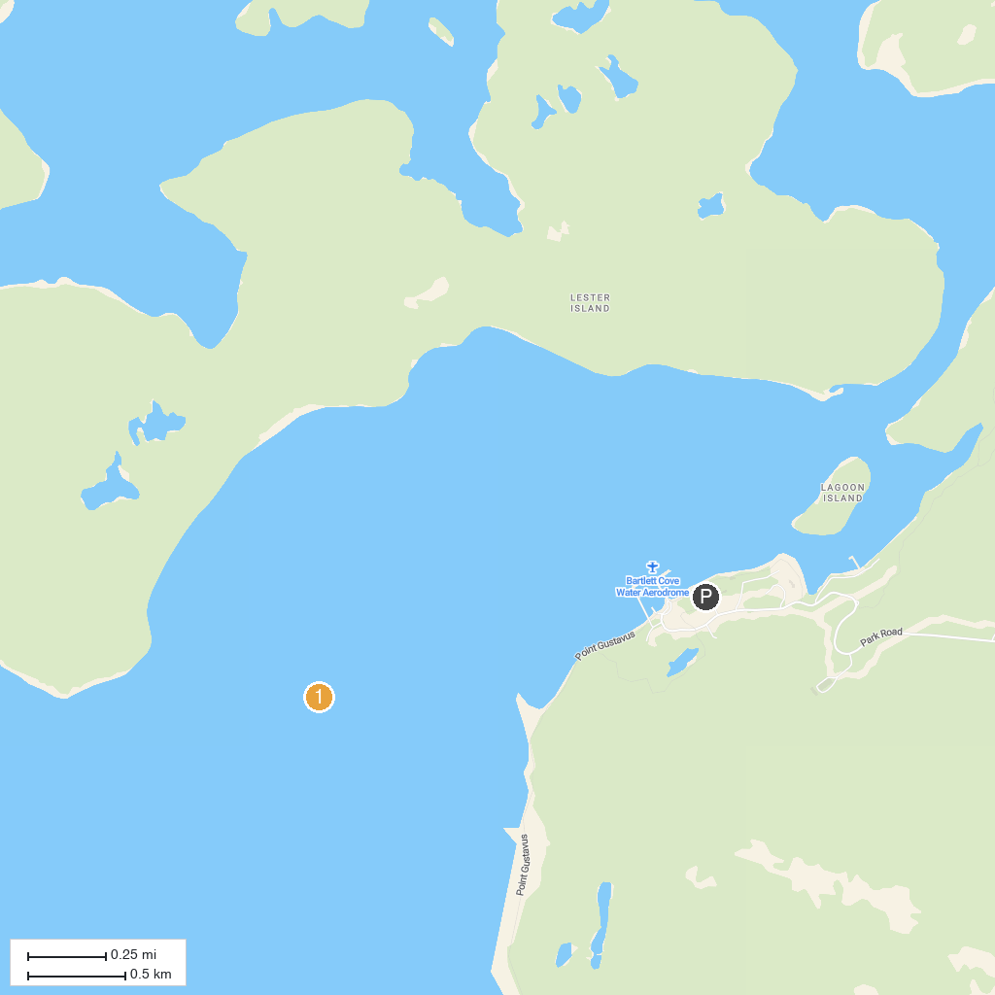
MAP KEY
1. Bartlett Cove
P. Cruise port / terminal
Map © MapTiler © OpenStreetMap contributors · cruiseports.org

